A Report for the
Electricity Commission
on its
Security of Supply Obligations

Final draft

Tony Baldwin
Law and Regulatory Policy Consultant
Wellington + Nelson

18 May 2005
  - Table of Contents

Disclaimer 7
About the author 7
Executive Summary 8
Part I: Preliminary 21
1 Introduction 22
Context 22
Scope of report 25
Preparation 25
Approach 26
Structure 27
Abbreviations and expressions 27
2 Legal rules 29
Outline 29
Rules of statutory interpretation 29
Relevance 31
Part II: Statutory context 32
3 History of governance and security 33
Outline 33
Market governance 33
Regulation of security of supply 35
Security of supply events 37
Relevance 39
4 Scheme of Act 40
Outline 40
Description of legal framework 40
Diagram 44
Comment on legal framework 45
Importance of security of supply 46
Allocation of responsibility 48
Other changes in 2004 48
5 Role of Government Policy Statement 51
Outline 51
Force of previous GPSs 51
Force of GPS under Act 51
Role of GPS under Act 52
Analysis of current GPS 53
Key conclusions 54
Diagram 55
Part III: Elements of security 56
6 Meaning of ‘security of supply’ 57
Outline 57
Search for a definition 57
Core definition 60
Characteristics of security 61
Relevance 63
7 Range of security risks 64
Outline 64
Possible classifications 64
Illustrative spectrum 65
Insolvency 67
Hydro fuel risk in NZ 68
Concerns in relation to reserve generation 70
Political perception of risks 70
Relevance 71
8 Risk management mechanisms in an international context 72
Outline 72
International context 72
Barriers to market security 73
Range of mechanisms 75
Relevance 76
Part IV: Analysis of security functions 77
9 Overview of security functions 78
Outline 78
Source of law 78
Description of security functions 78
Relationship between objectives, outcomes and functions 79
Diagram 83
Key conclusions 84
10 Obligation to ensure – ‘security of supply’ 85
Outline 85
Target security standard 86
Level of demand to be satisfied 88
Time-frame or range of risks 90
Range of mechanisms 91
Assumed regulatory and market structures 95
Key conclusions 96
11 Obligation to ensure - other elements 98
Outline 98
Meaning of ‘reasonable endeavours’ 98
Meaning of ‘contracting for reserve energy’ 103
Meaning of ‘while minimising distortions’ 105
Meaning of ‘normal operation’ 108
Meaning of ‘the market’ 110
Meaning of ‘without assuming’ 110
Meaning of ‘reductions in demand’ 111
Meaning of ‘emergency conservation campaigns’ 111
Key conclusions 114
Diagram 118
12 Managing emergency conservation campaigns 119
Outline 119
Purpose of section 172O(1)(g) 120
Scope of ‘emergency conversation campaigns’ 120
Limits on Commission’s use of emergency conservation campaigns 121
Key conclusions 125
Diagram 127
13 Other security functions 128
Outline 128
Function of recommending regulations and rules 128
Function of giving effect to GPS objectives and outcomes 131
Duty to perform all functions to achieve the specific outcomes 133
Diagram 133
Part V: Implications and recommendations 134
14 Practical implications + recommendations 135
Risk of legal challenge 135
Steps to date 135
Statements on obligations 136
Recommendations 137
Overview diagrams 138
Part VI: Appendices 140
Appendix 1: Analysis of GPS security 141
Appendix 2: Origin of obligation to ensure security 146
Outline 146
2003 Policy 146
Draft GPS and EGIB 147
Disjunction between EGIB and GPS 149
Reason for disjunction 150
Key conclusions 151
Appendix 3: History of electricity security in New Zealand 152
Until 1988: Pre-corporatisation 152
1988 to 1996: ECNZ pre-market 154
1996 to 2004: Initial wholesale market 159
Appendix 4: Bibliography 165

Disclaimer
This report was commissioned by the New Zealand Electricity Commission. Any views expressed in it are solely those of the author and do not necessarily reflect the views of the Commission.
The author has used all reasonable endeavours to ensure the accuracy and completeness of this report. However, parts of this report are based on information prepared by others, which is believed to reliable but has not been verified.
This report is also based on market structures, institutional arrangements, industry conditions and laws as at 31 March 2005. A change in any of these elements may require the advice in this report to change.
The author accepts no liability for any damage however caused arising from reliance on this report.

About the author
Tony Baldwin has worked as a commercial and securities lawyer with Chapman Tripp in Wellington, as in-house counsel for Thomson-CSF in Paris, France, and as a (non-political) policy adviser in the Department of the Prime Minister and Cabinet, with a particular interest in electricity reform. He is currently based in Wellington and Nelson. Further information is available at www.baldwin.org.nz

Note on draft – footnotes, paragraph references, and table of contents have yet to be cross-checked

Executive Summary

Outline
  - This executive summary sets out the key conclusions of this report, together with its recommendations. It does not cover all of the report’s contextual sections.
  - In reading this summary and the report, it would be useful to have at hand a fully annotated copy of the Electricity Act 1992 (‘the Act’).

Context and approach
  - Security of supply in electricity is complex. It is a function of many factors – engineering, operational, economic, legal, policy and political – the constraints and incentives of which are rarely well aligned.
  - For many years in New Zealand, the law has been relatively silent on electricity security of supply. Responsibility for managing risks of interruption or non-supply has been governed by contracts between industry parties and consumers. Last year, the law in New Zealand was changed, imposing various security obligations on the Commission. This report considers the legal nature and scope of these obligations.
  - Defining the Commission’s security obligations is, in essence, an exercise in statutory interpretation. As Lord Justice Scarman observed: “The meaning to be attributed to enacted words is a question of law, being a matter of statutory interpretation”.
  - This report applies the rules of statutory interpretation to the Commission’s security functions under the Act. It sets out the information a court would take into account in applying these rules. A significant amount of this information is contextual. To some readers, it may seem tangential or historical and of limited direct relevance. This is not the case. The reason for covering this background information is to show the range of material a court would consider in defining the scope and nature of the Commission’s security obligations.
  - It is important to put aside preconceived views and approach the Commission’s functions at law from a fresh and neutral perspective. This report examines the law as it is, not as the Commission, officials or industry parties may assume it to be.

Scheme of the Act
  - The Act’s scheme is amorphous and poorly designed. The Commission has a confusing array of objectives, outcomes, duties and functions. Among other things, the Commission is:
    - A statutory incarnation of the proposed industry Electricity Governance Board, the primary function of which would have been to oversee the rules and processes of the wholesale market;
    - A primary adviser to the Minister on how to achieve the Government’s electricity policy objectives;
    - A regulator, with access to coercive powers covering a wide range of activities in the industry;
    - A provider of (levy) funds for activities consistent with the Commission’s functions and duties, a role which has wider scope than many people assume;
    - A market participant in relation to reserve energy; and
    - Under the rules, a central planner in relation to transmission and (potentially) generation.
  - The degree of the Commission’s independence is ambiguous. The legislation provides a range of mechanisms for the Government to closely control and direct the Commission. Whether and how these are exercised depends on the Government of the day.
  - On the surface, the Commission’s powers to compel seem to be relatively limited. However, on its recommendation, a wide range of coercive decision-making powers can be conferred on the Commission under the rules. In addition, the Commission’s recommendations in relation to electricity governance regulations and rules are likely to carry considerable force, given that the Minister (i) cannot otherwise make such regulations and rules, and (ii) only has the power to veto the Commission’s recommendations. In aggregate, the Commission’s potential power to compel is therefore greater than the letter of the law may suggest.
  - How the Commission construes its security obligations and communicates its approach will have a material impact on how other parties manage their security risks, and the strength of other parties’ incentives to take action against the Commission when security events occur. A wide range of other parties will rely on the Commission meeting its security of supply obligations. A material failure by the Commission to perform these obligations properly will be actionable in court. The scope of potential liability is therefore material.
  - Except for the function of operating markets, the Act does not require the Commission’s other functions to be performed within a market. Unlike the UK legislation, the Act has no express overarching requirement for the Commission and Minister to promote effective competition or facilitate the market. Government officials may have intended the specific outcomes in section 172N(2) to constrain the Commission, so that it performs its functions within a market framework. However, this is unlikely to have been achieved.
  - The Act seems to support both a market and a more centralised approach, without providing any guidance on where or how the balance is to be drawn. It is clear, however, that ensuring security ranks above minimising distortions to the market.

Role of Government Policy Statement (GPS)
  - It has been widely assumed that the GPS is a binding legal instrument that effectively governs the manner in which Commission meets its security obligations under the Act. This is not correct at law.
  - At law, the Commission is governed by the Act and any regulations or rules made under it, not the GPS. The GPS is a relatively ephemeral statement of policy with very limited legal force. Except for two high level provisions, none of the GPS relating to security of supply is binding on the Commission.
  - The GPS does not determine the nature or scope of the Commission’s legal obligations. The Commission must exercise its own judgement on how best to satisfy its statutory obligations. Adhering to the GPS will not necessarily meet the Commission’s obligations in relation to security of supply. The Act’s security requirements have a different scope and effect compared to the relevant GPS provisions.

Definition of security of supply
  - ‘Security of supply’ can be defined as “a defined probability that electricity supply will meet certain levels of consumer demand for electricity over a given time-frame or range of contingencies”. This definition has five key elements:
    - The level of probability that supply will meet demand;
    - The level of demand to be satisfied;
    - The relevant time-frame over which security is to be provided. This element can also be considered in terms of the range of contingencies or risks to covered;
    - The range of mechanisms available to be used to provide security; and
    - The regulatory structure within which the system and its participants are to operate.
  - Using the rules of statutory interpretation, this report examines how each element applies in each of the Commission’s five statutory functions relating to security of supply.

Commission’s security functions
  - The Commission has eleven stand-alone functions under the Act. Five relate specifically to security of supply, namely:
    - To use reasonable endeavours to ensure security of supply, without assuming any reduction in demand from emergency conservation campaigns, while minimising distortions to the normal market;
    - To manage emergency conservation campaigns to avoid material risk of security of supply shortages;
    - To give effect to GPS objectives and outcomes as they relate to security of supply;
    - To formulate and recommend regulations and rules to give effect to the principal objectives, specific outcomes, GPS objectives and GPS outcomes, as each relates to security of supply; and
    - To perform all eleven statutory functions seeking to achieve (among other things) the specific outcome where “risks (including price risks) relating to security of supply are properly and efficiently managed”.
  - Each function is separate from the others. One does not have higher priority than the rest. One is not an instrument of another. Performance of one does not necessarily mean performance of any other.

Obligation to ensure security ^{[s172O(1)(d)]}

Security standard
  - The target standard of security required by section 172O(1)(d) is high. It makes the Commission the default guarantor of security, using reasonable endeavours.
  - With a view to minimising its legal risks and meeting the binding GPS objective of giving as much certainty as possible to the market, the Commission should define how it interprets the general standard of ‘ensuring’ in specific probability-based terms.
  - The target probability is not necessarily a 1 in 60 dry year, as proposed in the GPS. This standard is probably not binding on the Commission. It is too specific to be an objective or outcome at the level of section 172N(2)(b). Even if it were held to be binding, it does not prescribe the standard under section 172O(1)(d). At law, the Commission must form its own view on how best to meet its legal obligations.

Quantity of demand
  - If the Commission were to assess that scarcity of supply was not likely to be properly signalled in prices to consumers, it should be concerned that demand may not be sufficiently restrained on a voluntary (market) basis to match reduced supply. Under these conditions, the Commission would have to address the question of the quantity of demand to be satisfied within its target security standard under section 172O(1)(d).
  - The Act provides no guidance on the methodology that the Commission should apply to determine the level of demand to be satisfied at the target security standard. A court is likely to focus on whether the Commission has used a reasonable process, and whether (as in the UK) the level of demand it seeks to satisfy is reasonable.

Range of risks
  - The time-frame over which security is to be ensured by the Commission is not limited. Nor are any risks or contingencies excluded or prioritised. All risks come within its ambit. The range of potential security risks to be addressed by the Commission is therefore very wide.
  - It does not follow, however, that the same security standard must be applied to all types and levels of risk. The standard may be higher for some conditions, but lower for others.

Range of measures
  - The Commission is authorised to use contractual and exhortatory measures in seeking to ensure security under section 172O(1)(d), but not regulations and rules, which are to be recommended under section 172O(1)(a) for differently worded objectives and purposes.
  - Contracting for reserve energy is only one of the measures the Commission can use in seeking to ensure security of supply. The menu of options includes contracting to buy or subsidise energy, fuel, electricity conservation, energy efficiency services, and any other technology, systems or services that, in the Commission’s considered opinion, contribute to security of supply.
  - Unlike the GPS, the Act does not set any limits in relation to type, quantity, conditions of use, or the process for acquiring reserve energy. Buying base-load energy to ensure security is not precluded by the Act and the Commission should not say it would not consider entering into a contract for this purpose.
  - If the Commission were to limit its approach to reserve energy, and section 172O(1)(d), to a rigid application of the GPS, it could expose the Commission to the risk of failing to properly carry out its statutory function. The Commission must form its own view on how much reserve energy to acquire, and on when and how to use it, consistent with its broad obligation under section 172O(1)(d), not the requirements of the GPS.
  - For the avoidance of doubt, the Commission’s obligations under section 172O(1)(d) are not currently restrained by the GPS –
    - Cap of 1200GWh over any given four month period,
    - Preference for plant with low fixed costs and high operating costs, rather than baseload plant,
    - Criteria for evaluating alternative reserve energy proposals, including demand-side savings, or
    - Conditions of using reserve energy, including a minimum offer price.

‘Reasonable endeavours’
  - ‘Using reasonable endeavours’ means “applying a fair, proper and due degree of care and ability”. Having regard to the Commission’s powers, assumed expertise, potential funding and the importance placed on improving security of supply in the scheme of the Act, ‘reasonable endeavours’ in the context of section 172O(1)(d) requires a high level of effort from the Commission, but less than ‘leaving no stone unturned’, and less than the standard of a fiduciary.
  - ‘Reasonable endeavours’ does not soften the target security standard. Nor does it require the Commission to trade-off expected security gains against economic costs to the nation. Rather, it qualifies the level of effort to be applied in seeking to achieve the target standard.

‘Minimising distortions’
  - Section 172O(1)(d) does not prohibit measures that distort the normal operation of the market. The Commission is required to choose the option that most effectively addresses the security risk with the lowest market distortion. If, for example, the risk is high and the measure that mitigates the risk in the most optimal manner also involves (in absolute terms) a high degree of distortion, it fits within section 172(O)(1)(d). Ensuring security ranks above minimising distortions.
  - The Commission is only required to minimise distortions to the market as it operates in normal conditions. At law, this probably excludes uncommon conditions, such as unusual shortages or extremely high prices. In other words, the Commission is not obliged by section 172O(1)(d) to minimise distortions to the market in a very dry period or a significant unexpected generation or lines outage.
  - It is not clear which market the Act is referring to. The Commission should define the market it is assessing for the purposes of section 172O(1)(d. The Commission may define the market in narrow or wide terms – for example, only the residential retail market in a particular location (at one end of the spectrum) or electricity market as a whole (at the other end). This choice of approach could limit or enlarge the practical effect of the duty to minimise distortion under section 172O(1)(d).
  - The Commission is required to minimise distortions in relation to measures to ensure security. However, the Commission is not required to ‘minimise distortions’ in relation to the other elements of section 172O(1)(d) – namely, its level of effort (‘reasonable endeavours’), the target standard of security (‘ensure security’), or the exclusion of emergency savings (‘without assuming any reduction in demand from emergency conservation campaigns’).

Excluding ‘emergency conservation’
  - The scope of assumed demand savings from emergency conservation campaigns to be excluded under section 172O(1)(d) is wide. It is not limited to campaigns managed by the Commission under section 172O(1)(g). It could include any programme or procedure to save electricity in response to any type of emergency, whether implemented by the Commission, the Government, market participants, consumers or any other person, and whether implemented by contract, exhortation or regulation. It could be for long periods (fuel shortages) or short periods (brief plant outages). It is not limited to national advertising campaigns under the GPS. It need not be a nation-wide activity.
  - The scope of this exclusion in section 172O(1)(d) is likely to lead to a more conservative approach to security (with a higher buffer or margin) than would otherwise be the case.

Obligation to manage emergency conservation campaigns ^{[s172O(1)(g)]}
  - Section 172O(1)(g) gives the Commission authority to manage emergency conservation campaigns on a contractual or exhortatory basis, which the rest of section 172O would not otherwise provide. As mentioned above, a wide range of measures comes within the legal definition of ‘emergency conservation campaign’. It is not limited to nation-wide advertising campaigns under the GPS.
  - Recommending regulations or rules for emergency conservation measures is not covered by section 172O(1)(g). It is a separate function under (1)(a), which is to be exercised for a different set of objectives.
  - The Commission’s goal under section 172O(1)(g) is to avoid a material risk of supply shortage. ‘Material’ is not defined in terms of a specific threshold. The Commission must decide what a court is likely to regard as ‘material’. It is not dictated by the GPS. It is not necessarily ‘1 in 60’.
  - Any contractual or exhortatory emergency conservation campaign by the Commission under section 172O(1)(g) would have to start at a relatively late stage in the development of a shortage, perhaps after:
    - Action by the Commission under section 172O(1)(a) [rules and regulations] and section 172O(1)(d) [supply side and non-emergency demand-side initiatives of a contractual or exhortatory nature]; and
    - Action by other parties, including market participants, consumers and the Government.
  - ‘Shortage’ is also not defined. A court is likely to leave it to the Commission to determine and publish its assumptions and policy parameters of when supply is available for the purposes of section 172O(1)(g).
  - A court is likely to decide that demand assumptions under section 172O(1)(g) should be (i) based on prices consumers are likely to be asked to pay as supply reduces, (ii) likely industry behaviour and (iii) any Ministerial involvement.

Obligation to recommend regulations and rules for security ^{[172O(1)(a)]}
  - Recommending regulations and rules under section 172O(1)(a) is also separate from section 172O(1)(g) and (1)(d).
  - In formulating regulations and rules under section 172O(1)(a), the Commission is required to give effect to (among other things) the specific outcome where “risks (including price risks) relating to security of supply are properly and efficiently managed”^{[s172N(2)(b)]}. This is different from the Commission’s objective of ensuring security under section 172O(1)(d). There is a tension between sections 172O(1)(d) and 172N(2)(b).
  - There are also potential tensions between sections 172D and 172N(2)(b). It is quite possible that the purposes for which regulations and rules may be made under section 172D are not consistent with the range of possible interpretations of section 172N(2)(b).

Obligation to give effect to GPS security objectives and outcomes ^{[s172O(1)(j)]}
  - The function of giving effect to GPS objectives and outcomes under section 172O(1)(j) could give rise to additional security obligations. However, out of the 48 paragraphs relating to security of supply in the current GPS, only two are clearly ‘GPS objectives or outcomes’ that are additional to the principal objectives and specific outcomes in the Act – namely:
    - The objective of providing well-researched information on short and long term security of supply, including likely availabilities of fuels, new generation options, and likely price trends under various scenarios; and
    - The “overriding objective” of giving as much certainty as possible to the market in relation to the Commission’s security of supply policy.
  - While there is a considerable overlap between objectives and outcomes in section 172N and the GPS objectives and outcomes, section 172O(1)(j) may give the Commission more contractual or exhortatory options to achieve them its other functions under section 172O(1) provide.

Overview diagrams
  - I have attempted to represent in diagrammatic form below the role of the Commission relative to the market in relation to security of supply, as it seems to be currently viewed by the Commission and the industry from the GPS.

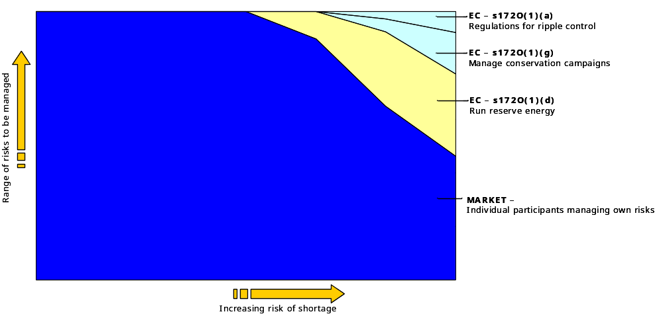
  - The diagram below represents the scope Commission’s obligations under the Act in relation to security of supply.

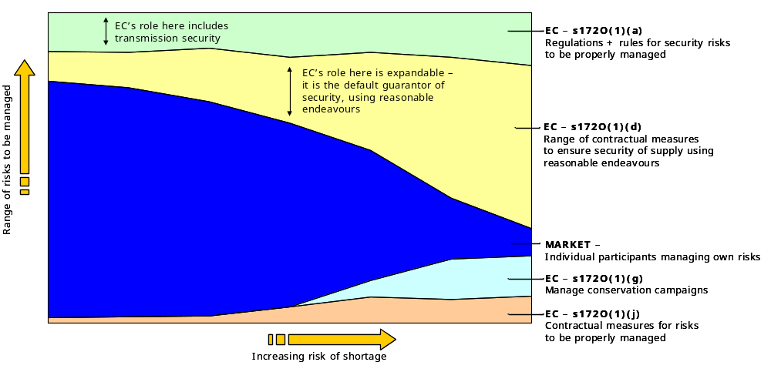
  - Another problem is the uncertainty in how to interpret and inter-relate the two different objectives set for the Commission under the Act in relation to security of supply, a problem the diagram below seeks to represent.
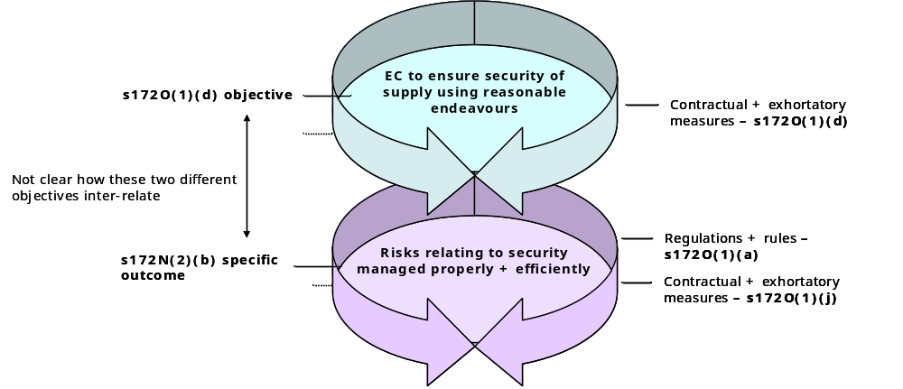

Commission’s policy to date
  - The Commission seems to have adopted the GPS as its security policy. Each of the consultation documents issued by the Commission to date clearly sets out that its focus has been on how to interpret and implement the GPS provisions relating to security. The consultation documents are intended to develop practical processes to put the proposed GPS mechanisms into operation.
  - While this work to date is helpful from the perspective of giving effect to the Government’s wishes, it does not necessarily give effect to the Commission’s legal obligations. Adherence to the GPS will not necessarily meet the broader requirements of the Act, which prevail over the GPS.

Recommendations
  - Perceptions of responsibility for security of electricity supply are ‘fuzzy’, blurred by politics, poorly informed expectations, technical complexity, and lack of familiarity with managing security risks efficiently. This lack of clarity is not assisted by the poor design of the Act and the GPS.
  - However, to mitigate the risks of legal challenge, and to promote a better functioning electricity market, the Commission should set out clearly and accurately how it interprets, and intends to implement, its security obligations under the Act.
  - This report may be a useful first step. Next, the Commission should develop its policy on the key variables within the relevant statutory functions, and then publish a paper that sets out, for the market and other interested parties, how it interprets the Act’s requirements in relation to security, including:
    - The scope of the Commission’s obligations, recognising that it is extremely broad, and that the Commission is, in effect, the ‘default guarantor’ of security;
    - The target security standard required under section 172O(1)(d), recognising that, at law, ‘ensure’ sets an extremely high standard;
    - The Commission’s assumptions in relation to the degree to which prices reflecting scarcity of supply will be signalled to consumers, and therefore influence the level of demand in a shortage;
    - The range of security risks to be covered by the Commission, recognising that it is significantly wider than simply hydrology risk;
    - The wide range of mechanisms available to the Commission to provide security;
    - Legal parameters that apply in relation to reserve energy, recognising that the Commission is not currently constrained by the GPS parameters;
    - The Commission’s assumptions in relation to amount of demand-side savings to be excluded from its assessment of security needs under section 172(1)(d), recognising that this is likely to lead to a higher supply margin than the market would otherwise provide;
    - The limits of ‘normal operation of the market’, beyond which the Commission is not required to minimise distortions; and
    - When the ‘material risk’ threshold is reached under section 172O(1)(g).
  - The Commission should also establish a process for checking that it has the necessarily legal authority to put in place a proposed security measure. The decision should be checked against the Act to confirm that it fits within the legal parameters of the appropriate statutory function. This is a useful internal auditing process for all decisions.
  - The Commission should also amend how it describes its security obligations in various publications, such as its Statement of Intent, Annual Report and web site, which are not correct at law.

Part I: Preliminary

Introduction
“Electricity security of supply is essential to all aspects of our personal and working lives” Foreword to the Government Policy Statement, October 2004
“One of the problems with security as an objective is the difficulty of quantifying it” “The Energy Review”, UK Energy Review, 2002

Context
  - Security of supply is a significant issue for the New Zealand electricity industry. Over recent years, it has also emerged as a key policy concern in many other countries. The Executive Director of the International Energy Agency, Robert Priddle, observed in 2002: “Energy security is back at the top of the agenda”. A leading economic consulting firm, NERA reiterates that “adequate levels of security of electricity and gas supply are…a significant preoccupation of OECD Governments; indeed most espouse adequate energy security as a major policy objective”.
  - However, security of supply in electricity is complex. It is a function of many factors – engineering, operational, economic, legal, policy and political – the constraints and incentives of which are rarely well aligned. It involves all components in an electricity system – generation, transmission, distribution, retail and consumption. And it has different implications over different durations, from instantaneous to long term.
  - While a variety of models is possible, two drivers are unassailable. One is the technical imperative that production and consumption must be equal at all times. The other is the political and economic imperative that electricity must be delivered in developed countries with a high level of reliability.
  - Until relatively recently, electricity systems in most OECD countries were vertically integrated, near-monopoly, state-owned utilities. Security of supply was seen as a pure ‘public good’ and therefore a central government responsibility. Additions to generation and transmission capacity were the principal mechanisms for seeking to ensure security. This investment was mainly centrally planned. Brown-outs and rolling blackouts were used to manage excess demand in periods of shortage.
  - Over the last 15 years, most OECD countries have moved toward electricity markets for generation and retail. The transition from traditional state-owned monopoly utilities to private competitive markets has been a major challenge in most countries that have adopted this policy of liberalisation. In its 2002 report on security of supply, the IEA notes: “Electricity markets do not develop overnight and a sustained government effort is needed during the transition to liberalised markets to monitor reliability, adapt policies and regulations to the needs of open electricity markets and, ultimately, ensure energy security”.
  - How well security is managed in a market framework depends on a range of critical factors, in particular whether the market’s structure provides effective competition, whether prices fully reflect changes in supply and demand, whether prices are properly signalled to consumers, and whether market participants and consumers take responsibility for their exposure to the risks of non-supply.
  - Security of supply in New Zealand is made more complex by the structural change that is now occurring in price of new generation. As Evans and Quigley observe: “New Zealand may be entering a period which is fundamentally unlike the past in that there is not a plentiful supply of gas, water is scarce, there are additional environmental constraints, and there is even more uncertainty about optimal investment strategies. Pending technological innovation and the sudden discovery of large gas reserves, all the economic and policy signals suggest higher real costs of energy in the future, no matter what the system”.
  - For many years in New Zealand, the law has been relatively silent on electricity security of supply. Responsibility for managing risks of interruption or non-supply has been governed by contracts between industry parties and consumers. Last year, the law in New Zealand was changed, imposing various security obligations on the Commission. This report considers the legal nature and scope of these obligations.
  - It is important to put aside preconceived views and approach the law’s requirements of the Commission from a fresh and neutral perspective. This report examines the law as it is, not as the Commission, officials or industry parties may assume it to be.
  - For the avoidance of doubt, the analysis, conclusions and recommendations set out in this report are also entirely independent of any policy views the author may have on how the electricity market should be structured.

Scope of report
  - In July 2004, the Commission asked me to:
    - Assist in identifying any inconsistencies between the Electricity and Gas Industries Bill (‘the EGIB’) and the proposed Government Policy Statement (‘the draft GPS’), as each related to security of supply; and
    - Advise on the nature of the Commission’s obligations, from a legal-policy perspective, under the EGIB and the draft GPS in relation to security of supply.
  - In September 2004, I supported Commission staff in discussions with Government officials on various technical drafting, with a view to clarifying elements of the EGIB and the draft GPS. It was clear from these discussions that there was no scope for making changes to the EGIB.
  - Since then, the EGIB has been enacted and the Government issued in final form its GPS of October 2004.
  - This report focuses on the nature and scope of the Commission’s legal obligations in relation to security of supply, and the practical implications that arise for the Commission. It is confined to examining the Commission’s legal obligations. It does not seek to address perceived political expectations or moral obligations. Nor does it examine the law relating to security or quality of supply in connection with distribution lines.

Preparation
  - This report draws on a mix of legal, public policy and industry technical information. Key steps in its preparation have included:
    - Carefully reviewing previous GPSs and earlier drafts of the current GPS;
    - Analysing the EGIB and the Electricity Act in detail;
    - Searching a wide range of legal data-bases for guidance on key legal definitions;
    - Reviewing a range of international and NZ papers on mechanisms for delivering security of supply in electricity systems; and
    - With prior approval from Commission staff, discussing with Government officials various risks relating to how the GPS and Act may be interpreted in relation to security of supply.

Approach
  - I have assumed that this report will be read by a range of interested parties, some of whom may have a less detailed knowledge of the industry than the Commission. The information in various sections is therefore more extensive than would otherwise be the case.
  - Distilling the Commission’s security of supply obligations at law is, in essence, a question of statutory interpretation. We therefore need to address the issues as a court would. This requires us to:
    - Disregard existing industry assumptions and start from a ‘clean sheet’, examining the legislation and GPS as if reading both for the first time;
    - Take an objective approach to the legislation, addressing the outcomes of statutory language as it is written, not as Ministers or officials may have intended the outcomes to be;
    - Apply the rules of statutory interpretation (outlined in the next section); and
    - Draw on expert evidence that is likely to be considered by a court.
  - A court would start by seeking to understand how electricity is produced, transported and consumed in New Zealand. Evidence would be provided by industry experts describing the NZ electricity system: its key assets, fuels, outputs, market participants, risk management mechanisms, control and co-ordination systems, contracting and new investment processes, together with the rules and practical procedures within which the industry operates. A court would address issues relating to security of supply against this practical background.

Structure
  - The first nine sections of this report set out a foundation for interpreting the Commission’s obligations under section 172O. This may seem like a lengthy ‘entrée’ to the ‘main course’; however, a court seeking to interpret the Commission’s security obligations for the first time is likely to consider this contextual information before addressing the detail of the relevant statutory provisions.
  - It may also be useful to consider the discussion set out in the accompanying paper on the key differences between the EGIB and the (final) 2004 Amendment.
  - My analysis of the Commission’s obligations is set out in sections 11 to 13 below. The practical implications and recommendations flowing from this analysis are set out in section 14.

Abbreviations and expressions
  - In this report:
    - ‘Accompanying report’ means the ‘Report for the Commission on its Legal Framework’ dated [ ] October 2004, which I prepared for the Commission
    - ‘Act’ or ‘Electricity Act’ mean the Electricity Act 1992 following the enactment of the 2004 Amendment
    - ‘2001 Amendment’ means the Electricity Amendment Act 2001
    - ‘2004 Amendment’ means the Electricity Amendment Act 2004 (which enacts part of the EGIB)
    - ‘CEA’ means the Crown Entities Act 2004, which came from the PS (SSM) Bill
    - ‘Commerce Act’ means the Commerce Act 1986
    - ‘ECNZ’ means the Electricity Corporation of New Zealand
    - ‘EGIB’ or ‘the Bill’ means the Electricity and Gas Industries Bill, which was introduced into Parliament on 28 October 2003 and had its First Reading on 6 November 2003. The Commerce Select Committee issued its report on the Bill on 30 June 2004. It was amended by Supplementary Order Paper No 243 dated 10 August 2004. On its Third Reading in October 2004, the EGIB was split into separate Bills: the Electricity Amendment Bill, Gas Amendment Bill, Commerce Amendment Bill and the Electricity Industry Reform Amendment Bill
    - ‘GPS’ means the Government Policy Statement of issued by the Minister of Energy in October 2004 following the enactment of the EGIB. An early draft of the GPS was released on 14 September 2003, before the EGIB was introduced into Parliament. I have seen five subsequent drafts of the GPS produced in March, April, July, August and September 2004
    - ‘IEA’ means International Energy Agency
    - ‘Legislation’ means the Electricity Act, the Regulations and the Rules
    - ‘PS (SSM) Bill’ means the Public Sector (State Sector Management) Bill as reported back to the House by the Finance and Expenditure Select Committee on 6 September 2004
    - ‘Regulations’ means the Electricity Governance Regulations 2003
    - ‘Rules’ means the Electricity Governance Rules approved by the Minister of Energy under sections 172H, 172I and 172E(2) of the Electricity Act 1992 on 18 December 2003, with effect from 1 March 2004, except for Part F, which came into effect on 28 May 2004
    - ‘SCI’ means a statement of corporate intent issued under section 14 of the SOE Act
    - ‘SOE’ means State-owned enterprise
    - ‘SOE Act’ means the State-owned Enterprises Act 1986
  - In the footnotes of this report, if reference is made to a statutory provision but the relevant Act is not mentioned, it refers to the Electricity Act.

Legal rules

Outline
  - In a 1983 UK Court of Appeal decision, Lord Scarman observed that “[t]he meaning to be attributed to enacted words is a question of law, being a matter of statutory interpretation”. The process by which the courts define statutory words is governed by a set of rules or conventions.
  - The Commission’s security obligations are set out in the Act. These rules must therefore be applied to determine the nature and scope of its obligations. This section summarises the rules of statutory interpretation.

Rules of statutory interpretation
  - The starting point is to give a statutory expression its plain and ordinary meaning. If such an interpretation would not give effect to the purpose of the legislation, the plain and ordinary meaning “must give way to the construction which will promote the purpose or object of the Act”.
  - This rule is reflected in section 5(1) of the Interpretation Act 1999, which requires the meaning of an enactment to be “ascertained from its text and in the light of its purpose”. The purposive approach is the currently the dominant method in statutory interpretation.
  - A range of contextual references can be used in interpreting the meaning and purpose of statutory language. References within an Act include:
    - The context of the other words of the section in which the relevant words appears;
    - The theme or purpose of the part of the Act in which the relevant words have been placed;
    - The scheme of the Act as a whole;
    - Statements of purpose, short titles and preambles; and
    - Other statutory indications of purpose.
  - Contextual references outside an Act can include:
    - Analogous provisions in other statutes;
    - Earlier Acts or common law repealed by the legislation under consideration;
    - Regulations, particularly where “the Act provides a framework built on by contemporaneously prepared regulations”;
    - Post-Act conduct by those charged with the administration of the Act in a complex area;
    - The economic or social framework within which the Act is operate. For example, in relation to understanding the Commerce Act, our Court of Appeal has commented: “One must first have an understanding of markets and how they operate, and an understanding of the particular market in question. These are proper areas for expert evidence”; and
    - The parliamentary history of the relevant Act, including reports of committees or commissions recommending the legislation, explanatory notes accompanying the introduction copy of the Bill, changes made to the Bill during its passage through the House, commentary of the Select Committee and debates in Parliament.
  - However, no matter how compelling an expression of opinion in Hansard, in committee reports or anywhere else, “those opinions cannot be used to alter the meaning of statutory words that are clear as they stand. The formal communication of the legislature, on which citizens and their advisers rely, cannot be distorted by non-legislative material”.
  - Two recent decisions of our new Supreme Court confirm that, in interpreting a piece of legislation, the New Zealand courts will consider the overall scheme of the relevant Act, which can involve using the statute’s legislative history to determine the mischief it is intended to remedy. However, the Supreme Court declined to use specific speeches from the Parliamentary debates.
  - New Zealand courts have also declined to accept Cabinet papers and instructions to Parliamentary Counsel, Treasury paper addressed to the Minister of Finance (on outstanding policy issues in a taxation amendment Bill) and other material of this kind in interpreting statutory language.

Relevance
  - These rules govern the interpretation of the Commission’s security of supply obligations under the Act and I have applied them in this report. The sections that follow set out the industry and statutory context in which the Act is to be construed.

Part II: Statutory context

History of governance and security

Outline
  - Consistent with the rules of statutory interpretation, a court would consider the context of the Act as it relates to security of supply. In particular, how the wholesale electricity market was governed before the 2004 Amendment, the law relating to security of supply leading up to 2004, and how security of supply events influenced the Government’s decision to change the law in 2004.

Market governance
  - A wholesale electricity (‘spot’) market was formed in 1996 by a multilateral contract among various market participants. Certain elements of the contract were authorised by the Commerce Commission. Among other things, the multilateral contract set out the rules of the market, including processes by which rules could be adopted, changed and enforced.
  - Between 1996 and 2004, the ‘spot’ market was governed these rules, which had the force of a contract operating within the general law. It was ‘self-governing’, with no market-specific regulation. Successive Governments expressed their position in relation to the wholesale market in various non-binding policy statements.
  - The structure of the wholesale electricity market evolved over several years. The significant step-changes were as follows:
    - In 1994 MARIA was established. It was a set of rules to record and reconcile physical flows of electricity. MARIA was first established to allow competition for commercial and industrial consumers. It was later broadened to cover all consumers;
    - In 1996 Contact Energy was separated out from ECNZ, and an external spot market was established;
    - In 1997 the Interim Grid Security Committee was formed to review transmission grid security standards. In 1999, the Commerce Commission authorised MACQS, which established a self-governing industry process to agree rules to set standards for common quality (including security), a contractual structure for implementing agreed standards, together with a monitoring, compliance and dispute resolution process;
    - In 1999 ECNZ was split into three competing SOEs, and Contact Energy was privatised;
    - In 2000 the Electricity Governance Establishment Project (‘EGPEP’) commenced. It was an industry process responding to a new Government policy which, among other things, proposed a single self-regulatory governance structure to replace NZEM, MARIA and MACQS. The Government promised to use regulatory powers to put it in place if the industry did not. The Government’s policy was based on the recommendations of a Ministerial Inquiry into the electricity industry completed in mid-2000;
    - In 2001 the Electricity Act was amended to enable the Government to regulate the wholesale market and establish an Electricity Governance Board (‘EGB’) to administer the regulations and rules governing the market. The Government threatened to bring these provisions into force if the industry failed to put in place governance arrangements that satisfied the Government’s policy objectives;
    - In 2002 Commerce Commission authorised a new set of rules developed by the EGPEP, which integrated NZEM, MARIA and MACQS; and
    - In April 2003 the rules developed by EGPEP were not adopted by a substantial majority of market participants and consumers. Votes in favour came from 4.5% of the consumer class, 66.2% of the trader class, and 53.2% in the transporter class. This was not sufficient for implementation of the rules to proceed.
  - Following the industry’s failure to put in place the proposed self-governing rules, the Government made an Order in Council to bring the 2001 provisions into force, and established a statutory EGB. The wholesale electricity market moved from self-governance to Government regulation.

Regulation of security of supply
  - Appendix [ ] sets out an historical overview of security of supply in New Zealand. The key points in relation to the law governing security of supply are distilled below.
  - It is unclear whether legislation imposed any security of supply obligations on the Government, local authorities or electric power boards before the market was established in the mid-1990s. In practice, security levels were likely to have been driven by central and local government perceptions of public expectations and competing political priorities in funding public works.
  - Since at least 1994, there have been no express legislative requirements on electricity suppliers, the Government or any Government agency in relation to ensuring security of supply. Security of supply has been determined by:
    - Contracts between suppliers and customers; and
    - ‘Good industry practice’, which is, in effect, a consensus industry view (often unwritten) that has evolved from an aggregate of internal policies of suppliers and operators, and practices agreed by professional bodies such as engineers, risk-managers and underwriters.
  - Residential supply contracts typically exclude the supplier from any liability for most events of non-supply. There is no clear security of supply standard. In essence, the supplier promises to supply electricity only to the extent it is available. Express security standards tend to appear in select contracts, mainly with larger electricity consumers.
  - The SOE legislation has the potential to create obligations on electricity SOEs in relation to security of supply. Section 5(2) of the SOE Act requires all decisions relating to the operation of a State enterprise to be made in accordance with its statement of corporate intent (SCI). Therefore, if an SCI sets out objectives or performance targets in relation to security of supply, it may give rise to legal obligations.
  - I have not reviewed the SCI of all electricity SOEs since 1987 to ascertain to extent to which security of supply standards have been included in SCIs. In relation to Transpower, however, its SCI between 1998 and 2003 obliged it to provide the level of quality and security “required by gird users through a process of agreement with users…where trade-offs between price and alternative levels of service are made by users”. In other words, security was to be customer-driven and set out in contracts.
  - Transpower’s SCI was significantly changed from 2003. It is now required to “work with regulatory agencies to ensure that risks to security of supply assessed by Transpower are highlighted…[and] provide transmission services at the standard of quality and security agreed with grid users or required by regulatory agencies”. The previous emphasis on customers making trade-offs between price and service levels based on explicit information provided by Transpower has been removed. It is also clear that its SCI does not set out any security of supply standards. The SCI assumes these are set by the Commission or grid users.
  - To summarise, unless the SCIs of the generator SCIs set clear goals in relation to security of supply (which is unlikely), it is reasonable to conclude that:
    - Since at least 1994 (and probably earlier), there have been no statutory obligations on any market participants or the Government in relation to security of supply;
    - Security of supply has been a contractual matter between suppliers and customers. In practice, however, suppliers have assumed extremely limited legal responsibility for security;
    - Security levels have been determined by two primary factors:
      - The aggregate of market participants’ commercial strategies in relation to managing risk and growing shareholder value, particularly in deciding whether to increase output or capacity; and
      - Perceptions by market participants and the Government of public expectations in relation to security. Public discontent is often expressed strongly in political processes when electricity supply is interrupted beyond the level that businesses and communities are prepared to tolerate. “Firms, consumers and politicians have grown used to the expectation that Government will intervene when energy supplies are tight”. Strong reputational incentives come into play among market participants and politicians perceived as potentially accountable.

Security of supply events
  - It is clear that the EGIB was strongly influenced by two fuel shortages prior to its introduction. A court would therefore consider these before forming a view on the scheme and purpose of the 2004 Amendment.
  - Appendix [ ] briefly describes the history of security of supply events in New Zealand. In summary:
    - New Zealand has a particular exposure to the risk of hydro fuel shortages. This is described further below;
    - Brown-outs and shortages occurred with some frequency in the 1940s and 1970s;
    - 1992 was a significant dry period. It lead to an independent review and a set of recommendations, including the formation of an external spot market;
    - Another dry period occurred in 2001. In hydroelectric terms, 2001 was the worst drought experienced in the previous 71 years. It was worse than the shortage in 1992. It was also very cold. In June-July, demand was 5.8% higher than the same period in the previous year. The dry sequence started in March. Spot prices increased dramatically. However, most of the load was on variable quantity tariffs and hence there were no direct financial incentives for many customers to respond. A 10% nation-wide conservation campaign ran from late July until mid September. Some demand exchange arrangements were put in place. The industry also agreed a protocol for common quality standards to enhance energy transfers. No compulsory physical rationing was required;
    - In October 2002, Ministers started to consider options for addressing security of supply issues relating to the provision of new generation to meet demand growth, and the transition to new fuel sources with the depletion of the Maui gas field. In February 2003, Cabinet established a group of Ministers to consider and develop the Government’s policy and response on infrastructure issues; and then –
    - In early 2003, hydro inflows again became seriously low. The first five months were similar to 2001, building an accumulated deficit of 2,000-2,500GHw. Average monthly spot prices reached $200 MWh. The 2003 low inflows were compounded by a significant reduction in the available natural gas from the Maui field.

Relevance
  - These events provide a setting in which to place the enactment of the 2004 Amendment. As noted earlier, a court would take this context into account in distilling the Act’s scheme and purpose.

Scheme of Act

Outline
  - As discussed above, section 5(1) of the Interpretation Act 1999 requires the meaning of an enactment to be “ascertained from its text and in the light of its purpose”. This section of the report sets out the scheme and purpose of the Act, against which a court may interpret the meaning of the Commission’s obligations in relation to security of supply.

Description of legal framework
  - The legal framework within which the Commission is to operate is considered in some detail in the accompanying paper, some elements of which are also described below.

Objectives
  - As illustrated in the diagram below, the Commission is supposed to be guided by several layers of objectives in performing its functions. None is weighted. Most are interrelated. Many require major trade-offs. All are open to wide interpretation as to how they are best achieved. The Government seems to have adopted a ‘kitchen sink’ approach. As a whole, the structure of the Commission’s legal objectives is confused.
  - The relationship between objectives, outcomes, duties and functions is also poorly structured. In a legal sense, the definition of the Commission’s functions is paramount. However, the Act’s formulation is an odd patchwork of specifics and generalities. Some are clearly functions. Others are more in the nature of objectives; for example, efficient electricity use appears as principal objective, a specific outcome and a function.
Amalgam of legal-related objectives
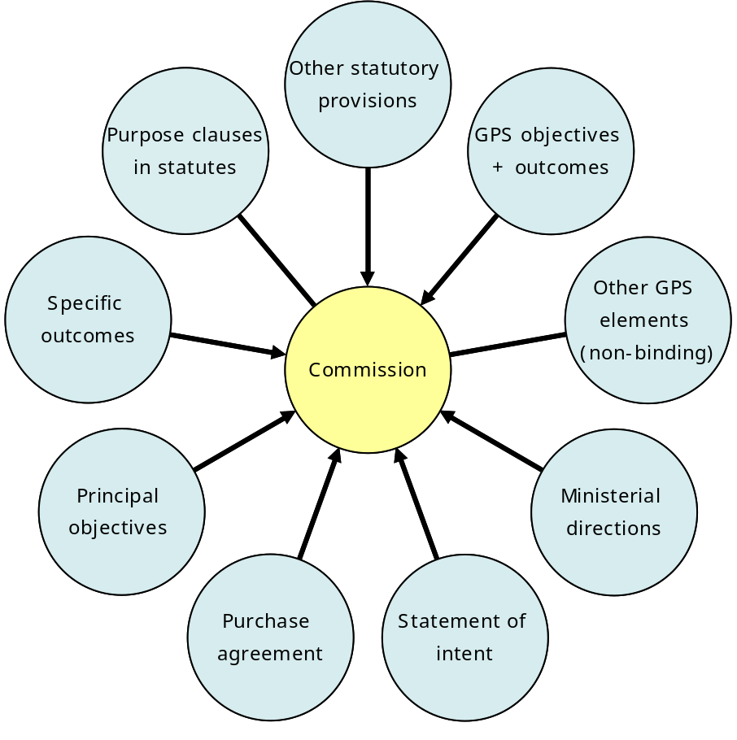

Proximity to Government
  - The Act creates a statutory body, at first called the EGB and later renamed the Commission. It is a ‘Crown agent’, akin to a government department. ‘Crown agents’ are the least independent of Crown entities and must give effect to Government policy when directed by the responsible Minister.
  - The Government has three separate powers of direction over the Commission, covering its objectives, functions, how it performs its functions, and how it contributes to whole of government policies.

Statutory functions
  - The Commission may only carry out its statutory functions. If an activity or decision does not come within the Commission’s functions, it is not authorised. The Commission has eleven functions, which can be grouped as follows:
    - Regulations and rules – recommend, administer, monitor, investigate, and enforce a wide range of regulations and rules. In formulating recommendations, the Commission must give effect to its principal objectives and specific outcomes, and its GPS objectives and outcomes;
    - Markets – establish, operate and facilitate markets for industry participants, consumers or both;
    - GPS objectives and outcomes – give effect to them;
    - Electricity efficiency – promote efficient use and conservation of electricity;
    - General – undertake supply and demand forecasting, develop best practice methodologies and model agreements, approve complaint resolution systems and provide advice to the Minister on the industry; and
    - Security of supply – there are five security functions, which are examined in section [9] below.
  - Under the Act, each function is independent of the others. One is not constrained by any or all of the rest. One does not have higher priority than another. One is not an instrument of the others.
  - The Act sets out principal objectives and specific objectives for the Commission. These are expressed at a relatively high level of generality. How they are best achieved is open to a wide range of interpretations. Furthermore, a decision that promotes some outcomes may be at the expense of others. Significant trade-offs are therefore inevitable. The Act provides no guidance on how one objective or outcome is to be weighted relative to the others.

Impact of objectives and outcomes
  - A court would no doubt find that the Commission is to perform its functions as a whole to achieve the principal objectives, although this connection is not clearly expressed in the Act. The legal relationship between the functions as a whole and the specific outcomes is stronger. This is discussed further in section [9] below.
  - The Act imposes a duty on the Commission to give effect to the specific outcomes. However, the Commission has not been given the function of carrying out its statutory duties. Therefore, if the Commission wanted to pursue a course of action to achieve one or more of the specific outcomes, but the action did not fall within one of its functions, the Commission could not do it.

Scope and force of market rules
  - Between 1996 and 2004, the wholesale market rules were terms of a private contract. Under the Act, the rules are subordinate legislation made by the Minister, on the Commission’s recommendation. Certain statutory evaluation and consultation processes are now required in making and changing rules.
  - In recommending a regulation to the Executive Council, or in making a rule, the Minister must implement the effect of the Commission’s recommendation and not differ from it in any material way (other than, for example, in drafting style). The Minister’s other options are to not act or refer it back to the Commission. However, these two options are only available if such a response would better give effect to the principal objectives and specific outcomes. The Minister therefore only has the power to veto recommended regulations and rules.
  - The range of matters on which regulations and rules may be made is extremely wide. It is broader than under NZEM, MACQS and MARIA. It is also broader than under the 2001 Amendment. (This is illustrated in a later diagram)

Duties and funding
  - The duties of the Commission’s board are distinct from the duties of the Commission. The board’s collective duties are to ensure (among other things) that the Commission performs its functions efficiently and effectively, and acts in a manner consistent with its objectives and functions, its current statement of intent and output agreement, and the spirit of service to the public. There is no reference in the board’s collective duties to the Commission’s specific outcomes or the GPS objective and outcomes.
  - Actions and decisions within the statutory functions can be fully funded by the industry levy. However, in practise the Government can control the scope and nature of the Commission’s activities by limiting the level of the levy, the level of funding provided by the Government to the Commission, and its activities in the statement of intent or output agreement.

Role of GPS
  - In performing its statutory functions, the Commission must exercise its own independent judgement, not just implement the GPS or any other Government policy, unless it is set out in a valid Ministerial direction or it is binding under the Act. The role of the GPS at law is discussed in detail in section [5] below.

Diagram
  - The diagram below illustrates the legal connections between each key component in the Act’s scheme as it relates to the Commission.
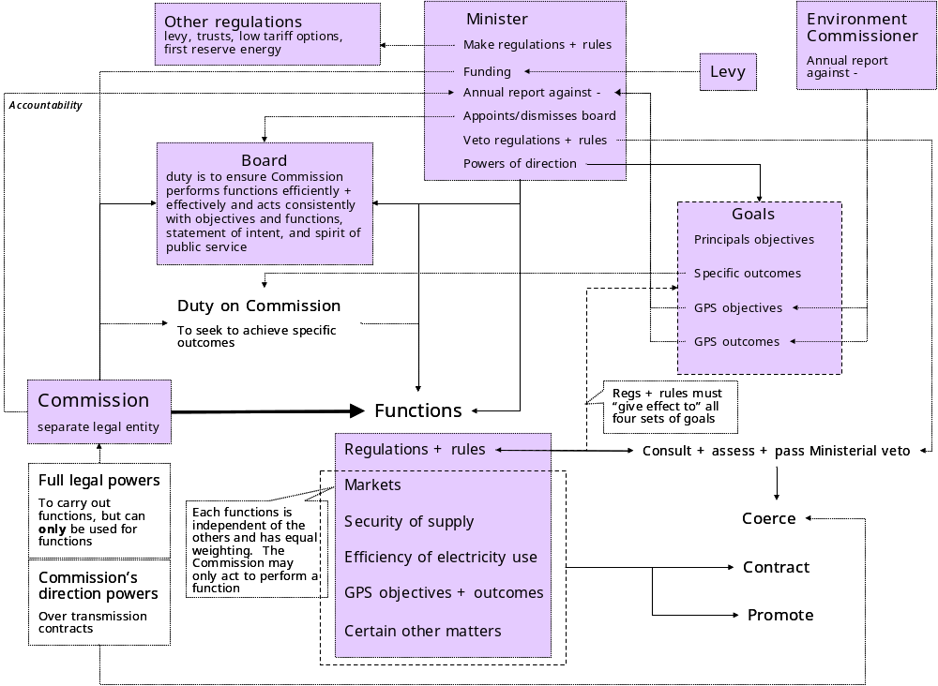

Comment on legal framework
  - The Act’s scheme is somewhat amorphous. Among other things, the Commission is:
    - A statutory incarnation of the proposed industry EGB, the primary function of which would have been to oversee the rules and processes of the wholesale market;
    - A primary adviser to the Minister on how to achieve the Government electricity policy objectives;
    - A regulator, with access to coercive powers covering a wide range of activities in the industry;
    - A provider of (levy) funds for activities consistent with the Commission’s functions and duties. This has wider scope than many people assume;
    - A market participant in relation to reserve energy; and
    - Under the rules, a central planner in relation to transmission and (potentially) generation.
  - On the surface, the Commission’s powers to compel seem to be relatively limited. However, on its recommendation, a wide range of coercive decision-making powers can be conferred on the Commission under the rules. In addition, the Commission’s recommendations in relation to electricity governance regulations and rules are likely to carry considerable force, given that the Minister cannot otherwise make such regulations and rules. In aggregate, the Commission’s potential power to compel is therefore greater than the letter of the law may at first suggest.
  - The level of the Commission’s independence is ambiguous. The legislation provides a range of mechanisms to closely control and direct the Commission. The degree to which these are exercised depends on the Government of the day.

Importance of security of supply
  - The 2001 Amendment was passed to provide a regulated governance arrangement if the industry’s self-governance proposals failed. However, when the proposals were not adopted by the required majority in April 2003, the Government decided the regulatory package provided by the 2001 Amendment was no longer sufficient.
  - The failure of the industry’s proposed rulebook in April 2003 coincided with a second significant hydro shortage in three years. From useableavailable? external references, it is clear that the Government lost confidence in the market’s ability to deliver adequate security of supply:
    - As the Minister of Energy emphasised in a paper to Cabinet in May 2003: “Security of electricity supply has become a serious concern to the Government and the wider community, and the lack of secure supply poses a significant risk to New Zealand’s sustainable economic growth”;
    - The Government considered that “the market – the industry – has been deemed responsible for managing dry year risk [since the early 1990s]. It has not done that to our satisfaction”. “Infrastructure Ministers have concluded that the current policy settings for electricity are unlikely to ensure an acceptable level of supply security”.
  - The Government was concerned that the electricity market was not operating to any particular security standard. The May 2003 Cabinet paper shows that the Government wanted a clear standard set “in the form of a requirement that the electricity sector ensure that electricity demand can be met in a 1 in 60 dry year without the need for national conservation campaigns and threats of blackouts. In addition, the standard should be set so as to help mange some other fuel shortage issues such as Maui platform outages”.
  - The Government intended that “the Commission will have the powers of an Electricity Governance Board outlined in the Electricity Amendment Act 2001 and will be given an additional ‘tool box of powers’ to deliver on its security objective”. From the Government’s perspective, the 2004 Amendment was enacted to provide regulatory and contractual mechanisms it considered necessary to deliver the Government’s security of supply objective.
  - As discussed later in this report, the 2004 Amendment does not put in place a specific security of supply standard. The 2004 Amendment only states that one of its principal purposes is “to improve security of supply of electricity”. However, it does give the Commission certain security obligations and contracting powers. It also significantly expands the range of potential regulations. The Commerce Select Committee referred to sections 172CA (reserve energy) and 172D (electricity governance regulations and rules) as the Commission’s ‘tool box of powers’.

Allocation of responsibility
  - As outlined earlier, legislation has been silent for many years in relation to security of supply. Under the market formed in 1996, individual market participants were legally responsible for managing their own exposure to shortage risks. The Government’s intended position was that it would not step in to protect market participants and consumers from the adverse effects of a shortage. This was emphasised in a series policy statements issued by successive Governments.
  - A significant feature of the 2004 Amendment is that it allocates legal responsibility for ensuring security to the Commission. This is clearly an important change in the law. At law, the Commission would appear to be the ‘default guarantor’ of security. This key issue is discussed further in later sections of this report.
  - A wide range of other parties will rely on the Commission meeting its security of supply obligations. A material failure by the Commission to perform these obligations properly will be actionable in court. The scope of potential liability is material.
  - How the Commission construes its security obligations (and communicates its approach) will have a material impact on how other parties manage their security risks and the strength of other parties’ incentives to take action against the Commission when security events occur.

Other changes in 2004
  - The accompanying paper examines in some detail the changes introduced by the 2004 Amendment. Two key changes need to be noted in this report. One is the expansion of the Commission’s function. The other is the expansion of regulation-making power.
  - The table below summarises how the Commission’s functions were enlarged in 2004.
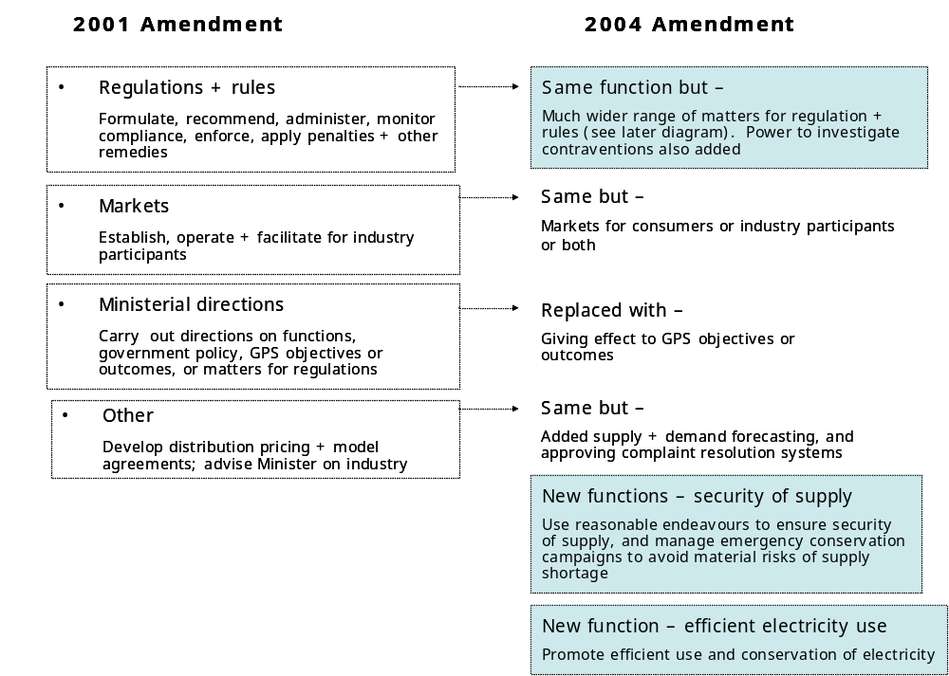

  - The diagram below illustrates how the regulation and rule-making powers were considerably expanded in 2004.
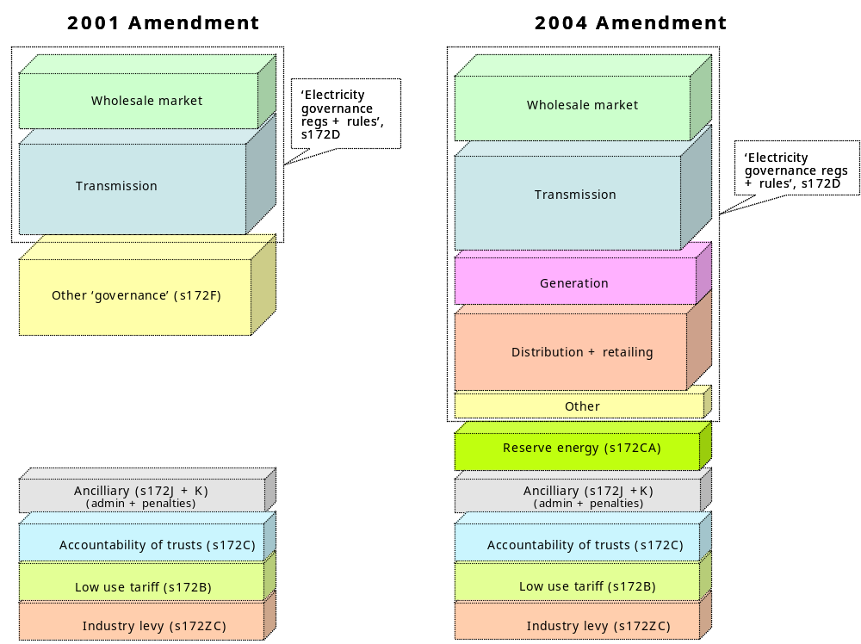
  - As noted above, sections 172CA and 172D have been described as the Commission’s ‘tool box of powers’.

Role of Government Policy Statement

Outline
  - Over recent years, the GPS has assumed a high profile in the industry. It seems to shape strongly the Commission’s interpretation of its role and responsibilities, and its work programme. In some quarters, the GPS has been (and still is) wrongly regarded as ‘the bible’ – a prescription the Commission must follow. At law, this is not the case. This section of the report examines the legal force and effect of the GPS.

Force of previous GPSs
  - The GPS mechanism has been used in the electricity industry since the mid-90s. Until 2004, it was simply a communication of Government policy with no legislative status whatsoever. In some cases, a GPS has been translated into a statement of economic policy under section 26 of the Commerce Act, which the Commerce Commission is required to take into account. However, its force in the industry has been political, not legal. The Government’s underlying levers to procure compliance have flowed mainly from its ownership of the electricity SOEs, and actual or potential threats to enforce its will by regulating.

Force of GPS under Act
  - Under the Act, the Commission is bound by ‘GPS objectives and outcomes’. These are GPS provisions that, in substance, are equivalent to the principal objectives or specific outcomes in the Act. GPS provisions relating to processes, or to how an objective is to be achieved, are not ‘GPS objectives and outcomes’ and therefore not binding.
  - ‘GPS objectives and outcomes’ must also be consistent with the statutory purposes of Part 15 of the Act, and the functions, principal objectives and specific outcomes of the Commission. If a ‘GPS objective or outcome’ is not consistent with these parts of the Act, it is also not binding.

Role of GPS under Act
  - Under the Act, GPS objectives and outcomes are relevant in five contexts:
    - GPS objectives and outcomes are yardsticks for assessing the Commission’s annual performance;
    - The Commission’s annual ‘performance standards’, which are to be agreed with the Minister, must relate to all of the GPS objectives and outcomes;
    - The Parliamentary Commissioner for the Environment must examine the extent to which the Commission is meeting the GPS objectives and outcomes concerning the environment;
    - In recommending regulations and rules, the Commission must give effect (among other things) to its GPS objectives and outcomes; and
    - As a separate statutory function, the Commission is to give effect to GPS objectives and outcomes.
  - The Commission is not otherwise required to perform its functions with a view expressly to achieving any part of the GPS, nor to take it into account in performing its functions. Nor is the Commission or its board otherwise required to ensure that the Commission acts in a manner consistent with any part of the GPS.

Analysis of current GPS
  - From a legal perspective, the GPS is poorly drafted. This is unfortunate given the role of the GPS under the Act and its practical influence in the industry. Its lack of clarity and precision hinders any legal analysis. However, within these limitations, I have analysed each paragraph of the GPS as it relates to security of supply. A summary of this analysis is set out in Appendix [ ].
  - Each GPS provisions relating to security of supply can be categorised into a hierarchy of:
    - Objectives and outcomes;
    - Statutory functions;
    - Mechanisms or processes for performing functions, or achieving objectives or outcomes;
    - Parameters or specifications for mechanisms or processes;
    - Factors to be taken into account in implementing mechanisms or processes; and
    - Contextual or descriptive statements, which simply describe issues or background information.
  - Within the GPS, there seems to be four levels of objectives or outcomes relating to security of supply:
    - The principal objectives in paragraph 1, which includes the goal of ‘reliability’;
    - The specific outcome in paragraph 2(b), where ‘risks (including price risks) relating to security of supply are properly and efficiently managed’;
    - ‘GPS objective or outcomes’ not covered by the principal objectives or specific outcomes; and
    - The ‘security of supply objective’ in paragraph 37, part of which is in fact a statutory function [s172O(1)(d)], not an objective.
  - Out of the 48 paragraphs in the section of the GPS relating to security of supply, only two are clearly ‘GPS objectives or outcomes’ that are additional to the principal objectives and specific outcomes in the Act – namely:
    - The objective of providing well-researched information on short and long term security of supply, including likely availability of fuels, new generation options, and likely price trends under various scenarios; and
    - The ‘overriding’ objective of giving as much certainty as possible to the market in relation to the Commission’s security of supply policy.
  - The rest of the GPS provisions on security of supply are mainly mechanisms or processes, parameters or specifications, implementation factors, or contextual statements, none of which are legally binding on the Commission.
  - The legal status of one key sentence is not entirely clear. It reads: ‘In particular, the Government wants the Commission to use reasonable endeavours to ensure security of supply in a 1 in 60 dry year’. The 1 in 60 dry year formula is at a level of specificity below the specific outcomes in section 172N(2). I would therefore conclude it is not a ‘GPS objective or outcome’ under the Act and not binding on the Commission.

Key conclusions
  - Some key conclusions from this section of the report:
    - At law, the Commission is governed by the Act and any regulations or rules made under it, not the GPS;
    - The GPS is a relatively ephemeral statement of policy with very limited legal force. Except for two provisions, none of the GPS relating to security of supply is binding on the Commission;
    - The GPS does not determine the nature or scope of the Commission’s legal obligations;
    - The Commission must exercise its own judgement on how best to satisfy its statutory obligations;
    - Adhering to the GPS will not necessarily meet the Commission’s obligations in relation to security of supply. The Act’s security requirements have a different scope and effect compared to the relevant GPS provisions.

Part III: Elements of security

Meaning of ‘security of supply’

Outline
  - Before analysing the Commission’s five security functions, we need to establish the legal meaning of ‘security of supply’. This definition is central to the nature and scope of the Commission’s security of supply obligations.
  - I have searched a range of sources and authorities that lawyers are likely to use in making legal submissions on the meaning of ‘security of supply’. A bibliography of the leading reports and articles obtained from several literature searches is set out in Appendix [ ]. Based on this material, and applying the rules of statutory interpretation outlined above, a court could distil the following analysis.

Search for a definition
  - ‘Security of supply’ is not defined in the 2004 Amendment, regulations, rules or any other relevant legislation. It has not been defined in any relevant case law. Nor is it defined in any available legal dictionary or technical literature. It is an expression of industry ‘art’.

‘Security’ of networks
  - In relation to transmission and distribution networks:
    - ‘Security of supply’ has been defined as “the inherent ability of a network to meet the customer demand for energy delivery without interruption”.
    - This is distinguished from ‘reliability of supply’ or ‘adequacy’, which has been defined as “the actual performance of the network in terms of the amount of interruption actually experienced by the customer”;
    - The notion of ‘quality’ is also often used in relation to transmission and distribution networks to describe standards of voltage, frequency regulation and other system quality characteristics.
  - There is no indication in the Act that ‘security of supply’ excludes ‘reliability’ or ‘quality’ as these expressions are used in relation to transmission and distribution networks.
  - In its December 2004 Consultation Paper on Grid Reliability Standards, the Commission seeks to differentiate between ‘reliability’, ‘security’ and ‘quality’ in relation to transmission networks. It also points out that these expressions are often used interchangeably, and that the meaning of each expression depends on local terminology and context.
  - To add a further layer of imprecision, ‘reliability’ has a different meaning when used to express a characteristic of system security, as explained later in this section.

‘Security’ of overall system
  - In relation to the electricity system as a whole, the International Energy Agency’s view is that “security of supply refers to the likelihood that energy will be supplied without disruptions”. Security of supply is therefore generally expressed in terms of risk.
  - In its 2002 Energy Review, the UK Energy Review defines ‘insecurity’ as “a substantial risk of a physical supply interruption”. The review notes that:
    - “This need not necessarily lead to actual interruptions in all cases. A market reaction to prospective interruptions will usually be sudden increases in price over the period of the expected shortfall”.
    - “Interruptions to supply can also derive from shocks to the energy system, which could in turn be the result of deliberate acts of disruption or unexpected generic faults in the energy supply technology”.
    - “We can think of supply interruption in terms of quantity risk, while the possibility of sustained high or spiky prices is price risk”.
  - ‘Security of supply’ therefore has both physical and economic characteristics. It is not simply a function of physical capacity on the supply side to meet any level of demand.

Security in a market
  - In a market framework, security is a property of the system as whole, and not of the actions of one market participant. It relies on various conditions and incentives to coordinate decentralised decision-making among competing market participants. There are several significant barriers to achieving a well functioning market. These are outlined in section [8] below.
  - The literature observes that short term balancing of supply and demand in a well functioning market is characterised by the following dynamic:
    - Prices rises during times of shortage to reflect scarcity of supply. Consumers voluntarily reduce demand as the market price reaches a level where it is more profitable not to consume electricity. This price point varies among consumers;
    - The market price rises until supply and demand equal. Consumers that put a low value on electricity cut back first, higher value users later. If prices are properly signalled to consumers, and there is an efficient hedge market, physical or forced rationing is not required;
    - ‘Rationing’ reduced electricity supply in a market occurs on an individual (not centralised) basis, with consumers trading-off the value of lowering consumption against the cost of buying electricity as the spot price rises to reflect scarcity. Security in a market therefore relates to the risk of consumers facing unacceptably high spot prices, not the risk of centralised savings campaigns or forced rationing.
  - Medium to long term security in a well functioning market relies on the interplay of accurate medium term price signals, an efficient hedging market, and market participants taking full responsibility for their exposure to risks relating to electricity.
  - Price is a pivotal element in defining security in a market. An electricity market is considered to be ‘secure’ when:
    - the risk that consumers will be unable to access energy supplies at prices that reflect the cost of provision is sufficiently low; or, put another way –
    - the probability that supply is sufficient to meet demand at or below a specified price is greater than a specified acceptable level.

Level of security
  - It is widely agreed among industry experts that the cost of providing 100% security over all timeframes and all demand levels is prohibitive. As Steve Smith of OFGEM observed: “No set of arrangements can guarantee security of supply”. Governments consider it uneconomic to build adequate standby generation to cover all potential risks, which may include catastrophic natural or unforeseeable technical events.
  - This is reinforced by MacKerron and Lieb-Doczy: “No system is ever totally secure and – at some cost – every system can always be made more secure. Because there is no direct ‘market’ in security, it is difficult to know how much security is enough”. As NERA points out: “There will normally be a trade-off between security and cost. Lower levels of risk (higher levels of security) can only be reached at higher costs”.

Core definition
  - Drawing these strands together, ‘security of supply’ can be defined as:
A defined probability that electricity supply will meet certain levels of consumer demand for electricity over a given time-frame or range of contingencies
  - This definition has five key elements:
    - The level of the probability that supply will meet demand;
    - The level of demand to be satisfied;
    - The relevant time-frame over which security is to be provided. This element can also be considered in terms of the range of contingencies or risks to covered;
    - The range of mechanisms available to be used to provide security; and
    - The regulatory structure within which the system and its participants operate.
  - Using the rules of statutory interpretation, I will examine how each element operates under each of the Commission’s five statutory functions relating to security of supply.

Characteristics of security
  - The GPS Foreword refers to an electricity system that is, among other things, ‘reliable’ and ‘resilient’. On a technical level, ‘reliability’ and ‘resilience’ are two of four “ill-defined system characteristics that the relevant literature suggests are important for security of energy supply”.

Diversity
  - The first of the four characteristics – diversity – is not mentioned in the GPS Foreword. However, it is pervasive in security debates. This is the idea of ‘not putting all one’s eggs in one basket’ or risk spreading. The 2002 UK Energy Review describes diversity as “a general hedge against all kinds of risk and uncertainty. It is a property of a whole system rather than a particular option or technology”.
  - NERA notes that “diversity is not universally beneficial for security nor does it generally come free of cost”. This is echoed in the 2002 UK Energy Review: “It is less clear what exactly should be diversified and how much diversity is enough. The extent to which diversity is pursued depends on the balance between the extra costs and the degree of risk reduction achieved”.
  - NERA’s view is that diversity should refer at least “to any or all fuel types, fuel sources (by company or region), technology types and technology”.

Reliability
  - Reliability in this context seems to refer to the technical reliability of plant and equipment. “A more diverse system may be less secure if on average it is less reliable – ie it experiences higher levels of unplanned or forced outages. It is important to examine the differences in reliability as between different mixes of plant and different market conditions”.

Resilience
  - NERA describes resilience as a quality “which helps systems cope with shocks of various kinds: it minimises the impact on consumers of any given system shock. It clearly overlaps with diversity but has some different qualities. While diversity describes a system in a static sense, resilience has to do with ability to cope with a given event in real time”.
  - The 2002 UK Energy Review describes resilience as the product of diversity and flexibility (or responsiveness), which “serves to reduce both physical and economic vulnerability, where possible and subject to costs” .

Responsiveness
  - Like diversity, the fourth characteristic – responsiveness or flexibility – is also not mentioned in the GPS Foreword. It is “the ability to adapt quickly at low cost”.
  - NERA points out that “responsiveness may be a quality of either the demand side of a system – the ability of the system to reduce demand levels with acceptable impacts on consumers – or the supply side. Storage capacity is an obvious indicator of responsiveness and there can be particular technologies, which are more capable of rapid response to an emergency caused by loss of supply than others”.
  - Examples of flexibility given in the 2002 UK Energy Review include the installation of dual-firing capacity in fossil fuel plants, the stockpiling of fuels to cope with supply interruptions, and the deliberate maintenance of excess capacity.

Relevance
  - These characteristics provide a broad qualitative gauge for overall security in an electricity system. A court may consider the Commission should have regard to these factors when evaluating security of supply in New Zealand.

Range of security risks

Outline
  - Many parties in the industry seem to have assumed that the Commission’s security responsibilities relate primarily to hydrology risk. Before analysing the scope of risks covered by the Act, we need to consider security risks in general, together with the spectrum of potential mechanisms for managing these risks. The question addressed later in this report is whether the Act excludes any of these risks or mechanisms from the Commission’s security functions.

Possible classifications
  - The range of risks that impact on security of supply is extremely broad, covering every component of the electricity system. There have been many attempts to classify security risks, but no single system of classification is used in the industry. Security risks could be grouped by:
    - Industry sector – risk categories include the supply, demand, transport or user side of the industry;
    - Notice period – categories include without notice, some hours, weeks, months or years. In general, very short notice events tend to relate to operational systems, while long notice risks tend to centre on patterns of investment;
    - Probability – categories range from extremely unlikely or to highly probable. (Of course, some contingencies are hard to predict due to a lack of previous experience or data);
    - Severity of consequence – risk categories range from minimal to extreme. (Some risks with a low probability can, of course, have extremely high costs if they occur);
    - Cause – categories include forces of nature, engineering defects, fuel availability, non-investment, regulation, malfeasance or third party accident (recognising that some events have several contributory causes); or
    - Cost of mitigation or avoidance – the risk categories also range from low to high.
  - Other taxonomies are possible. Each has utility depending on the context.

Illustrative spectrum
  - For convenience, I have grouped the following illustrative range of risks by the duration of warning time.
No notice (immediate)
  - Events for which there is no notice, including unexpected outages in generation, transmission, distribution lines, or thermal fuel supply due to –
    - Forces of nature (earthquake, flood, wind, temperature, lightening);
    - Some acts of human interference (war, terrorism, sabotage or other malfeasance);
    - Operational errors;
    - Design or engineering defects;
    - Maintenance deficiencies; or
    - A combination of the above.
  - These outages may have a local, regional or national impact, but tend to last for hours or days, not weeks or months. Electricity systems normally maintain a capability to increase supply or decrease demand in response to these sudden and random failures of plant or spikes in demand.
  - Both generators and consumers can supply reserve capability for this purpose. Generator reserves are normally supplied by plant which is either synchronised to the network but not producing energy (spinning), or plant that has been ‘backed off’ to run below its maximum output
Short term notice
  - These events unfold within hours, days or weeks, including:
    - A sharp increase in demand due to a significant and unexpected change in temperature;
    - An unexpected outage in generation, transmission, distribution lines, or thermal fuel supply due to any or all of the causes referred to above; or
    - A combination of these events.
Medium term notice
  - These events unfold over a period of months, including:
    - A seasonal shortage of hydro fuel due to low inflows;
    - A sustained seasonal increase in demand due to unexpected temperatures; or
    - Interruption to the supply of fuel from overseas.
Longer term notice
  - These events develop over years, including:
    - Lack of investment in generation, transmission and/or distribution;
    - Higher than expected economic growth, driving higher than expected increases in demand;
    - A sudden substantial write-down of gas reserves in known fields;
    - High prices for alternative uses of gas, reducing the volumes of gas available for electricity generation; and/or
    - Failure to find or access sufficient additional fuel to meet growing demand over time.

Insolvency
  - The financial collapse of a generator or retailer is not likely to cause a security of supply problem. Unlike other insolvent businesses, sales by an electricity company in financial crisis are not ‘frozen’. Consumers’ demands for power continue to be satisfied so long as they remain physically connected to the network. Insolvency by a market participant would not normally provide grounds to disconnect customers.
  - Insolvency or financial crisis may cause a change of ownership or capital structure of the relevant market participant, which may impact on consumers’ choice of electricity supplier. However, it is not likely to impact on security of supply in the short to medium term. As NERA observed: “In general, bankruptcy in the retail supply market is unlikely to pose any major problem [in relation to security of supply]”.

Hydro fuel risk in NZ
  - The New Zealand electricity system is more exposed than many to the risk of insufficient hydro fuel (water). It has a high percentage of hydro generation (60%), with relatively uneven and unpredictable inflows (six monthly inflows may fluctuate by plus or minus 20% or more) and only modest long term storage capacity (around 10 weeks of annual inflows or approximately 3,500 GWh of long term storage). Generation patterns in a dry period can cause transmission constraints that exacerbate supply shortages, particularly when flows over the HVDC link are reversed to run north to south.
  - Ensuring medium term security in New Zealand therefore requires careful management of the limited hydro storage, and thermal back-up capacity to cover periods of very low inflows.
  - An analysis of monthly inflows between 1931 and 2003 shows they are lowest from May to September and highest from October to January. It also shows that inflow variations on a month-by-month basis are large and the distribution is skewed (high inflows tend to be very high).
  - With only minimum monthly inflows, thermal plant alone cannot meet total winter demand. Some draw-down from long-term hydro storage (up to 500MW or 400GHh per month) is needed to avoid a shortage situation. To provide this buffer of hydro storage, it is necessary to run spare thermal plant prior to winter, to build up hydro storage to a level sufficient to cover the risk of several low inflow months during winter. About 500-600 MW of firming capacity is required to provide 4,000 GWh in an extreme dry year. This corresponds to the New Plymouth station and one to two units from Huntly.
  - Minimum inflows and the available thermal plant are sufficient to meet approximately 90% of the NZ load on an average energy basis during winter except for June, July and August. In these months, up to 15% to 20% demand savings might be required.
  - Two factors are therefore critical factors for dry year security:
    - The use of spare thermal capacity during summer and autumn to ensure lakes are sufficiently full prior to winter; and
    - The reliable ‘energy’ capability of the thermal plant to ramp up production to limit dry year demand for hydro releases to be within the buffer provided by pre-winter storage levels. This type of thermal plant is called ‘hydro firming’ plant, which (as noted above) has traditionally been provided by the New Plymouth and Huntly stations.
  - The New Zealand system can be expected to have more than sufficient supply capability to meet customers' peak and energy demands for long periods. Only very occasionally will inflows be low enough to cause a shortage situation during which there is a significant risk that customers may need to restrict their demands. Recent ‘dry year’ shortages have lasted several weeks. Worst case, the risk of a severe hydro shortage could last some months.
  - This contrasts with the risks inherent in a typical all-thermal power system, where the critical risk is that supply capacity is not sufficient to meet instantaneous daily peak demands. This risk will generally only be significant for a few hours at a time, but can occur quite frequently whenever there is a plant outage during abnormal winter or summer peak demand periods.
  - The overall level of risk may be similar but the distribution is quite different. A typical thermal system can expect relatively frequent short periods of risk. By contrast, a hydro system like New Zealand’s can expect very infrequent but much longer periods of risk.
  - In summary, the New Zealand system is largely ‘energy constrained’, not ‘peak constrained’. However it is likely to become progressively more ‘peak constrained’ over time.
  - Another important feature of the New Zealand system is its physical isolation, which means it does not have the option of short term power supply from an interconnected system.

Concerns in relation to reserve generation
  - Reserve generation is a key measure in managing serious shortages. In a market, this plant is only used when spot prices are very high. It typically has low capital costs (relative to base-load generation) and high operating costs (because it uses expensive fuel, like oil).
  - However, New Zealand is an ‘energy only’ market, in which a generator-seller only receives revenues for electricity dispatched. In an extreme shortage when reserve generation is expected to run, there is a concern that spot prices may be suppressed making new reserve generation unprofitable. Revenues could be insufficient to cover its cost of capital. This risk makes it uncertain whether the market would provide the required reserve generation.
  - Different mechanisms are used in different markets to address this uncertainty. The Act gives the Commission the power to buy and sell reserve energy.

Political perception of risks
  - Around the world, security of electricity supply is of high economic and political importance. Governments may have a range of energy policies objectives – economic, social and environmental – but “cutting across these is the need for security”. It is widely viewed as a vital building block for economic and social development.
  - Given the lack of alternatives to electricity, the sudden and serious consequences of major interruptions, and the public’s tendency to blame the Government for perceived failures, “Government interest in supply security for energy is understandably stronger than for many, if not most, other commodities”. The politics of security have therefore driven many traditional vertically integrated utilities, Government-owned or regulated, to over-invest.
  - From a political perspective, under-investment tends to be viewed as having a higher cost than over-investment. This asymmetry arises from a difference in public profile: “Blackouts and other consequences of under-investment are highly visible and may carry substantial penalties for regulators and policy makers. Over-investment, on the other hand, is less visible and may not be politically penalised”.
  - From an economic perspective, it is not the case that insufficient or late generation is necessarily more costly than excessive or premature generation. The opposite may apply. It is clear, however, that public perceptions and political considerations are key influences in how security of supply is managed.

Relevance
  - As outlined above, the range of risks that affects security of supply is extremely wide. A key question for this report is whether the Act imposes any limits on the range of risks for which the Commission is responsible.
  - It is interesting to note that in Australia, most power failures experienced by customers are not due to problems in the wholesale market, but failures at the local distribution level.

Risk management mechanisms in an international context

Outline
  - This section considers the range of mechanisms available to manage security risks in an international context. It discusses the barriers to an efficient electricity market, and the spectrum of options used in various countries to mitigate these barriers.
  - The key question, addressed later in this report, is whether the Act limits or excludes any of these options.

International context
  - As discussed earlier, electricity systems in most OECD countries were, until relatively recently, vertically integrated, near-monopoly, state-owned utilities. Security of supply has been seen as a ‘public good’ and therefore a central government responsibility. Additions to generation and transmission capacity were the principal mechanisms for seeking to ensure security. This investment was mainly centrally planned. Brown-outs and rolling blackouts were used to manage excess demand in periods of shortage.
  - Over the last 15 years, most OECD countries have moved toward electricity markets for generation and retail, in which price is intended to be the primary signal for matching supply and demand. A brief overview of international trends is set out in Appendix [ ].
  - The transition from traditional state-owned monopoly utilities to private competitive markets has been a major challenge in most countries that have adopted this policy of liberalisation. In its 2002 report on security of supply, the IEA points out that “electricity markets do not develop overnight and a sustained government effort is needed during the transition to liberalised markets to monitor reliability, adapt policies and regulations to the needs of open electricity markets and, ultimately, ensure energy security”.
  - Leading experts like Prof Paul Joskow are of the view that there is a need for a regulator “with special authority and expertise to diagnose and fix electricity market performance problems due to structural and market design problems and to monitor behaviour and performance during a transition period”. Prof Stephen Littlechild reiterates that, to assist the transition, modern regulatory frameworks typically give the utility regulator a duty to promote competition and encourage new entry.

Barriers to market security
  - In relation to security of supply, the literature indicates that there is “no over-riding or general reason to suppose that markets will generically fail to provide adequate security. However there may be specific barriers or obstacles that prevent markets from working to provide adequate energy security”. While these vary across countries, three barriers seem to recur:
    - The risk of political intervention to suppress prices and manage new investment in generation;
    - Market power issues arising from transmission constraints or supply shortages, combined with inelastic short term demand; and
    - Coordination of investment in new supply (generation or demand side) and transmission.
  - These and related barriers seem to have five main causes:
    - The physical characteristics of electricity, including the inability to store it economically, its adherence to the laws of physics not contracts, and the need for real-time network stability, which requires instantaneous supply and demand balancing;
    - The economic characteristics of electricity, including its very small aggregate short-run elasticity of demand, a feature that is exacerbated by the absence of time-of-use metering, communications and real-time pricing for smaller consumers;
    - Market design constraints, including the absence of long term contracts to back historical long-life sunk investments, the lumpy nature of investment in new generation and transmission, the monopoly position of distribution and transmission, the dominance of some players in certain market segments, and therefore problems in achieving effective competitive disciplines;
    - Uncertainty of Government involvement, particularly when prices are highly volatile and new investment is uncertain. Perceptions of likely Government action have a material impact on market participants’ incentives to manage their own risks; and
    - Defects in the design and implementation of regulatory mechanisms. As leading commentators such as Hogan and Joskow point out, electricity is complex, and detail has a significant impact on outcomes.

Range of mechanisms
  - Governments, regulators and markets around the world have developed a variety of mechanisms intended to overcome these barriers, particularly in relation to security of supply. The design and implementation of each mechanism varies, reflecting political, technical and structural features in the local context. An overview is set out below.

Centralised approach
  - At one end of the spectrum, security of supply in some countries is still managed by a central government agency, or regulated vertically integrated utility, with an express responsibility for ensuring adequacy of supply. New investment decisions in transmission and generation are centralised. Prices do not vary significantly in periods of shortage. Security is viewed as a ‘physical’ service, and shortages are rationed by brown-out and rolling black-outs.

Market approach
  - At the other end of the spectrum, a market approach is predicated on buyers and sellers managing their own exposure to shortage risks, particularly very high or extremely volatile spot prices. Management options include controlling demand in response to changing prices, energy efficiency measures, self-generation, financial hedging, and contracting tailored price profiles.
  - Some contracts may be ‘physical’, but most will be ‘financial’ (hedging volumes against spot price uncertainty). If risk is allocated efficiently, and the hedge market is transparent and competitive, counter-parties have strong incentives to avoid shortages. Proponents of a market approach argue that these incentives, in aggregate, should lead to the efficient deployment of fuel, plant and other factors of production in a manner that provides the level of security demanded by consumers.

Other options
  - Between these ends of the spectrum is a menu of regulatory mechanisms, including:
    - Rules and arrangements for specific monitoring, modelling and information in relation to security of supply;
    - Information disclosure requirements on market participants;
    - Removing regulatory impediments to new investment in generation;
    - Prudential management requirements on market participants to hold bonds, financial guarantees or balance sheet minima to cover financial exposure to ‘dry year’ spot prices;
    - A mandatory hedge offering or purchasing regime;
    - A capacity payments regime combined with an obligation on certain generators to provide reserve generation. The options for a capacity payments include mandatory tradable security hedges, or a pool price margin (levy) to cover the fixed costs of reserve generation;
    - Subsidies or tax benefits for investment in particular technologies or fuels, for example renewables, co-generation and residues-based generation;
    - Promotion, subsidies or tax benefits for demand-side management;
    - Powers for the regulator to control fuels and/or plant operations;
    - A centralised supply of reserve energy established by the regulator;
    - A cap on spot or retail prices; and/or
    - Controls of various kinds on new investment decisions, including shareholding Ministers deciding new generation proposals, or a monopoly wholesaler deciding where, when and what to build.

Relevance
  - The question addressed later in this report is whether the Act limits or excludes any of these mechanisms.

Part IV: Analysis of security functions

Overview of security functions

Outline
  - This section provides an overview of the Commission’s five security functions. It also examines the legal relationship between the functions and the Commission’s statutory objectives.

Source of law
  - The Commission’s legal obligations in relation to security of supply come from legislation, not common law. The obligations flow from the Act requiring the Commission to perform certain statutory functions. In isolation, statutory objectives and powers do not give rise to legal obligations.

Description of security functions
  - As noted earlier, the Commission has eleven stand-alone functions under the Act. Five relate specifically to security of supply, namely:
    - To use reasonable endeavours to ensure security of supply, without assuming any reduction in demand from emergency conservation campaigns, while minimising distortions to the normal market:
    - To manage emergency conservation campaigns to avoid material risk of security of supply shortages;
    - To give effect to GPS objectives and outcomes as they relate to security of supply;
    - To formulate and recommend regulations and rules to give effect to the principal objectives, specific outcomes, GPS objectives and GPS outcomes, as each relates to security of supply; and
    - To perform all eleven statutory functions seeking to achieve (among other things) the specific outcome where “risks (including price risks) relating to security of supply are properly and efficiently managed”.
  - The legal meaning of each function is analysed in detailed in the next sections of this report.

Relationship between objectives, outcomes and functions
  - As noted earlier, the Act’s formulation is of objectives and outcomes is odd patchwork of specifics and generalities. The Government seems to have adopted a ‘kitchen sink’ approach. The legal relationships between objectives, outcomes and functions are also poorly structured.

Relationship between functions
  - As discussed earlier, each function at law is independent of the others. One is not constrained by the rest. One does not have higher priority than the others. One is not an instrument of another. Performance of one does not necessarily mean performance of any other: for example, giving effect to the GPS objectives and outcomes does not necessarily satisfy any other function, even if there is an overlap.

Relationship between objectives in GPS and the Act
  - The Act requires GPS objectives and outcomes to be consistent with the Commission’s statutory functions, principal objectives and specific outcomes. The Act’s provisions therefore prevail over the GPS. The GPS may only add to the Commission’s principal objectives and specific outcomes at the same level of generality, without diminishing or changing those objectives and outcomes, or the Commission’s functions.

Relationship between principal objectives
  - There are two principal objectives:
    - To ensure that electricity is produced and delivered to all classes of consumers in an efficient, fair, reliable, and environmentally sustainable manner; and
    - To promote and facilitate the efficient use of electricity.
  - The two objectives are not weighted. One has equal ranking with the other.
  - The first objective has several components: efficiency, fairness, reliability, and environmental sustainability. Again, one does not have priority over the other, and the Act provides no guidance on how to make trade-offs.
  - However, the second principal objective – promoting efficient use of electricity – ranks equally with the whole of the first objective. This means that, in the event of a conflict between promoting efficient use and any of the individual components of the first objective, efficient use would have to prevail.

Relationship between principal objectives and specific outcomes
  - Seeking to achieve the specific outcomes in the Act is to be “consistent with those principal objectives”. The Act’s principal objectives are therefore dominant over all specific outcomes.

Relationship between specific outcomes
  - The Commission’s specific outcomes are not ranked or weighted in the Act. There is no legal basis for giving priority to one over any of the others. Nor is there a framework or set of criteria at law for trading-off benefits and detriments between outcomes. In addition, each outcome is open to a range of possible interpretations and different views on how it is best achieved under the Commission’s functions.

Relationship between principal objectives and functions
  - A court would no doubt find that the Commission is to carry out its functions, as a whole, to achieve the principal objectives, as a whole, although this connection is not clearly expressed in the Act.

Relationship between specific outcomes and functions
  - The Commission is required to “seek to achieve” the specific outcomes. While the Act does not say this is to be done by performing its functions, it must be implied as the Commission operates by carrying out its functions.
  - Two of the Commission’s security functions set out their own objectives:
    - The objective in section 172O(1)(d) is to ensure security of supply. The Commission’s function is to “use reasonable endeavours” to achieve it;
    - The objective in section 172O(1)(g) is to avoid a material risk of supply shortages.
  - Are the two objectives the same or different? How do these objectives relate to the Commission’s duty to seek to achieve a specific outcome where “risks (including price risks) relating to security of supply are properly and efficiently managed”. Are they separate or integrated? If integrated, does one constrain the other? On a first reading, the answers are not obvious. The discussion below considers possible clues in the Act.
  - It is curious that the Commission’s function under section 172O(1)(a) – of formulating regulations and rules – is specifically tied to the objectives and outcomes in the Act and GPS, but the Commission’s other functions are not. This may suggest at law that, where a function contains its own objective, it ‘speaks’ to that function more directly than the specific outcomes, which are expressed at higher level and relate to the Commission’s functions as a whole.
  - There is a telling difference between the specific outcome relating to security of supply and the objectives within the two functions mentioned above:
    - The specific outcome – “risks (including price risks) relating to security of supply are properly and efficiently managed” – does not prescribe a role for the Commission. It may be achieved by the interaction of various players and mechanisms. It may involve market participants and market rules, with or without additional regulatory intervention.
    - By contrast, the objective of ensuring security of supply is to be achieved by the Commission using reasonable endeavours, such as buying reserve energy. The objective of avoiding material risk of supply shortages is to be achieved by the Commission managing emergency conservation campaigns. In both cases, the objective is to be met exclusively by the Commission performing its statutory function.
  - There is also another key difference:
    - The specific outcome in section 172N(2)(b) focuses on how risks relating to security are managed. It does not require security to be ensured. Under section 172N(2)(b), security may be delivered with a comparatively high probability of shortage if this is the aggregate result of parties managing their risks efficiently;
    - By contrast, section 172O(1)(d) requires security to be ensured. It sets a high standard, which the Commission is to achieve using reasonable endeavours.
  - The specific outcome in N(2)(b) is therefore not the same as the objective in O(1)(d). The question is, how are they related at law? At least three interpretations are possible:
    - Stand-alone: Under this interpretation, the O(1)(d) and (g) objectives displace N(2)(b) for the purposes of the Commission carrying out its functions under O(1)(d) and (g). The specific outcome and the O(1)(d) and (g) objectives are separate and stand-alone. The specific outcomes govern functions that do not set out their own objectives, like (1)(a), but not those that do, like O(1)(d) and (g); or
    - Specific outcomes prevail: Under this interpretation, the specific outcomes, particularly N(2)(b), prevail over and possibly limit the objectives in O(1)(d) and (g). In other words, O(1)(d) and (g) must be performed in a manner that is consistent with N(2)(b); or
    - Function objectives prevail: Under this interpretation, the objectives in O(1)(d) and (g) prevail over and possibly limit the specific outcomes, particularly N(2)(b). In other words, how N(2)(b) is achieved is subject to O(1)(d) and (g).
  - On one level, the differences may be viewed as theoretical. On another level, the practical impact may be significant:
    - If the specific outcomes prevail over the objectives in O(1)(d) and (g), and N(2)(b) is construed as implying a decentralised (market) approach to security, N(2)(b) would limit the scope and nature of the Commission’s potential interventions under O(1)(d);
    - If the objectives in O(1)(d) and (g) are stand-alone from N(2)(b), the scope and nature of O(1)(d) and (g) would be determined independently of N(2)(b). It is therefore possible that the security objectives for particular functions could be different;
    - If N(2)(b) is subject to the objectives in (1)(d) and (g), and the latter provisions are interpreted as allowing a substantial degree of intervention by the Commission, N(2)(b) would have limited effect in promoting a market approach to security.
  - Which interpretation is adopted may depend on the policy orientation of the court. In my view, the third interpretation is more likely to be correct. If so, the restraints on the Commission intervening in a market would be relatively limited.

Diagram
  - The diagram below aims to show the legal relationships between the principal objectives, specific outcomes, functions, and GPS objectives and outcomes.
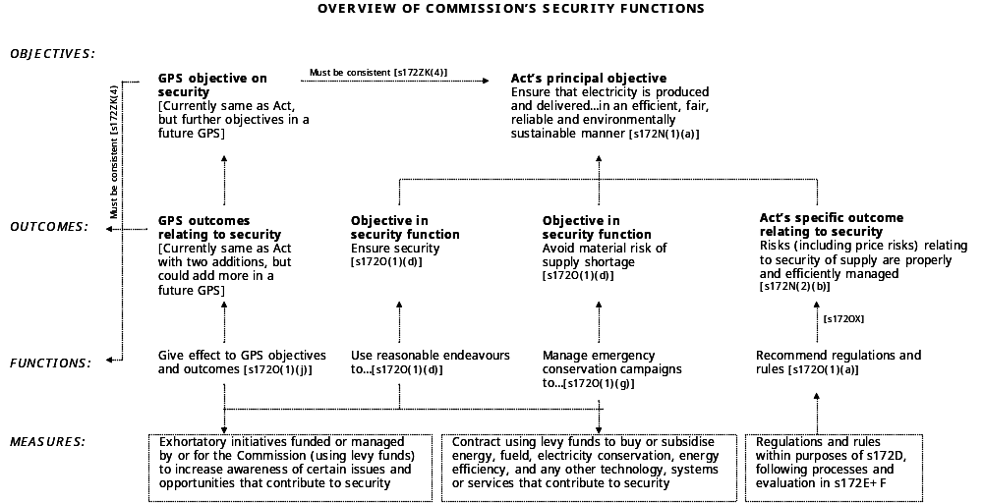

Key conclusions
  - Key conclusions from this section of the report are as follows:
    - The Commission has four stand-alone security functions. Each is to be performed to achieve its own outcome or objective.
    - The specific outcome relating to security – where “risks (including price risks) relating to security are properly and efficiently managed” – does not determine the nature and scope of the Commission’s functions. The opposite is the case – the legal nature and scope of the Commission’s security functions will strongly influence how the specific outcome is achieved.
    - Put another way, the Commission’s wide responsibility for ensuring security of supply is necessarily an outcome where “risks relating to security are properly and efficiently managed”.

Obligation to ensure – ‘security of supply’

Outline
  - Section 172O(1)(d) requires the Commission to:
“Use reasonable endeavours to ensure security of supply (including reserve energy), without assuming any reduction in demand from emergency conservation campaigns, while minimising distortions to the normal operation of the market”
  - A court would find the legal meaning of each key component, namely: ‘reasonable endeavours’, ‘ensure’, ‘security of supply’, ‘reserve energy’, ‘without assuming’, ‘any reduction in demand’, ‘from emergency conservation campaigns’, ‘while minimising distortions’, and ‘to the normal operation of the market’.
  - The discussion below focuses on the meaning of ‘ensure security of supply’. The legal meaning of the other components is discussed in section [11] below.
  - A core legal definition of ‘security of supply’ is set out in section [6] above. It has five key elements:
    - The level of probability that supply will meet demand;
    - The level of demand to be satisfied;
    - The relevant time-frame over which security is to be provided. This element can also be considered in terms of the range of contingencies or risks to covered;
    - The range of mechanisms available to be used to provide security; and
    - The regulatory structure within which the system and its participants are to operate.
  - This section examines how each element is defined under section 172O(1)(d).

Target security standard
  - While the Act does not prescribe a specific security target, the word ‘ensure’ denotes a high security standard under section 172O(1)(d). This is consistent with the purpose and scheme of the 2004 Amendment. As outlined in section [4] above, security under the Act is clearly intended to be improved relative to outcomes delivered by the market between 1996 and 2004. However, the degree of improvement required is not clear.
  - As noted in section [6] above, 100% security is not achievable, from an economic or technical perspective. This was recognised by the Government in the 2003 Cabinet Paper, which acknowledges: “The Commission will not be expected to deliver certainty over every possible contingency – this would be too expensive”.
  - With a view to minimising its legal risks and meeting the binding GPS objective of giving as much certainty as possible to the market, the Commission should define, in specific probability-based terms, how it interprets the general standard of ‘ensuring’. The Commission should follow a robust and transparent process in defining its security target.
  - This is not the same as implementing the GPS. At law, the Commission must form its own view on how best to achieve the requirements of section 172O(1)(d). The Commission’s process should take the GPS into account, but at law it should not be driven or limited by it. The Commission’s legal obligation is to give effect to the Act, not the mechanisms, parameters and processes set out in the GPS.
  - Among other things, the 1 in 60 dry year standard in the GPS is probably not binding, it lacks practical clarity, and it is focused on hydrology while security risks to be addressed under section 172O(1)(d) are not limited to this field.
  - Under a central control regime, the electricity system was operated to a 1 in 20 security standard. This was a policy decision by the Electricity Department and then ECNZ; it was not a legal requirement. The standard was increased, on an interim basis, to 1 in 60 following the recommendations of the Inquiry into the 1992 hydro shortage. As noted in Appendix [ ], the system has not operated on a central security standard since the market started in 1996.
  - Morrison & Co suggests that the 1 in 60 standard proposed by the Government in May 2003 (and now reflected in the GPS) “probably reflects a pragmatic political judgement rather than an economic assessment”. The same report also comments that:
    - Other countries typically express the standard in terms of ‘expected unserved energy’ or ‘expected hours per annum of forced rationing’. These measures incorporate both the frequency and depth of rationing;
    - The Reliability Panel in Australia set its standard at 0.002% for expected unserved energy in each region;
    - 1 in 60 translates into a risk of forced rationing (or expected unserved energy) of 0.02 to 0.05%;
    - 1 in 60 implies that the nation is prepared to spend 12-20c per kWh on diesel to avoid a 1 in 60 risk of running out and thus require some degree of forced rationing at a national cost of $9-12 per kWh; and
    - The actual ‘value of lost load’ or ‘cost of non-supply’ in New Zealand is estimated to be around $5 per kWh, which would translate into a security standard of around 1 in 30. Based on a national cost benefit economic assessment, the security standard could be less than 1 in 30.
  - NERA observes that achieving desired levels of security involves balancing the benefits of risk reduction against the costs of achieving it. MacKerron + Lieb-Doczy note that “identifying a single optimum level of risk and security is, in practical terms, impossible”, given that (i) there is no direct market for security, (ii) it has some ‘public good’ elements, and (iii) some consumers are likely to be willing to pay more than others to avoid the risk of interruptions. However, as illustrated below, NERA considers it is possible to define a ‘zone of adequacy’ within which security will be adequate and where costs will not rise excessively if the optimum is missed in either direction.
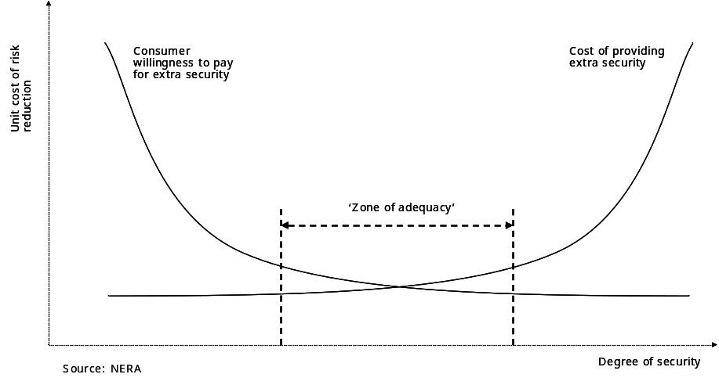
  - This is a theoretical framework. In practice, the Commission should carry out some empirical analysis, in particular on the ‘value of lost load’ for a range of consumers and the cost of alternative options for delivering a reasonable probability of security. The process should be robust and transparent.
  - Consistent with the scheme of the Act, any specific standard established by the Commission must be higher than the security outcomes delivered by the market to date.

Level of demand to be satisfied
  - The Act is silent on the level of demand to be satisfied within the target security standard.
  - By contrast, the UK legislation requires the Secretary of State and Ofgem to carry out their statutory functions in a manner “best calculated to further the principal objective, having regard [among other things] to the need to secure that all reasonable demands for electricity are met” ^{[Italics added]}. While not specific, this statutory requirement clearly signals that not all electricity demand is to be met with a high probability of security.
  - How would a New Zealand court view the level of demand to be satisfied under section 172O(1)(d)? Among other things, it depends on what assumptions are made about the degree to which market prices are allowed to rise to restrain demand in periods of shortage.
  - In theory, spot prices in the New Zealand wholesale market are uncapped, moving to the level necessary to ensure that demand equals supply. In periods of shortage, spot prices rise to reflect scarcity, and consumers voluntarily reduce demand as the market price reaches a level where it becomes more profitable not to consume electricity. ‘Rationing’ constrained supply in a market therefore occurs on an individual (not centralised) basis and the level of demand to be satisfied is ‘self selecting’ at different prices.
  - If, however, spot prices do not vary properly to reflect scarcity, and rising prices are not signalled to consumers, demand may not be adequately reduced. Voluntary national savings or mandatory physical cuts may become necessary. Under this scenario, the Commission would have to consider the level of demand to be satisfied within its target security standard under section 172O(1)(d).
  - As discussed earlier in this report, spot prices could be suppressed or not signalled to consumers for a variety of reasons in the New Zealand market. (Among several examples, domestic consumers tend not to face price increases during periods of shortage). If the Commission were to assess a material risk of a significant disconnect between consumer prices and scarcity of supply, it should be concerned that demand may not be sufficiently restrained on a voluntary basis to match reduced supply. In this case, the Commission would have to address the question of the quantity of demand to be satisfied within its target security standard under section 172O(1)(d).
  - The Act provides no guidance on the methodology that the Commission should apply to determine the level of demand to be satisfied at the target security standard. A court is likely to focus on whether the Commission has followed a reasonable process, and whether (as in the UK) the level of demand it seeks to satisfy is reasonable.

Time-frame or range of risks
  - Security in the GPS focuses primarily on hydrology risks. This is clear from a variety of references. The priority it gives to improving security arises specifically from the 2001 and 2003 hydro shortages. The security standard it proposes (1 in 60) is based on the probability of hydro inflows. The security policy it calls on the Commission to develop is to “specify the steps that the Commission will take at a various stages during a contingent event such as an extended dry sequence”. Its primary assessment mechanism is a “minimum hydro zone”. In addition, reserve energy is to be “a primary mechanism for the Commission in endeavouring to ensure security of supply in a 1 in 60 dry year” .
  - This hydrology focus is also found in the Cabinet paper of May 2003. However, it is not reflected in the Act. Under section 172O(1)(d), the time-frame over which security is to be ensured by the Commission is not limited. Nor are any risks or contingencies excluded or prioritised. All risks come within its ambit. As described in section [7] above, the range of potential security risks is very wide.
  - It does not follow, however, that the same security standard must be applied to all types and levels of risk. The standard may be higher for some conditions, but lower for others. In other words, the standard may vary, reflecting the Commission’s reasonable assessment of the costs to ensure security over different conditions. This is illustrated in the diagram below.
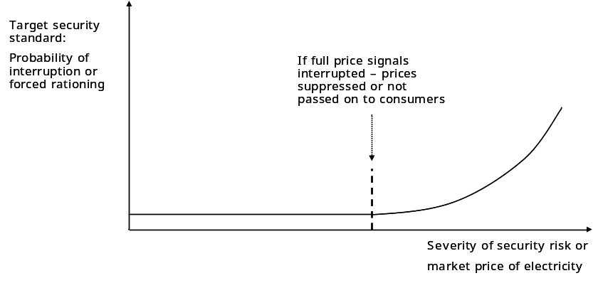
  - In my view, a court would find that the range of risks to be taken into account by the Commission is not limited under section 172O(1)(d). This is consistent with section 172N(2)(b), which requires the Commission to seek to achieve a specific outcome where “risks (including price risks) relating to security of supply are properly and efficiently managed”. A plain reading of this outcome would suggest that the scope of risks is not intended to be constrained.
  - There is also no indication in the Act that ‘security of supply’ excludes ‘reliability’ or ‘quality’ as these expressions are used in relation to transmission and distribution networks. Risks relating to transmission and distribution therefore come within section 172O(1)(d).

Range of mechanisms
  - As outlined in section [8] above, a wide range of mechanisms is used to address security of supply across OECD countries.

Menu under the Act
  - The mechanisms available to the Commission under the Act fall into three categories: coercive, contractual and exhortatory:
    - Coercive measures include recommending electricity governance regulations and rules. (This is coercive in the sense that the Minister’s role is, in effect, limited to a veto). Coercive also includes making decisions and exercising powers delegated to the Commission under regulations and rules.
    - Contractual measures include entering into a contract for any purpose authorised by the Act. This could include contracting to buy or subsidise energy, fuel, electricity conservation, energy efficiency services, and any other technology, systems or services that, in the Commission’s considered opinion, contribute to security of supply.
    - Exhortatory measures include programmes and initiatives funded or managed by or for the Commission to increase awareness of certain issues or opportunities, with a view to changing the behaviour of market participants or consumers voluntarily to ensure security of supply.
  - At face value, it could be argued that all of these measures should be available to the Commission in using reasonable endeavours to ensure security of supply under section 172O(1)(d). However, the Act has been structured so that the Commission’s main coercive tool – recommending regulations and rules – comes under section 172O(1)(a), which is a separate function, to be exercised to achieve a different set of objectives.

Regulations available for (1)(d)
  - As outlined earlier, the rules of statutory interpretation would ordinarily hold that each function under the Act is separate and independent, and that one is not an instrument of the others. However, this could lead to an outcome where some regulations or rules the Commission may wish to recommend to ensure security of supply under section 172O(1)(d) are not available under (1)(a). This may not be consistent with the ‘tool box’ approach referred to in the Select Committee’s report and the May 2003 Cabinet paper.
  - A court may try to better integrate sections 172O(1)(a) and (1)(d). The degree to which this can be achieved depends on whether:
    - The Commission seeking to ensure security of supply ^{[s172O(1)(d)]} –
is the same as –
    - The specific outcome where risks (including price risks) relating to security of supply are properly and efficiently managed ^{[s172N(2)(b)]}.
  - It also depends on whether:
    - Formulating governance regulations and rules ^{[s172O(1)(a)]} –
comes within –
    - Reasonable endeavours ^{[s172O(1)(d)]}.
  - If the answer to both questions is yes, the Commission can, in effect, recommend regulations and rules under section 172O(1)(a) to ensure security of supply under section 172O(1)(d). However, if answer to one or the other is no, some regulations or rules the Commission may wish to recommend for (1)(d) may not be available under (1)(a).

Relationship between (1)(d) and N(2)(b)
  - So is the Commission ensuring security of supply ^{[s172O(1)(d)]} the same as an outcome where risks (including price risks) relating to security of supply are properly and efficiently managed ^{[s172N(2)(b)]}? This question is discussed in some detail in section [9] above and section [13] below.
  - The answer also depends to some degree on which policy framework is applied and the nature of the Commission’s actions. Under a market framework, security risks are considered to be most efficiently managed by individual market participants responding to timely information (including full price signals) about the nature of the risks they face. It could therefore be argued that the Commission’s primary role in seeking to ensure security under (1)(d) is to facilitate a well functioning market. Actions that derogate from market participants taking responsibility for their own risks would not be consistent with the efficient outcome required by N(2)(b).
  - Under this interpretation, N(2)(b) acts as a check on the Commission’s actions under (1)(d). It also limits the Commission’s capacity to recommend regulations and rules under (1)(a) in relation to security that are not consistent with an efficient market approach.
  - By contrast, under a more regulated policy framework, security risks are considered to be efficiently managed by a mix of measures – some market, some regulated – with the regulator taking a strong role, recognising that responsibility for overall security rests ultimately with the Government, through the Commission. It would therefore be argued that the Commission’s primary role in seeking to ensure security under (1)(d) is to manage directly the risks that it considers are beyond the market’s capacity to manage.
  - Under this hybrid interpretation, there is no tension between (1)(d), (1)(a) and N(2)(b) – they run in parallel. If so, regulations and rules under (1)(a) could be effectively available to the Commission as part of its repertoire of measures for ensuring security of supply under (1)(d).
  - A third interpretation is that the specific outcome in N(2)(b), where risks relating to security are managed “properly and efficiently”, is subject to the Commission’s role as ‘default guarantor’ of security under (1)(d) and (1)g). However, each function stands alone, and the objectives in (1)(d), (1)(g) and N(2)(b) are different.

Conclusion
  - As discussed in section [9] above, in my view:
    - The specific outcome in N(2)(b) is not the same as the objective in (1)(d). N(2)(b) is subject to the objectives in (1)(d) and (1)(a). This allows a substantial degree of intervention by the Commission; and
    - Security under (1)(a) ^{[linking directly to N(2)(b)]} has a different emphasis from security under (1)(d). For the reasons outlined in section [13] below, the Commission’s functions in (1)(a) and (1)(d) are separate at law.
  - To ensure security under (1)(d), the Commission may therefore use the range of contractual and exhortatory measures outlined in paragraph [11.29] above, but not the coercive mechanisms.

Assumed regulatory and market structures
  - The fifth element in the legal definition of ‘security of supply’ set out in section [6] of this report is whether security is to be delivered by a market, central planning or some hybrid of the two. For reasons which should now be apparent, this assumption has a significant impact on how the Commission’s security obligation in section 172O(1)(d) is interpreted and applied in practice.
  - As explained in section [10] above, a court would consider the way the relevant electricity markets work in practice, not the way they are intended to work. The degree to which the New Zealand electricity markets are competitive is not clear. This is compounded by difficulties in determining whether any party is exercising market power. As Guthrie + Videbeck observed, the techniques to detect potential or actual market power have major problems in the New Zealand context. However, several of the barriers to effective competition outlined in section [8] above seem to apply in New Zealand. A court is likely to conclude that, in general, the New Zealand electricity markets are oligopolistic, with periods when some parties could exercise significant market power.
  - The Commission should set out clearly its understanding of the current competitive and regulatory framework within which it is to exercise its security function under section 172O(1)(d), in particular its assumptions of the extent to which:
    - The relevant market is competitive across a range of operating conditions;
    - The relevant market is likely to deliver the target security standard implied by section 172O(1)(d);
    - Remedial options that will address any ‘gap’ between the market’s likely level of security and the standard implied by section 172O(1)(d);
    - The options are, among other criteria, consistent with the existing competitive and regulatory framework, including whether competition will be impaired or enhanced.
  - While it may not have been intended, these assumptions in relation to the structure and operation of the markets could have the practical effect of enabling the Commission to widen or narrow its range of possible interventions in particular markets.

Key conclusions
  - Key conclusions from the discussion above are as follows:
    - While the Act does not prescribe a specific security target, the word ‘ensure’ indicates that a high security standard is required under section 172O(1)(d). With a view to minimising its legal risks and meeting the binding GPS objective of giving as much certainty as possible to the market, the Commission should define how it interprets the general standard of ‘ensuring’ in specific probability-based terms;
    - This is not the same as implementing the GPS. At law, the Commission must form its own view on how best to achieve the requirements of section 172O(1)(d). The Commission should follow a robust and transparent process for this purpose;
    - If the Commission were to assess that scarcity of supply was not likely to be properly signalled in prices to consumers, it should be concerned that demand may not be sufficiently restrained on a voluntary (market) basis to match reduced supply. Under these conditions, the Commission would have to address the question of the quantity of demand to be satisfied within its target security standard under section 172O(1)(d);
    - The Act provides no guidance on the methodology that the Commission should use to determine the level of demand to be satisfied at the target security standard. A court is likely to focus on whether the Commission has used a reasonable process, and whether (as in the UK) the level of demand it seeks to satisfy is reasonable;
    - Under section 172O(1)(d), the time-frame over which security is to be ensured by the Commission is not limited. Nor are any risks or contingencies excluded or prioritised. All risks come within its ambit. As described in section 6 of this report, the range of potential security risks is very wide.
    - It does not follow, however, that the same security standard must be applied to all types and levels of risk. The standard may be higher for some conditions, but lower for others. In other words, the standard may vary, reflecting the Commission’s reasonable assessment of the costs to ensure security over different conditions.
    - To ensure security under section 172O(1)(d), the Commission may use the range of contractual and exhortatory measures outlined in paragraph [ ] above, but not the coercive mechanisms.

Obligation to ensure - other elements

Outline
  - The other elements of section 172O(1)(d) to be defined at law are:
    - Reasonable endeavours;
    - Contracting for reserve energy;
    - While minimising distortions;
    - Normal operation;
    - The market;
    - Reductions in demand; and
    - Emergency conservation campaigns.
  - Consistent with the rules of statutory interpretation, a court would start by giving each word its plain and ordinary meaning. This may be refined to give effect to the Act’s purpose and scheme, as outlined in sections [ ] above.

Meaning of ‘reasonable endeavours’
  - There is very little relevant judicial authority from New Zealand courts on the meaning of ‘reasonable endeavours’ in a statutory context. There is, however, a wide body of New Zealand, Australian and English cases on ‘best endeavours, ‘all reasonable endeavours’ and ‘reasonable endeavours’ in a variety of contractual contexts. These may provide some guidance in interpreting section 172O(1)(d).

Case law
  - The cases suggest that:
    - All phrases must be interpreted in the context of the surrounding words and setting;
    - ‘Best endeavours’ requires a person to use all efforts and skills to the extent it is reasonable to do so in the circumstances. The nature, capacity, qualifications and responsibilities of the person required to make ‘best endeavours’ are taken into account;
    - ‘Best endeavours’ is now considerably less than the extremely high test of ‘leaving no stone unturned’ set by the Sheffield decision back in 1911;
    - The English courts view ‘reasonable endeavours’ to be “appreciably less than best endeavours”. ‘Reasonable endeavours’ requires only ‘an honest try’. Any financial or practical impediment may justify the person taking limited or no action;
    - The Australian courts do not consider there to be a large difference between ‘reasonable’ and ‘best’. ‘Best’ is close to ‘reasonable’’;
    - ‘Reasonable endeavours’ does not mean an obligation to act ‘reasonably’, as it is used in normal everyday speech;
    - A leading decision held that the standard of ‘reasonableness’ is objective. To be enforceable, there must be some clear criteria against which to measure whether a party’s efforts are ‘reasonable’. Without express or implied criteria, the obligation is unenforceable; and
    - ‘All reasonable endeavours’ is a middle position: more than ‘reasonable’ but less than ‘best’.
  - In almost all of the cases referred to above, the meaning of these phrases were considered in the context of commercial contracts, where one private party expected another private party to take steps to assist it in procuring some sort of commercial benefit. The basic principles may be applied, but the courts’ approach is likely to have a different emphasis in relation to a public regulatory body (the Commission) required by statute to exercise reasonable endeavours to achieve certain policy outcomes, which are viewed by Parliament as having an important and wider public benefit.

Application to section 172O(1)(d)
  - Applying the basic principles from these contract cases to the Commission’s function under section 172O(1)(d), a court would take into account the following factors in deciding whether the Commission has exercised ‘reasonable endeavours’:
    - The clarity of the objectives to be achieved under the Act;
    - The importance of security of supply under the scheme of the Act;
    - The extent of the Commission’s responsibilities in relation to security under the Act, including the scope and nature of the security risks to be addressed by the Commission; and
    - The quality of funding, ‘tools’ and other resources available to the Commission to ensure security.
  - As discussed earlier:
    - The Commission’s objectives under the Act are amorphous and lack clarity;
    - Improving security of supply has an extremely high level of importance under the Act’s scheme;
    - The Commission has an extremely high degree of legal responsibility for security. In essence, it is the guarantor of security; and
    - The Commission’s funding, ‘tools’ and other resources can be measured in a given period, but these factors are likely to vary over time as Government priorities and policies change. Over all, the scope and depth of potential resources is high.

Possible interpretations
  - There are at least three possible interpretations of ‘reasonable endeavours’ in section 172O(1)(d). The first is ‘honest try but minimal effort’. This is the approach of the English courts where ‘reasonable endeavours’ is used in commercial contracts.
  - The second interpretation is ‘a fair, proper and due degree of care and ability having regard to the circumstances’. The argument for this Australian approach is that if the Commission was required at law to apply only an ‘honest but minimal effort’, it may not adequately improve security of supply, which is the pivotal purpose in the scheme of the 2004 Amendment. New Zealand courts may therefore find that, given the powers and resources available to the Commission, together with the wider public impacts of security of supply, ‘reasonable endeavours’ in section 172O(1)(d) require a greater effort than the English courts have held for private parties in commercial contracts.
  - The third interpretation is closer to ‘leaving no stone unturned’. Under the scheme of the 2004 Amendment, it could be argued that, in relation to security of supply, the Commission’s position is analogous to a fiduciary, in that its role is to ensure security for the public as a whole. The court could therefore elevate ‘reasonable endeavours’ near to ‘best endeavours’ as interpreted in the Sheffield case, in which the relevant commercial party was viewed as a fiduciary.
  - On balance, I consider the courts will incline toward the more onerous end of the second interpretation, reflecting public and Government expectations of the Commission in relation to degree of care required, level of assumed expertise, regulatory powers available, scope of potential levy funding, and the importance of security of supply under the scheme of the Act.

UK approach
  - There is another possible rationale for the expression ‘reasonable endeavours’ in section 172O(1)(d). Unqualified, the words ‘ensure security of supply’ may have been viewed by drafters as imposing an absolute standard of security, which (as discussed earlier) is impossible to deliver in practical and economic terms. ‘Reasonable endeavours’ may have been inserted to qualify the perceived stringency of the obligation. However, the expression ‘reasonable endeavours’ does not directly soften the standard of security to be delivered. Rather, it lowers the level of effort required of the Commission to achieve it. If English common law were to be applied, the result would be a high target, with a relatively low obligation to deliver.
  - The drafters’ desired outcome is more likely to have been the reverse: a reasonable standard, with a high obligation on the Commission to achieve it. This is more akin to the UK approach, where the Secretary of State and Ofgem are required to carry out their statutory functions in a manner “best calculated to further the principal objective, having regard [among other things] to the need to secure that all reasonable demands for electricity are met” ^{[Italics added]}.

Officials’ rationale
  - The Government’s policy package released in May 2003 provided for the Commission “to ensure the electricity sector meets [a] 1 in 60 security standard”. This was later reduced to “use reasonable endeavours to ensure”.
  - As outlined in Appendix 2, it is likely that, following the Morrison & Co report in August 2003, officials inserted “reasonable endeavours” with a view to enabling the Commission, in relation to a possible intervention, to trade-off the expected security gains against the cost to the nation and the degree of distortion to the market.
  - From a legal perspective, however, ‘reasonable endeavours’ does not perform this function. In section 172O(1)(d), ‘reasonable’ does not relate to whether it is reasonable to intervene in the market, or whether the cost to the nation is reasonable relative to the gains. ‘Reasonable’ relates to the degree of effort the Commission is expected to exercise. The degree of effort required by section 172O(1)(d) is ‘a fair, proper and due degree of care and ability having regard to the circumstances’.
  - Like many other aspects of the Act, officials’ apparent policy purpose and the Act’s legal effect are not well connected.

Meaning of ‘contracting for reserve energy’
  - ‘Reserve energy’ is “energy that is secured by contract (including by contracting for demand side savings) by, or on behalf of, the Commission for the purpose of ensuring security of supply”.
  - Under section 172O(1)(d), contracting for reserve energy is expressly included within the umbrella of “reasonable endeavours to ensure security of supply”. However, it is only one of many measures available to the Commission under section 172O(1)(d). Reserve energy is not necessarily a preferred mechanism. By contrast, under the GPS reserve energy is viewed as “a primary mechanism for the Commission in endeavouring to ensure security of supply in a 1 in 60 dry year” .
  - Regulations can be made to prescribe how the Commission is to secure and use reserve energy. None has yet been made, however the Government has signalled its intention to promulgate regulations to implement key elements of the reserve energy scheme set out in the GPS. However, given that this scheme is to be reviewed by 31 March 2007, the Government may decide to delay making regulations until the review has been completed.
  - In the absence of regulations, the Commission is not bound at law by any of the detailed GPS provisions relating to reserve energy. Nor does implementing the GPS necessarily discharge the Commission’s obligation under section 172O(1)(d), which is broader than the parameters set out in the GPS.
  - The Act does not impose any limits in relation to the type, quantity, conditions of use or process of acquiring reserve energy. If the Commission secures any energy “for the purpose of ensuring security of supply”, it is, by definition, reserve energy.
  - It can be argued that section 172O(1)(d) creates a positive obligation on the Commission to secure reserve energy if it considers that:
    - Security of supply is at risk (without assuming demand reductions from emergency conservation campaigns);
    - Securing and using the energy would be a “reasonable endeavour”; and
    - It is done in a manner that “minimises distortions to the normal operation of the market”.
  - The last factor was no doubt intended to restrain the degree to which the Commission buys reserve energy. However, as discussed below, the scope and effect of the restraint is likely to be limited at law.
  - For the avoidance of doubt, the Commission’s obligation under section 172O(1)(d) is not restrained by the GPS:
    - Cap of 1200GWh over any given four month period;
    - Preference for plant with low fixed costs and high operating costs, rather than baseload plant;
    - Criteria for evaluating alternative reserve energy proposals, including demand-side savings; or
    - Conditions of using reserve energy, including a minimum offer price.
  - If the Commission were to limit its approach to reserve energy to a rigid application of the GPS, it could expose the Commission to the risk of failing to carry out properly its statutory function as it relates to reserve energy. The Commission must form its own view on how much reserve energy to acquire, and when and how to use it, consistent with its broad obligation under section 172O(1)(d), not the requirements of the GPS.
  - On the spectrum of possible interventions by the Commission to ensure security, buying base-load output tends to be regarded in policy circles as ‘off limits’. Under section 172O(1)(d), however, it is not impossible. If, in the future, the Commission formed a view on reasonable grounds that: (i) the market for new investment was not functioning properly; (ii) there was serious risk of shortage over the medium term; and (iii) there were no alternative lower-cost options to remedy the expected shortage, then a proposal by the Commission to buy base-load output, or to subsidise or underwrite the fuel supply or other costs relating to new capacity, would come within the obligation under section 172O(1)(d).

Meaning of ‘while minimising distortions’
  - Giving each word its plain and ordinary meaning:
    - ‘Minimise’ means “reduce to the smallest possible degree or amount”. While this is less demanding than ‘avoid’, it is more onerous than simply ‘reduce’ or ‘mitigate’.
    - ‘Distortion’ means “something that is twisted or pulled out of shape; contorted or deformed”.
    - ‘While’ means “at the same time”. In the context of section 172O(1)(d), it implies optimising (on the one hand) a possible action by the Commission to ensure security and (on the other) its possible distortion to the normal operation of the market.
  - Three questions arise in relation to the phrase ‘while minimising distortions’:
    - Does it apply if the market is already distorted?
    - How does the requirement to minimise distortions rank relative to the obligation to ensure security using reasonable endeavours?
    - Which elements of section 172O(1)(d) are affected by the requirement to minimise distortions?
  - In relation to the first question: what if the ‘normal operation of the market’ is flawed or dysfunctional in a manner that adversely impacts on security of supply – in other words, what if the market is already ‘contorted or deformed’? In this case, an intervention by the Commission that would otherwise distort a well-functioning market is unlikely to be viewed by a court as a distortion under section 172O(1)(d), so long as it did not make the existing distortion worse. In other words, the requirement on the Commission to minimise distortions is blunted if the market is already distorted.
  - In relation to the second question: section 172O(1)(d) requires the Commission to evaluate the distortionary impacts of alternative measures for ensuring security, and to choose the option that best achieves security with the least distortion. However, it is clear from the scheme of the Act outlined in section [ ] above that ensuring security using reasonable endeavours ranks above minimising market distortions. If a Commission measure is necessary for security, but it will also cause significant distortions, these are acceptable under the Act, so long as there is no other way of achieving the same security outcome for less cost or distortion.
  - In relation to the third question: section 172O(1)(d) has several components, including ‘use reasonable endeavours’, ‘ensure security of supply’, and ‘without assuming any reduction in demand from emergency conservation campaigns’. Does the requirement to minimise distortions to the market apply as a counter-balance in relation to each component? If so, it could, for example, constrain the Commission from seeking to achieve a security standard above the level that the market would otherwise deliver; or it could limit the extent to which demand reductions generated by the market are excluded in the Commission’s assessment of security needs under section 172O(1)(d).
  - On the other hand, if ‘minimise distortions’ applies only to measures to ensure security, such as buying reserve energy, the standard of security required by section 172O(1)(d), or the exclusion of demand savings in emergencies, could be set without concern for possible distortionary effects on the normal operation of the market.
  - Which interpretation would prevail is not clear. The discussion below examines some of the factors that could influence a court’s view.
    - Except for the function of operating markets, the Act does not require the Commission’s other functions to be performed within a market;
    - Unlike the UK legislation, the Act has no express overarching requirement for the Commission and Minister to promote effective competition or facilitate the market;
    - Government officials may have intended the specific outcomes in section 172N(2) to constrain the Commission, so that it performs its functions within a market framework. However, as discussed in section [9] above, it does not follow at law that these specific outcomes can only be delivered by a market;
    - The Act seems to supports both a market and a more centralised approach, without providing any guidance on where or how the balance is to be drawn. Minimising distortions does not rank above ensuring security. If the security risk is high and the measure that mitigates the risk in the most optimal manner also involves (in absolute terms) a high degree of distortion, it fits within section 172(O)(1)(d).
  - In my view, a court would conclude in relation to ‘minimising distortions’ that:
    - It applies to any measures put in place by the Commission under section 172O(1)(d) to ensure security; however –
    - The Commission is not required to ‘minimise distortions’ in relation to the other elements of section 172O(1)(d) – namely, its level of effort (‘reasonable endeavours’), the target standard of security (‘ensure security’), or the exclusion of emergency savings (‘without assuming any reduction in demand from emergency conservation campaigns’).
  - The key reason for this conclusion is that these other elements are inherently distortionary. They are also fundamental to two key aims underlying section 172O(1)(d), namely:
    - To have the Commission achieve security to a higher level than the market delivered before the 2004 Amendment; and
    - For this to be achieved without relying on emergency demand savings, so as to avoid inconvenience to the public and loss of reputation for the wider New Zealand economy.
  - It would therefore be illogical to require the Commission to minimise distortion in relation to these other elements.

Meaning of ‘normal operation’
  - Once again, we need to give each word its plain and ordinary meaning:
    - ‘Normal’ means “usual, regular, common or typical’; and
    - ‘Operation’ means “the process or manner of functioning”.
  - The question then arises, what is ‘normal’ in the electricity market?
    - Is it part of ‘normal operations’ to have low hydro inflows, unplanned outages, force majeure events or high prices in a shortage? Or –
    - Does ‘normal’ exclude conditions that are not common, typical or usual?
  - If ‘normal operation’ excludes uncommon events such as low hydro inflows and unplanned outages, the Commission would be required to minimise distortions to the market only where it operates in typical or common conditions. The converse would apply if uncommon events were held to be within the market’s ‘normal operation’.
  - How this question is answered at law clearly has a material impact on the degree to which the Commission is constrained in performing its obligation to use reasonable endeavours to ensure security of supply.
  - In my view, the courts would adopt a more conservative view of the market’s ‘normal operation’ – in other words, it would exclude uncommon events. This would mean that section 172O(1)(d) requires the Commission to minimise distortions to the market only where it operates in typical or common conditions. The restraint of minimising market distortions would not apply in relation to interventions by the Commission for uncommon or irregular conditions.
  - If this is so, the Commission may not decline to act to ensure security under section 172O(1)(d) on the grounds that its proposed measure would distort the market in unusual events. The requirement to minimise market distortions may have been intended by Government officials to restrain interventions by the Commission that rely on a more centralised or regulated approach, however is doubtful that effect has been achieved in the legal drafting.
  - Another key consideration in interpreting ‘normal operation of the market’ is that it does not refer to how the market should work. It is not a normative or ideal market. Rather, it refers to how the actual market in New Zealand operates over any given period. As discussed above, though an intervention might be considered a distortion of an ideal or well-functioning market, a court is not likely to view it as a distortion if, in its ‘normal operation’, the New Zealand market is already distorted in a manner that adversely affects security.
  - It is also important to note that section 172O(1)(d) does not exclude an intervention to ensure security even if it is likely to distort the market’s normal operation. Under the scheme of section 172O(1)(d), security is clearly the primary objective. Minimising distortions is a secondary consideration. Section 172O(1)(d) has the effect of requiring the Commission to weigh the likely impacts of alternative security measures, and to choose the option that best achieves security with the least distortion. The Act does not proscribe non-market measures or outcomes. If the least-cost intervention that best addresses the security need also involves significant market distortions, these are permitted under the Act.
  - As discussed above, buying significant quantities of energy, in excess of any limit proposed in the GPS, is not excluded by the Act. On the contrary, if the Commission reasonably considers it is the least-cost option that best ensures security, the Commission may be obliged to buy more reserve energy than the limits proposed in the GPS.

Meaning of ‘the market’
  - ‘The market’ is not defined in the Act. It is a technical expression that clearly refers to the electricity market. The question is, which market? The ‘spot’ market, the market for electricity contracts and hedges, the market for transporting electricity, the market for new generation capacity, the electricity fuels market, the market for demand-side savings, the market for industrial and commercial customers, the market for retail customers, or all of these markets? Each market can also be further categorised by other factors, including geographic areas and customer groups.
  - It is not clear which market the Act is referring to. The Commission should define the market it is assessing for the purposes of section 172O(1)(d), making its methodology and process transparent to the industry.
  - It may not have been intended, but this ambiguity could have the practical effect of enabling the Commission to widen or narrow its range of possible interventions in particular markets, given that the degree of a measure’s distortion will vary across different markets.

Meaning of ‘without assuming’
  - The ordinary meaning of both words is relatively clear in the context of section 172O(1)(d):
    - ‘Without’ means “not with; with the omission of; excluding”;
    - ‘Assuming’ means “supposing; accepting as true without proof”. By its nature, ensuring security of supply involves making projections or forecasts. Necessarily, these must be based on various assumptions, including levels of electricity supply and demand. ‘Assuming’ in section 172O(1)(d) is used in this sense.

Meaning of ‘reductions in demand’
  - The ordinary meaning of ‘reduction’ is not difficult – it means “an amount by which something is made a smaller or less in amount”.
  - By contrast, ‘demand’ is a technical expression, which refers to the aggregate quantity of electricity that consumers of electricity want to use over a given period. Of course, demand varies with a range factors, including temperature, daily consumer activity and economic growth. In a well-functioning market, demand for electricity also varies with changes in its price.
  - The process of calculating an assumed reduction in electricity demand is therefore complex and inexact. Among other things, it requires three elements:
    - A benchmark level of demand against which to measure the assumed reduction – in other words, a counterfactual of what demand would have been but for the intervention;
    - Some method of predicting the level of reduction expected to be induced by the intervention; and
    - In practice, some way of attributing what proportion of an actual reduction is caused by the intervention (rather than some other factor).
  - These are all technical issues. A change in any key assumption could have a material impact on the quantity of potential demand savings to be excluded from the Commission’s security assessment under section 172O(1)(d). A court is not likely to substitute its judgement on the appropriate methodology or results of this calculation. However, the Commission’s legal position would be enhanced by making its methodology and results transparent, and to demonstrate to the industry that these are reasonable.

Meaning of ‘emergency conservation campaigns’
  - This is more of a government policy, than a technical industry, expression. It also appears in section 172O(1)(g). No relevant case law defining it has been found. Applying each word’s plain and ordinary meaning:
    - ‘Emergency’ means “a sudden, urgent, usually unforeseen occurrence requiring immediate action”;
    - ‘Conservation’ means “the act of keeping from loss or waste”. Within the context of section 172O(1)(d), it is clear that ‘conservation’ relates to the supply or use of electricity; and
    - ‘Campaign’ means “a systematic course of activities for some special purpose”.
  - ‘Emergency conservation campaign’ could therefore be defined as “a systematic course of activities to avoid loss or waste of electricity supply or use in response to a sudden or urgent, usually unforeseen, event”.
  - A wide range of measures could fall within the ambit of this definition. It could include any programme or procedure to save electricity in response to any type of emergency. It could be for long periods (fuel shortages) or short periods (brief plant outages). It could be initiated by individual retailers or generators, groups of consumers, the Government, or the Commission. It need not be a nation-wide activity.
  - In a report for the Commission on emergency security of supply, Concept Consulting identified two broad categories of possible responses:
    - ‘Pre-emergency’ measures, including short run contracts to extract additional supply and demand response from the market; greater demand-side involvement, with more consumer buy-back schemes and stronger price signalling; and emergency generation capacity (such as temporary diesel units); and
    - ‘Emergency’ measures (if the GPS 1 in 60 standard is breached), including extended water heating cuts; rolling supply cuts; mandatory savings for targeted consumption, such as street lights, commercial signage, and Government departments; suspending the market, with the Commission controlling fuel use and production; and/or a nation-wide advertising campaign encouraging all consumers to save power.
  - At law, demand-side savings generated by any of the above measures, whether implemented by contract, exhortation or regulation, could come within the legal definition ‘emergency conservation campaign’ under section 172O(1)(d).
  - Applying this definition of ‘emergency conservation campaigns’, the Commission would need to take an expansive approach in excluding assumed demand reductions from its assessment of security under section 172O(1)(d). This could result in a more conservative approach to security, leading to a higher security margin across the electricity system than would otherwise be the case.
  - It could be argued that section 172O(1)(d) refers to emergency conservation campaigns managed only by the Commission under section 172O(1)(g) “to avoid material risk of supply shortages”. This would exclude all urgent demand-saving initiatives by everyone except the Commission. It would also exclude Commission programmes to conserve electricity to avoid a shortage with a risk that is less than “material”. This would narrow the scope of potential demand reductions to be excluded from the Commission’s assessment of security needs under section 172O(1)(d), leading to a lower security margin across the system as a whole than is likely to result from the wider definition of ‘emergency conservation campaigns’ above.
  - From a legal drafting perspective, the natural interpretation of section 172O, given the way it has been structured, is that:
    - ‘Emergency conservation campaigns’ in (1)(d) refers to all types of measures that fit within the ordinary (wider) definition of ‘emergency conservation campaign’ set out above, not just those managed by the Commission to avoid a material risk of supply shortage under (1)(g); and
    - Section 172O(1)(g) has been provided to give the Commission the authority to manage emergency conservation campaigns on a contractual basis, which is not provided by the rest of section 1720.
  - Under the GPS, the notion of a conservation campaign is more specific and narrow. The GPS proposes that the Commission “should have a second zone that would trigger a conservation campaign, on the basis that there is a significant probability that we are in a worse than 1 in 60 dry year event”.
  - The GPS concept of a conservation campaign seems to be a nation-wide advertising campaign to encourage the public to conserve electricity, like those put in place in 2003, 2001 and 1992, as mentioned in the Cabinet paper of May 2003. This is separate and distinct from other emergency measures mentioned in the GPS, such as ripple control of water heating and coordination of forced outages.
  - Some may argue that, as section 172(1)(d) is derived from an early draft of the GPS, ‘emergency conservation campaigns’ under the Act should be limited to nation-wide advertising campaigns, as contemplated in the GPS. At law, this is not a sound argument. As explained in section [5] above, the GPS does not dictate the meaning of provisions in the Act. The legislation must be interpreted on its own terms, consistent with the rules of statutory interpretation.
  - A court is therefore likely to decide that ‘emergency conservation campaigns’ are not limited to nation-wide advertising campaigns, but include any emergency programme or procedure initiated or managed by any party to conserve electricity, including demand-side buy-back schemes, targeted uses (like street lighting), rolling cuts and stronger price signals to consumers, and the other measures referred to above, whether implemented by contract, exhortation or regulation.
  - The Commission needs build these assumptions into its assessment of security under section 172O(1)(d).

Key conclusions
  - Key conclusions from this section of the report are summarised below:

General
    - Section 172O(1)(d) sets the objective of ensuring security of supply. This is a very high standard. It makes the Commission a default guarantor of security.
    - In seeking to achieve the objective:
      - The degree of effort required is ‘reasonable endeavours’;
      - Demand reductions from any emergency conservation measures are to be excluded when assessing security needs;
      - By implication, the Commission may not use emergency conservation campaigns to ensure security under section 172O(1)(d); and
      - Distortions to the normal operation of the market are to be minimised.
    - The Commission is authorised to use contractual and exhortatory measures, but not regulations and rules, which are to be recommended under (1)(a) for a differently worded security objective.

Use reasonable endeavours
    - ‘Use reasonable endeavours’ does not soften the standard of security to be aimed for. Nor, contrary to officials’ expectations, does it require the Commission to trade-off expected security gains against economic costs to the nation. Rather, it qualifies the level of effort to be applied in seeking to achieve the target standard.
    - ‘Use reasonable endeavours’ means apply a fair, proper and due degree of care and ability, having regard to the Commission’s powers, assumed expertise, potential funding and the importance placed on improving security of supply in the scheme of the Act.
    - A high level of effort is therefore required, but less than ‘leaving no stone unturned’, and less than that which would apply to a fiduciary.

Contracting for reserve energy
    - Contracting for reserve energy is but one of the measures the Commission can use in seeking to ensure security under section 172O(1)(d).
    - The Act does not set any limits in relation to type, quantity, conditions of use, or the process for acquiring reserve energy. Buying base-load energy to ensure security is not precluded by the Act.
    - The GPS limits in relation to reserve energy are not binding on the Commission.

Minimise distortions to the normal operation of the market
    - Section 172O(1)(d) does not prohibit measures that distort the normal operation of the market. It is clear from the scheme of the Act that ensuring security using reasonable endeavours ranks above minimising market distortions. If a Commission measure is necessary for security, but it will also cause significant distortions, these are acceptable under the Act, so long as there is no other way of achieving the same security outcome for less cost or distortion.
    - The Commission is not required to ‘minimise distortions’ in relation to its level of effort (‘reasonable endeavours’), the target standard of security (‘ensure security’), or the exclusion of emergency savings (‘without assuming any reduction in demand from emergency conservation campaigns’). The Commission must form its own view on these other elements, in a manner that may be independent of normal market parameters.
    - The Commission is only required to minimise distortions to the market as it operates in normal conditions. At law, this probably excludes uncommon conditions, such as unusual shortages or extremely high prices. In other words, the Commission is not obliged by section 172O(1)(d) to minimise distortions to the market in a very dry period or a significant unexpected generation or lines outage.
    - Though an intervention by the Commission might be considered a distortion of an ideal or well-functioning market, a court is not likely to view it as a distortion if, in its ‘normal operation’, the New Zealand market is already distorted in a manner that adversely affects security.
    - The Commission may define in narrow or wide terms the market in which it is to minimise distortions – for example, (at one end of the spectrum) only the residential retail market in a particular location, or (at the other end) the electricity market as a whole. This choice of approach could limit and enlarge the practical effect of the duty to minimise distortion under section 172O(1)(d).

Excluding emergency conservation campaign savings
    - The scope of assumed demand savings from emergency conservation campaigns, which are to be excluded under section 172O(1)(d), is wide. It could include any programme or procedure to save electricity in response to any type of emergency, whether implemented by the Commission, the Government, market participants, consumers or any other person, and whether implemented by contract, exhortation or regulation. It could be for long periods (fuel shortages) or short periods (brief plant outages). It is not limited to national advertising campaigns. It need not be a nation-wide activity.
    - The scope of this exclusion is likely to lead to a more conservative approach to security (with a higher buffer or margin) than would otherwise be the case.

GPS
    - As explained in section [5] above, the GPS does not determine the scope of the Commission’s obligation under the Act. Adhering to the GPS will not necessarily meet the Commission’s legal obligations in relation to security of supply.
    - If the Commission were to limit its approach to security under section 172O to a rigid application of the GPS, it could expose the Commission to the risk of failing to carry out properly its statutory function.

Diagram
  - The elements of the Commission’s obligation under section 172O(1)(d) can be summarised and represented in diagrammatic form as follows:
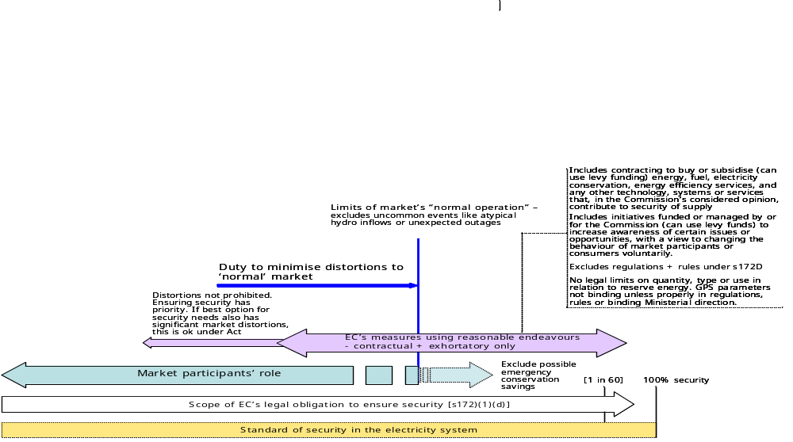

Managing emergency conservation campaigns

Outline
  - Section 172O(1)(g) of the Act requires the Commission to
“manage emergency conservation campaigns to avoid material risk of supply shortages”
  - As with section 172O(1)(d), a court would take each element of this function and find its legal meaning. Key words would be given their plain and ordinary meaning, unless the purpose or scheme of the Act requires otherwise. The elements of section 172O(1)(g) to be defined at law are:
    - Manage
    - Emergency
    - Conservation
    - Campaign
    - Avoid
    - Material
    - Risk
    - Supply shortages
  - Some aspects of this function have been discussed in relation to section 172O(1)(d). This earlier discussion is integrated into the analysis below.

Purpose of section 172O(1)(g)
  - In performing its obligation to ensure security of supply under section 172O(1)(d), the Commission is not to assume any reduction in demand from emergency conservation measures. The clear implication is that emergency conservation measures are not part of the Commission’s menu of measures (or reasonable endeavours) under (1)(d).
  - Under section 172O(1)(a), the Commission can recommend some emergency conservation measures as regulations or rules. Examples include demand-side exchanges, ripple control of hot water heating, and coordination of outages under sub-sections 172D(1)(12)-(14).
  - However, without section 172O(1)(g), the Commission would not have the authority to put in place emergency conservation measures on a contractual or exhortatory basis. On a plain reading, a court is therefore likely to conclude that:
    - Recommending regulations or rules for emergency conservation measures is not covered by section 172O(1)(g). It is a separate function under (1)(a), which is to be exercised for a different set of objectives; and
    - (1)(g) has been provided to give the Commission the authority to put in place emergency conservation measures on a contractual or exhortatory basis, which the rest of section 172O would not otherwise provide.

Scope of ‘emergency conversation campaigns’
  - The legal meaning of ‘emergency conservation campaign’ in section 172O(1)(d) was considered in section [11] above. The same definition would apply to ‘emergency conservation campaign’ in section 172O(1)(g). It means “a systematic course of activities to avoid loss or waste of electricity supply or use in response to a sudden or urgent, usually unforeseen, event”.
  - As discussed earlier, a wide range of measures could come within the ambit of this definition. It could include any programme or procedure to save electricity in response to any type of emergency. It could be for long periods (fuel shortages) or short periods (brief plant outages). It is not limited to national advertising campaigns. It need not be a nation-wide activity. It would include demand-side buy-back schemes, cuts for targeted uses (like street lighting), rolling cuts and stronger price signals to consumers, where these measures are applied in an emergency.

Limits on Commission’s use of emergency conservation campaigns
  - Emergency conservation campaigns to be taken into account under (1)(d) may be managed by any party, including the Government, the Commission, market participants, consumers or any other person.
  - By contrast, emergency conservation campaigns under (1)(g) are to be managed by the Commission. The ordinary meaning of ‘managed’ is “be in charge of; run; maintain control or influence over”. Programmes ‘managed’ (within this definition) by the Commission are therefore included within (1)(g); any others are excluded.
  - Two further limitations apply. Emergency conservation campaigns may only be managed by the Commission “to avoid material risk of supply shortage”. These circumstances are relatively restricted. This is consistent with the scheme of the Act and its legislative history. Plainly, one of the Government’s aims was to avoid inconvenience to the public and loss of reputation for the wider New Zealand economy from having to request or impose reduced levels of electricity demand.
  - The ordinary meaning of:
    - ‘Avoid’ is “prevent from happening”. It is a highly demanding requirement; more than ‘minimise’. It means that an emergency conservation campaign managed by the Commission may be as deep and severe as necessary to avoid a shortage;
    - ‘Material’ is “important; essential; relevant” and “weighty; momentous”. The question of when a supply risk would become ‘material’ is discussed further below;
    - ‘Risk’ is “a situation involving exposure to danger; the possibility that something unpleasant will happen”. As discussed earlier, risk is normally considered in terms of probability;
    - ‘Shortage’ is “a state or situation in which something needed cannot be obtained in sufficient amounts”. The question of sufficiency is also discussed further below; and
    - ‘Supply’ is “the amount of a good or service available”. In section 172O(1)(g), ‘supply’ is a technical expression meaning “the amount of electricity produced and delivered”.
  - In the context of (1)(g), two legal questions arise:
    - When is does a risk become ‘material’? and
    - When does insufficient supply become a ‘shortage’?
  - The answer to these two questions at law determines the scope of the Commission’s authority under (1)(g).

‘Material’
  - No doubt, a court would link ‘emergency’ and ‘material’. In other words, a risk becomes material (or important) when there is a sudden, urgent and therefore relatively high risk of insufficient supply. The Commission is required to manage emergency conservation campaigns to avoid this threshold.
  - Given the legislative history and scheme of the 2004 Amendment, a court may conclude that any contractual or exhortatory emergency conservation campaign by the Commission under (1)(g) should start at a relatively late stage in the development of a shortage, perhaps after:
    - Action by the Commission under (1)(a) [rules and regulations] and (1)(d) [supply-side and non-emergency demand-side initiatives of a contractual or exhortatory nature]; and
    - Action by other parties, including market participants, consumers and the Government.
  - Given the wide scope of programmes covered by the definition of ‘emergency conservation campaign’, this would be key restriction on the Commission in relation to emergency demand-side initiatives based on contract or exhortation.

‘Shortage’
  - On the question of when insufficient supply becomes a ‘shortage’ at law, the Act provides limited guidance. A range of questions come into play:
    - Is supply short when a certain margin of ‘back up’ generation is called to generate? Or is it when all available capacity is generating (with no ‘back up’ output left to call on), but it is not sufficient to meet total demand?
    - Is supply short if the system operator calls on particular consumers to reduce demand (for any duration by any amount) to balance aggregate supply and demand? Does it have to be a large amount for a longer duration to qualify as a shortage? If so, by how much?
    - Is supply short when consumers exposed to spot prices choose to reduce demand in response to high prices reflecting a scarcity of supply?
  - The Act is silent on these questions. This uncertainty once again raises the issue of what assumptions are to be made, in interpreting the Act, about the extent to which prices will be allowed to rise to reflect scarcity of supply. In a well-functioning market, a physical shortage is only likely to occur if prices are restrained or not properly signalled to consumers. Otherwise, consumers will ‘self ration’ based on the value to consumers of using additional electricity at higher prices.
  - If prices are restrained or not fully signalled, then demand is less likely to be adequately curtailed and the risk of an imbalance between supply and demand is likely to increase. Earlier in this report, it was observed that spot prices in the New Zealand market could be suppressed or not signalled to consumers for a variety of reasons. Among several examples, domestic consumers tend not to face price increases during periods of shortage.
  - If the Commission were to assess a material risk of a significant disconnect between consumer prices and scarcity of supply, it should be concerned that demand may not be sufficiently restrained on a voluntary basis to match reduced supply. The Commission would then have to address the risk of a physical shortage.
  - The legal questions are therefore:
    - When is supply ‘short’ under section 172O(1)(g)? and
    - What level of demand is to be used in assessing whether supply is ‘short’?
  - On the first question, a court is likely to leave it to the Commission to determine and publish its assumptions and policy parameters of when supply is available.
  - On the second question, a court may ask whether the level of demand is based on:
    - As many consumers as possible receiving price signals that reflect scarcity of supply; or
    - Prices remaining relatively constant, not rising to reflect scarcity.
  - Clearly, the second interpretation would give rise to much larger and more frequent shortages under section 172O(1)(g).
  - In my view, a court’s approach would reflect actual industry and Government practice in relation to how consumers’ prices vary (or not) with scarcity, including market rules, likely industry behaviour and any Ministerial involvement. Demand for determining shortage risks under section 172O(1)(g) would therefore be based on price signals consumers are likely to receive as supply reduces.

GPS
  - As noted earlier, the GPS proposes that the Commission “should have a second zone that would trigger a conservation campaign, on the basis that there is a significant probability that we are in a worse than 1 in 60 dry year event”. A conservation campaign under the GPS is separate and distinct from other emergency measures, such as ripple control of water heating and coordination of forced outages.
  - The GPS concept of a conservation campaign is also more specific and narrow than ‘emergency conservation campaigns’ under the Act. The GPS contemplates nation-wide advertising campaigns to encourage the public to conserve electricity, like those put in place in 2003, 2001 and 1992.
  - As discussed earlier, some may argue that, as sub-sections 172(1)(d) and (g) are based on an early draft of the GPS, ‘emergency conservation campaigns’ under the Act should be limited to nation-wide advertising campaigns, as contemplated in the GPS. It may also be argued that a significant probability of a worse than 1 in 60 dry year sets the threshold of when the risk of a shortage is ‘material’ under (1)(g).
  - At law, these are not sound arguments. The GPS does not determine the meaning of provisions in the Act. The legislation must be interpreted by the Commission on its own terms, consistent with the rules of statutory interpretation. Adherence to the GPS does not necessarily ensure that the requirements of the Act are satisfied.

Key conclusions
  - In my view, a court is likely to decide that:
    - Section 172O(1)(g) gives the Commission the authority to manage emergency conservation campaigns on a contractual or exhortatory basis, which the rest of section 172O would not otherwise authorise.
    - Recommending regulations or rules for emergency conservation measures is not covered by section 172O(1)(g). It is a separate function under (1)(a), which is to be exercised for a different set of objectives.
    - A wide range of measures comes within the legal definition of ‘emergency conservation campaign’. It is not limited to nation-wide advertising campaigns under the GPS.
    - The Commission may only put in place an emergency conservation campaign under (1)(g) to avoid a material risk of shortage. This is not necessarily when the GPS 1 in 60 standard is breached.
    - Any contractual or exhortatory emergency conservation campaign by the Commission under (1)(g) would have to start at a relatively late stage in the development of a shortage, perhaps after:
      - Action by the Commission under (1)(a) [rules and regulations] and (1)(d) [supply side and non-emergency demand-side initiatives of a contractual or exhortatory nature]; and
      - Action by other parties, including market participants, consumers and the Government.
    - A court is likely to leave it to the Commission to determine and publish its assumptions and policy parameters of when supply is available for the purposes of (1)(g).
    - A court is likely to decide that demand assumptions under section (1)(g) should be based on prices consumers are likely to receive as supply reduces, based on market rules, likely industry behaviour and any Ministerial involvement.
    - As for each of the Commission’s other statutory functions, the GPS does not determine how (1)(g) should be interpreted or implemented. It must be interpreted on its on terms, consistent with the rules of statutory interpretation. Adherence to the GPS will not necessarily ensure that the requirements of (1)(g) are satisfied.

Diagram
  - The Commission’s obligation under section 172O(1)(g) can be summarised and represented in diagrammatic form as follows:
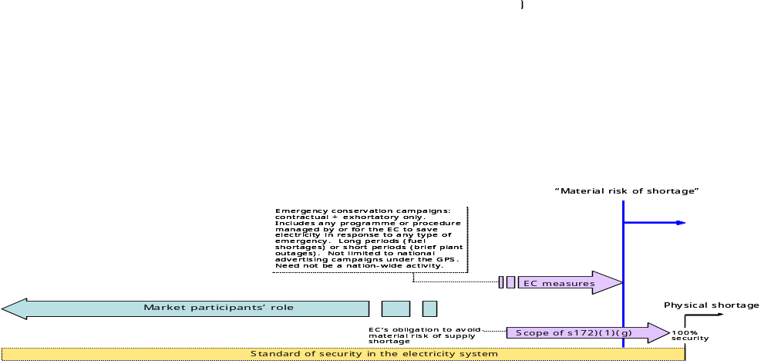

Other security functions

Outline
  - In addition to its obligation under sections 172O(1)(d) and (1)(g), the Commission has three other security functions:
    - Recommending regulations and rules under (1)(a);
    - Giving effect to GPS objectives and outcomes under (1)(j); and
    - In performing all of its functions under section 172O, seeking to achieve the specific outcomes in section 172N(2).
  - Each is function is discussed below.

Function of recommending regulations and rules
  - The Act requires the Commission to:
“Formulate and make recommendations concerning electricity governance regulations and rules ^{[s172O(1(a)]} to give effect to ^{[s172X]} [among other things] the specific outcome where risks (including price risks) relating to security of supply are properly and efficiently managed ^{[s172N(b)]}
  - A very wide range of regulations and rules can be made under the Act, as illustrated in a diagram at the end of section [9] of this report. Many of these could affect security of supply.
  - An electricity governance regulation or rule must fit within one of the 31 purposes set out in section 172D. Only two of the 31 refer expressly to a competitive market. One of the two – section 172D(1)(2) – authorises regulations or rules “providing for generation of electricity and management of supply and price risks in a competitive market”, including in relation to fuels, contract offerings, disclosure of information, spot price offers and hydro spill.
  - If a regulation or rule recommended under section 172D(1)(2) were not consistent with a competitive market, it would not be authorised. While this may seem to be a rigorous restraint, its effect at law may be less demanding given the technical difficulties in determining whether an electricity market is competitive or not.
  - The other key restraint on the Commission recommending regulations and rules under section 172O(1)(a) is the requirement to give effect to (among other things) the specific outcomes in section 172N(2). All of the specific outcomes have an impact to some degree on security of supply. However, the outcome that addresses security directly is section 172N(2)(b): “Risks (including price risks) relating to security of supply are properly and efficiently managed”.
  - Its legal meaning is not clear:
    - “Efficiently” could be given its plain and ordinary meaning, its technical engineering meaning, or its technical economic meaning;
    - The purpose and effect of “properly” relative to “efficiently” is somewhat obscure;
    - Overall, the specific outcome could support a range of policy measures, no doubt spanning a wider spectrum than intended by the officials responsible for its drafting. The legal interpretation may depend, in the end, on the policy orientation of the court.
  - It is clear, however, that under section 172N(2)(b):
    - The range of risks relating to security is intended to be expansive. Unlike the GPS, it is not focused on hydrology;
    - In contrast to section 172O(1)(d), no overarching security of supply standard is required or implied;
    - The focus is on managing risk “properly and efficiently”, which may involve market participants cutting consumption rather than incurring costs to ensure supply. By comparison, the focus of section 172O(1)(d) is more on ensuring supply;
    - The market is to play a key role in managing security risks. This is signalled by the reference to price risks in section 172N2(b), which are normally only material in a market; and
    - Security is not necessarily to be provided or ensured by the Commission. It may be achieved by any means, so long as the security risks are managed “properly and efficiently”. This contrasts with section 172O(1)(d), which requires the Commission to ensure security using reasonable endeavours.
  - Security under section (1)(a) therefore has a different emphasis compared to security under section (1)(d). As discussed in the sections 11 and 12 of this report, in my view the two functions are separate at law. Among other things:
    - Regulations and rules must be recommended under (1)(a) for purposes consistent with sections 172N(2)(b) and 172D, which are not necessarily the same as section (1)(d); and
    - Recommending regulations and rules under (1)(d) is a statutory function, not a ‘reasonable endeavour’ under (1)(d); and
    - (1)(d) is concerned with the Commission’s role in ensuring security. (1)(a) is concerned with the regulations and rules that could affect a wide range of parties.
  - Recommending regulations and rules under (1)(a) is also separate from (1)(g), which authorises the Commission to manage emergency conservation campaigns on a contractual and exhortatory basis.
  - It is quite possible that the purposes for which regulations and rules may be made under section 172D are not consistent with the range of potential interpretations of section 172N(2)(b), which is one of the objectives the Commission is required to give effect to in recommending regulations and rules under section 172O(1)(a). This tension between sections 172D and 172N(2)(b) could be approached in a variety of ways:
    - Section 172N(2)(b) could be viewed as a restraint on how the Commission recommends regulations and rules under 172D; or
    - The range of purposes in 172D could be viewed as necessarily falling within (and therefore to some degree defining) 172N(2)(b). This would mean that using regulations and rules to coerce certain security outcomes is, by definition, part of “properly and efficiently” managing risks relating to security.
  - The second approach would suggest that N(2)(b) does not necessarily require a market outcome. In my view, a court is likely to prefer this second approach, given that N(2)(b) is open to a range of interpretations.

Function of giving effect to GPS objectives and outcomes
  - Under section 172O(1)(j), the Commission is required to give effect to GPS objectives and outcomes. This has two key definitional elements:
    - ‘Give effect to’ means “do an act or thing in pursuance of or in accordance with”;
    - ‘GPS objectives and outcomes’ means GPS provisions that are, in substance, equivalent to the principal objectives or specific outcomes in the Act. As outlined in section 4 of this report, GPS provisions relating to processes, or to how an objective is to be achieved, are not ‘GPS objectives and outcomes’ and therefore not binding.
  - Out of the 48 paragraphs relating to security of supply in the current GPS, only two are clearly ‘GPS objectives or outcomes’ that are additional to the principal objectives and specific outcomes in the Act – namely:
    - The objective of providing well-researched information on short and long term security of supply, including likely availability of fuels, new generation options, and likely price trends under various scenarios; and
    - The “overriding objective” of giving as much certainty as possible to the market in relation to the Commission’s security of supply policy.
  - The two additional GPS objectives or outcomes satisfy the requirements of section 172ZK and are therefore binding on the Commission. As outlined in Appendix 2, the rest of the GPS provisions on security supply are mainly mechanisms or processes, parameters or specifications, implementation factors, or contextual statements, none of which are legally binding on the Commission.
  - The additional objectives or outcomes outlined above tend to support a market-based approach to security. However, as discussed earlier, the scheme of the Act permits a range of mechanisms and policy approaches to security, with varying degrees of market consistency. The boundaries at law will depend to some extent on the policy orientation of the court.
  - Cleary, there is a considerable overlap between objectives and outcomes in section 172N and the GPS objectives and outcomes. However, there is a difference in implementation –
    - Under the Act, the Commission has a duty to perform its statutory functions as a whole in a manner that seeks to achieve the outcomes in 172N(2) as a whole. However, each function also has its own parameters, which tend to dictate (in some cases, limit) how the Commission is to perform the relevant function.
    - By contrast, 172O(1)(j) allows the Commission to use contractual and exhortatory measures to achieve directly the objectives and outcomes set out in 172N, as these are also set out in the GPS. The Commission is not therefore constrained by the parameters of other functions in how it achieves these objectives and outcomes.
  - This may give the Commission more contractual or exhortatory options than the other functions provide. However, note that recommending regulations and rules comes under (1)(a), not (1)(j). Also note that levy funding can be used to support any initiative by the Commission under (1)(j).
  - If a future GPS does not include the section 172N objectives and outcomes, the Commission’s options for achieving them directly using contractual or exhortatory measures may not be enlarged by 172O(1)(j).

Duty to perform all functions to achieve the specific outcomes
  - The accompanying paper observes that the Act implies a further overall function for the Commission of performing all of its functions under section 172O in a manner that seeks to achieve all of the specific outcomes in section 172N(2). In relation to security, this includes (but is not limited to) an outcome where “risks (including price risks) relating to security of supply are properly and efficiently managed”.
  - This is noted only for completeness, as in legal substance it does not significantly refine or add to the Commission’s legal obligations in relation to security. It only reinforces the conclusion that the principal objectives, specific outcomes and GPS objectives and outcomes are amorphous in legal terms, permitting a wider range of policy approaches than the drafters may have intended.

Diagram
  - The Commission’s obligations under sections 172O(1)(a) and (j) can be summarised and represented in diagrammatic form as follows:
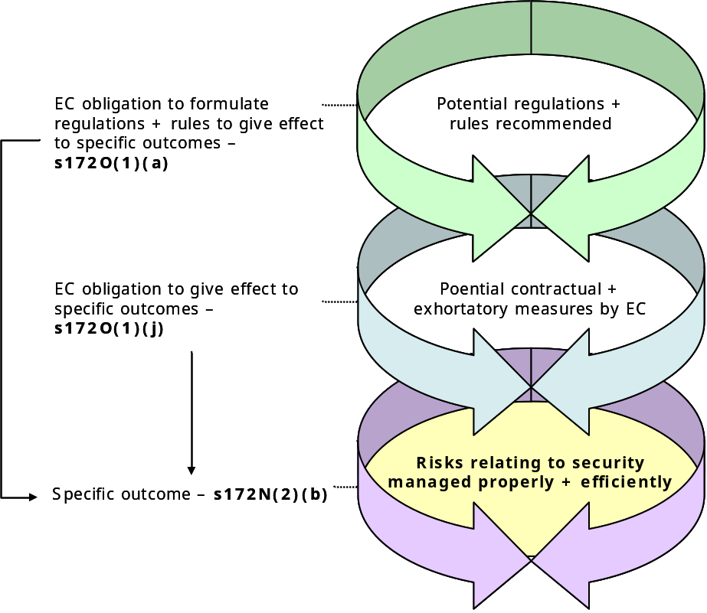

Part V: Implications and recommendations

Practical implications + recommendations

Risk of legal challenge
  - It is hard to assess the risks of a party successfully challenging the Commission’s performance of its functions under the Act. Clearly, a variety of legal causes of action are available to potential litigants, including:
    - Failure to carry out properly a statutory obligation;
    - Judicial review in relation to any statutory action or inaction by the Commission;
    - Breach of contract, where a measure or programme is put in place by contract;
    - Negligence in relation to any action or inaction by the Commission that causes reasonably foreseeable damage to a party to whom the Commission owed a duty of care.
  - The scope and probability of success of each potential cause of action clearly depends on the facts of any specific challenge. However, as a general observation, the Commission is a broadly equivalent position to any other party under the civil law, with the additional layer of possible challenge in relation to properly performing statutory obligations.

Steps to date
  - Since August 2004, the Commission has been in a process of consultation and advice to develop its security of supply policy. It has established the Security Advisory Group comprising industry and consumer members, with THE? Commissioner acting as chair. It has also issued consultation documents on:
    - Managing security to a 1 in 60 standard (‘security of supply policy development’);
    - Tendering for reserve energy;
    - Emergency risk management measures; and
    - An assessment of reserve energy requirements for 2005 and 2006 respectively.
  - As each of the relevant documents clearly sets out, the focus has been on how to interpret and implement the GPS provisions relating to security. The Commission seems to have adopted the GPS as its security policy. The steps to date are intended to develop practical processes to put the proposed GPS mechanisms into operation.
  - While this work to date is helpful from the perspective of giving effect to the Government’s wishes, it does not necessarily give effect to the Commission’s legal obligations. As discussed at length in this report, there a several significant ‘disconnects’ between the GPS and Act. Adherence to the GPS will not necessarily meet the broader requirements of the Act. However, the Act prevails – it determines the Commission’s obligations, not the GPS.

Statements on obligations
  - The Commission has made various statements in other publications and presentations on the nature and scope of its security obligations, for example:
    - The Commission “is responsible for managing the electricity sector so that electricity demand can be met in a 1 in 60 dry year, without the need for emergency conservation campaigns”;
    - “The Commission does not provide baseload generation”;
    - Its role is to “oversee security of electricity supply”;
    - The Act “recognises, among other things, the mixed public and private ownership of the industry”; and
    - “The Commission does not build new power plants or make decisions about what kind of new generation should be built”.
  - Unfortunately, these are not accurate representations of the Act or the Commission’s statutory obligations in relation to security.

Recommendations
  - Perceptions of responsibility for security of electricity supply are ‘fuzzy’, blurred by politics, poorly informed expectations, technical complexity, and lack of familiarity with managing security risks efficiently. This lack of clarity is not assisted by the poor design of the Act and the GPS.
  - To mitigate the risks of legal challenge, and to promote a better functioning electricity market, the Commission should set out clearly and accurately how it interprets, and intends to implement, its security obligations under the Act.
  - This report should be a useful first step. Next, the Commission should develop its policy on the key variables within the relevant statutory functions, and then publish a paper that sets out, for the market and other interested parties, how it interprets the Act’s requirements in relation to security, including:
    - The scope of the Commission’s obligations, recognising that they are extremely broad, and that the Commission is, in effect, the ‘default guarantor’ of security;
    - The target security standard required under section 172O(1)(d), recognising that, at law, ‘ensure’ sets an extremely high standard;
    - The Commission’s assumptions in relation to the degree to which prices reflecting scarcity of supply will be signalled to consumers, and therefore influence the level of demand in a shortage;
    - The range of security risks to be covered by the Commission, recognising that it is significantly wider than simply hydrology risk;
    - The wide range of mechanisms available to the Commission to provide security;
    - Legal parameters that apply in relation to reserve energy, recognising that the Commission is not currently constrained by the GPS parameters;
    - The Commission’s assumptions in relation to the amount of demand-side savings to be excluded from its assessment of security needs under section 172(1)(d), recognising that this is likely to lead to a higher supply margin than the market would otherwise provide;
    - The limits of ‘normal operation of the market’, beyond which the Commission is not required to minimise distortions; and
    - When the ‘material risk’ threshold is reached under section 172O(1)(g).
  - The Commission should also establish a process for checking that the Commission has the necessarily legal authority to put in place a proposed security measure. The decision should be checked against the Act to confirm that it fits within the legal parameters of the appropriate statutory function. This is a useful internal auditing process for all decisions.

Overview diagram
  - The combined effect of the Commission’s four security functions – sections 172O(1)(a), (d), (g) and (j) – can be summarised and represented in diagrammatic form as follows:
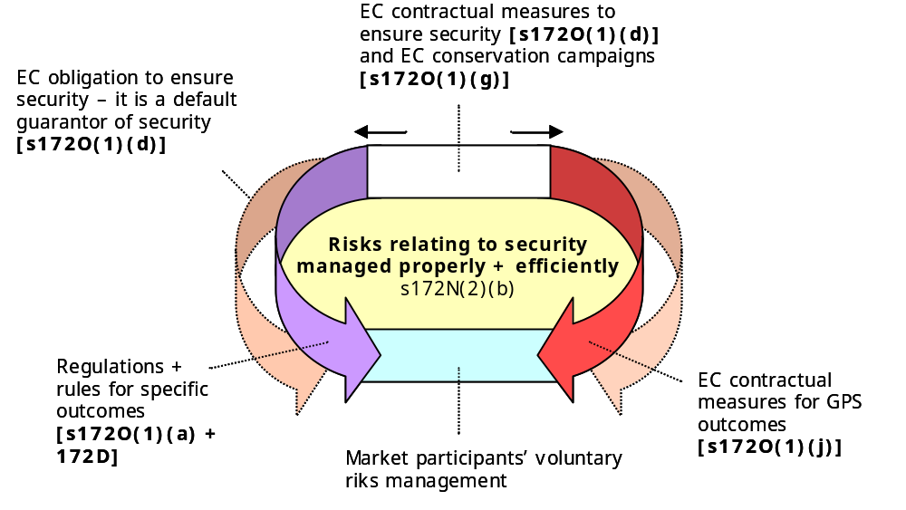

Part VI: Appendices

Appendix 1: Analysis of GPS security
GPS para | GPS content  (summarised) | ‘GPS objective or outcome’ | Required by another statutory function | Binding under Act | Comment
 | Background
35 | Security of supply is a key priority, vital to achieving Government’s objective of sustainable economic development | No | No | No | Contextual
36 | Key components of security of supply are sufficient capacity to meet demand growth, managing capacity and fuels to deal with dry hydro periods better, having sufficient reserve energy, and the grid and lines meeting specified reliability objectives | No | No | No | Contextual
 | Security of supply objective for the Commission
37 | A function of the Commission’s is [as set out in s172O(1)(d)] (to use reasonable endeavours to ensure security of supply) | No | Yes, s172O(1)(d) | Yes | Statutory function
37 | In particular, the Government wants the Commission to use reasonable endeavours to ensure security of supply in a 1 in 60 dry year | No | No | No | Next level down from an objective. See para [ ] of report
37 | The Commission should also work with stakeholders to identify industry contingencies and develop strategies consistent with the operation of the electricity market to achieve its security of supply objectives | No | No | No | Process
 | Information, modelling and forecasting
38 | The Commission should undertake and publish supply and demand modelling and forecasting | No | Yes, s172O(1)(e) | Yes | Mechanism
38 | The objective is to provide well-researched information on short and long term security of supply | Yes | No | Yes | GPS objective or outcome
39 | The Commission should ensure that public information is provided on thermal fuel availability, hydro lake levels, hydro spill and generation capacity | No | No, but  s172D powers | No | Mechanism
40 | The Commission should follow certain modelling processes to establish the need for additional reserve energy | No | No | No | Process
 | Security of supply policy
41 | The Commission should establish a security of supply policy, which should specify the steps it will take at various stages during a contingent event such as an extended dry sequence, and included reserve energy procurement policies | No | No | Yes | Process

GPS para | GPS content  (summarised) | ‘GPS objective or outcome’ | Required by another statutory function | Binding under Act | Comment
41 | The overriding objective is to give as much certainty as possible to the market | Yes | No, but  s172CA power | No | GPS objective or outcome
42 | The Commission should develop and publish an operational security of supply standard, possibly expressed as a loss of load expectation | No | No | No | Process
 | Minimum hydro zone
43 | The Commission should develop and publish a minimum hydro zone, with estimates of minimum storage required to avoid shortages in a 1 in 60 dry year. The zone is to take various factors into account | No | No | No | Mechanism
44 | The Commission should consult with interested parties on the hydro zone | No | No | No | Process. While not binding under the legislation, consultation would be required as a matter of good practice and probably under the common law
45 | The Commission should have a second zone that would trigger a conservation campaign (if worse than 1 in 60) | No | No, but s172O(1)(g) | No | Mechanism
 | Good processes
46 | In relation to its security of supply policies, the Commission should put in place good consultation processes, ensure transparency and stability, avoid ad hoc and discriminatory interventions, and have protocols to manage potential conflicts of interest | No | No | No | Process. Good consultation, transparency and non-discrimination probably required by common law. Some aspects of non-discrimination also covered by s172N(2)(d)
 | Reserve Energy
47 | The Commission is to contract for reserve energy to provide additional security beyond the level achieved by the ordinary market. This will be the primary mechanism for the Commission in endeavouring to ensure security of supply in a 1 in 60 dry year. Reserve energy should also be available to help cope with other unexpected contingencies | No | No, but s172(1)(d) + s172CA | No | Mechanism
48 | Reserve energy mechanism should operate as outlined below | No | No | No | Contextual
 | Quantity and type
49 | Portfolio of reserve energy should be limited to 1200GWh over any four months. Transmission constraints and other factors need to be taken into account | No | No | No | Parameters of a mechanism
50 | A firm maximum quantity is to ensure certainty as to the maximum role of the Commission, and to minimise the risk of reserve energy affective incentives | No | No | No | Contextual
GPS para | GPS content  (summarised) | ‘GPS objective or outcome’ | Required by another statutory function | Binding under Act | Comment
51 | The Commission should maximise static and dynamic efficiency in contracting for reserve energy. The flexibility of short term contracts should also be taken into account | No | No, but s172N(2)(a) | No | This first sentence has elements of an objective, however it is more like a set of factors to be taken into account in implementing a mechanism (reserve energy), which is to achieve the GPS objective or outcome of security of supply in para 37
52 | Generation plant for reserve energy should primarily comprise plant low fixed costs and high operating costs | No | No | No | Parameters of a mechanism
53 | The Commission should take into account the benefits of lower cost and potential detriments to security of supply and competition in the ordinary market | No | No | No | Factor in implementing a mechanism
54 | The Commission’s reserve energy portfolio should include contracted demand responses provided it is practicable and additional to normal demand-side responses | No | No, but reserve energy includes DSM | No | Parameter of a mechanism
55 | The Commission should publish its processes for procuring reserve energy | No | No | No | Process. Probably required by common law
56 | The Commission should seek to minimise impacts of reserve energy on the ordinary market | No | No,  but included in s172O(1)(d) | No | This is has elements of an objective, however it is more like a factor to be taken into account in implementing a mechanism (reserve energy), which is to achieve the GPS objective or outcome of security of supply in para 37
56 | The Commission should adopt tight ring-fencing (limiting the purposes for which reserve energy can be used) – to minimise affect on incentives | No | No | No | This describes how the factor (minimise impacts on the ordinary market) is to be delivered
57 | Reserve energy contracts should provide for fixed payments for availability and variable payments when it is used. Spot price revenues should go to the Commission for reducing reserve energy and other levies | No | No | No | Parameters of a mechanism
58 | The Whirinaki station will be available to the Commission for the purpose of reserve energy | No | Yes,  s18, 2004 Act | Yes | Contextual
59 | The Commission should not own reserve generation plant | No | No | No | Parameter of a mechanism. However, this could be covered in regulations under s172CA(1)

GPS para | GPS content  (summarised) | ‘GPS objective or outcome’ | Required by another statutory function | Binding under Act | Comment
 | Trigger mechanism
60 | Reserve energy should be offered at 20c/kWh or the variable payment, which ever is the higher | No | No | No | Parameter of a mechanism. However, this could be covered in regulations under s172CA(1)
61 | If the minzone is breached, reserve energy may be offered at a lower price to preserve hydro storage. The Commission should investigate why the Minzone is breached and all thermal stations are no being used | No | No | No | Parameter of a mechanism. However, this could be covered in regulations under s172CA(1)
 | Levy
62 | The Commission should recover some costs from sport market revenues. Net costs should be recovered initially by a levy | No | Yes in part, s172ZC(1A)(a) | Yes in part | Mechanism. Act does not require spot revenues to be paid to Commission, but could be covered in regulations under s172CA
63 | The levy will aim to recover the net costs the Commission incurs for reserve energy | No | No | No | Mechanism. Act does not require spot revenues to be paid to Commission, but could be covered in regulations under s172CA
 | Regulations
64 | The Government proposes to specify the key operational parameters of the reserve energy mechanism in regulations, to help provide regulatory certainty and minimise adverse impacts on incentives | No | No | No | Contextual + process
 | Review
65 | The Commission should contract an independent third party to review the efficiency and effectiveness of the reserve energy policy | No | No | No | Process
66 | The review should consider whether to relax the ring-fencing policy and use an alternative levy arrangement | No | No | No | Process
67 | The review should provide for public consultation and report to the Minister by 31 March 2007 | No | No | No | Process
 | Security of supply coordination
68 | Managing hydro lakes and thermal fuel use optimally is a key requirement for the secure operation of the NZ system | No | No | No | Contextual
68 | Risks of inadequate security of supply coordination will need to be monitored by the Commission | No | No, but within s172O(1)(d) | No | Mechanism
69 | The reserve energy mechanism may impact on security of supply coordination. There is a risk (for example) that lakes are run lower and thermal generators procure less fuel | No | No | No | Contextual
GPS para | GPS content  (summarised) | ‘GPS objective or outcome’ | Required by another statutory function | Binding under Act | Comment
70 | The Commission should minimise these risks by publishing information on lake levels, fuel availability, plant outage schedules and minimum hydro zone | No | No, but 172D(1)(2) powers | No | Mechanism
71 | The Commission is expected to monitor developments, recommending or requiring coordination tenders, minimum fuel provisions, and minimum contract offers by generators or purchases by retailers and other direct buyers | No | No, but s172D(1)(2) powers | No | Mechanism
 | Conservation campaigns during security of supply situations
72 | If there is a material risk of shortages (eg worse than 1 in 60 dry year), the Commission is expected to activate a conservation campaign in a timely manner | No | Yes,  s172O(1)(g) | Yes | This is a statutory function, not an objective or outcome akin to s172N
73 | The Commission is expected to ensure contingency arrangements are in place for the use of ripple control if conservation campaigns are required, and if events occur such as a major and unexpected plant or transmission line outage. | No | No, but s172D(1)(13) | No | Mechanism
 | Coordination of outages
74 | The Commission is expected to put in place arrangements for scheduling rolling outages in the extreme event of blackouts. It should recommend regulations and rules if required | No | No, but s172D(1)(14) | No | Mechanism

Appendix 2: Origin of obligation to ensure security

Outline
  - This section traces the legislative history of section 172O(1)(d) using reference material, external to the Act, that would be admissible in a court. This history is likely to be taken into account in interpreting the nature and scope of the Commission’s security functions.

2003 Policy
  - The Government’s policy package released in May 2003 provided for the Commission “to ensure the electricity industry meets [a] 1 in 60 security standard”. It was not, at that stage, qualified by having to ‘use reasonable endeavours’, or to ‘minimise market distortions’. In isolation, ‘ensure’ set an extremely high standard. Its plain and ordinary meaning is “to make certain that something will occur; guarantee”.
  - Following its May 2003 announcement, the Government obtained external advice on how a Commission should implement this policy, including a ‘practical working definition’ of the 1 in 60 security standard. Among other things, the Morrison & Co report pointed out that the Government’s policy was unclear on the meaning and effect of ‘ensuring’ security. The report asked:
    - Whether the Commission was to use ‘reasonable endeavours’ or ‘best endeavours’; and
    - Whether the obligation would relate only to security, or to achieving some balance of objectives.
  - The report proposed that supplementary objectives should be satisfied in seeking to ensure a 1 in 60 security standard, including:
    - Minimising national costs. This criterion was proposed to guard against the Commission building a large amount of reserve capacity. The report suggested that the most important way to minimise national costs was to minimise barriers to competition in generation and retail; and
    - Minimising distortions to electricity market. This criterion was proposed to guard against the Commission contracting a large amount of generation on a long term basis. The report advised that such an approach by the Commission would represent a very substantial intervention in the market and result in high economic costs to the economy, without necessarily improving security.
  - Morrison & Co concluded that:
    - “Requiring the Commission to use best endeavours to ‘ensure’ security without explicit reference the secondary objectives [proposed in its report] would inevitably lead it to very costly and substantial interventions in the market, or to [the Commission] being excessively conservative about the many factors beyond its direct control”; therefore –
    - “[Our] working assumption is that the Commission uses ‘reasonable endeavours’ so it can trade-off the level of intervention against the cost to the nation and the distortion to the market”.
  - However, this view on the effect of adding ‘reasonable endeavours’ to the obligation to ‘ensure’ is based on economic policy. As discussed below, it does not accord with the normal legal interpretation of ‘reasonable endeavours’.

Draft GPS and EGIB
  - Morrison & Co’s recommendations seem to have been adopted by the Government. The September 2003 draft GPS (which pre-dated the EGIB) proposed specific outcomes where:
    - “Barriers to competition in electricity industry are reduced for the long-term benefit of end-users” – and
    - “Risks (including price risks) relating to security of supply are properly and efficiently managed. In particular, the Government wants the Commission to use reasonable endeavours to ensure security of supply in a 1 in 60 dry year, without assuming any reduction in demand from emergency conservation campaigns, while minimising distortions to the normal operation of the market”. ^{[Italics added]}
  - The words in italics were transposed into the EGIB (and now the Act). Put simply, part of a draft GPS specific outcome was inserted into the Act as a function. Three features of this ‘cut and paste’ stand out:
    - Expressing part of an objective as a function creates uncertainty. Ensuring security of supply is an objective, which belongs with the other principal objectives or specific outcomes. The actual function relevant to achieving this objective under section 172O(1)(d) (as distinct from the other functions) is contracting for reserve energy and putting in place other security of supply measures on a contractual or exhortatory basis;
    - The draft GPS reference to ‘dry year’ was not transposed into the EGIB or the Act. If it had been, the range of security risks for which the Commission is responsible would have been limited primarily to hydrology. Without the reference to ‘dry year’, the range of risks to be managed is not limited; and
    - The draft GPS reference to a ‘1 in 60’ was also not transposed into the EGIB or the Act. Without it, the Act does not prescribe a specific security standard.
  - In the period following the EGIB’s introduction, the revised drafts of the GPS continued to limit the range of risk largely to low hydro inflows. Why were ‘1 in 60’ and ‘dry year’ not included in the EGIB? Several reasons are likely. ‘1 in 60’ was probably omitted because:
    - It was viewed as too technical and arbitrary a statute;
    - Future Governments may wish to change it;
    - While standards of this sort are better suited to regulations, officials may have assumed (incorrectly) that the GPS would have a legal effect equivalent to a regulation;
    - Officials viewed ‘1 in 60 dry year’ as a single integrated expression, not recognising its two distinct defining components – that is, the range of risks to be managed (hydrology) and the target standard (1 in 60). When excluding ‘1 in 60’, officials are likely to have automatically excluded ‘dry year’ as if it were part of a single expression; and
    - Officials recognised that the legal and practical meaning of ‘1 in 60 dry year’ is not clear. This lack of clarity is discussed further below.

Disjunction between EGIB and GPS
  - The exclusion of ‘1 in 60 dry year’ resulted in a disjunction between the EGIB and there draft GPS, where:
    - The EGIB as introduced had no legal limits on the range of security risks for which the Commission would be responsible, nor a precise definition of the target probability of shortage, while –
    - The draft GPS (until August 04) was largely confined to hydrology risk, with a defined target security standard.
  - Following the Commerce Select Committee’s report on the EGIB in late June 2004, the Government issued a revised draft GPS in July 2004, which:
    - Changed the specific outcome in the GPS relating to security of supply by deleting the second sentence referring to a 1 in 60 dry year (so the GPS and EGIB specific outcomes became the same); however –
    - Did not change the security of supply objective in the draft GPS. It still set a ‘1 in 60 dry year’. The disjunction between the EGIB and draft GPS therefore continued.
  - The Government sought to address the inconsistency in its August and September 2004 drafts of the GPS. In those drafts, the security of supply objective was changed to re-state the EGIB security function. However, two elements were added in the draft GPS:
    - The ‘1 in 60 dry year’ target was re-inserted as a separate sentence, making it a point of emphasis, not a parameter; and
    - New words were added requiring the Commission to “work with stakeholders” to “identify industry contingencies.
  - In effect, the Government seemed to acknowledge that, under the EGIB, the range of risks was unlimited and the security standard undefined. It is unlikely that this outcome was intended. The two add-ons referred to above were an attempt to impose some boundaries, while avoiding any changes to the EGIB.

Reason for disjunction
  - So why was the EGIB not clarified to reflect more accurately the Government’s original 1 in 60 dry year policy? Three reasons are possible:
    - The Government was constrained by timing and drafting sensitivities among members of the Select Committee. By August 2004, only very minor technical changes to the EGIB were acceptable;
    - The Government’s policy position on the scope of the Commission’s security of supply responsibilities was (and still is) ambiguous. It is likely that the Government was not (and is still not) sure what the boundaries should be. This is reflected in the layers of often confusing and imprecise language in the GPS and Act; and
    - The Government’s view on the Commission’s security of supply role is likely to have evolved between the EGIB’s introduction in October 2003 and its enactment in October 2004. I would surmise that the wide scope of the security obligation proposed under the EGIB was not intended. The Government no doubt assumed that the narrower GPS provisions would prevail. Though it may have been late in the Parliamentary process when officials focused on the implications of the EGIB prevailing, the wide scope of the security obligation set out in the EGIB emerged as a convenient accommodation for the ambiguity underlying the Government’s policy.

Key conclusions
  - Some key conclusions from this section of the report:
    - The 2004 Amendment has been poorly drafted. Parts of a draft GPS were transposed into the EGIB, without a great deal of apparent care or thought in relation to the legal meaning and effect of the statutory words, or in relation to how the GPS and the Act would inter-relate at law;
    - It has been widely assumed that the GPS is a binding legal instrument that effectively governs the manner in which Commission is to meet its security obligations under the Act. This is not correct at law;
    - Several key GPS requirements have not been reflected in the Act; for example, the 1 in 60 dry year standard, and the parameters of the reserve energy mechanism. These are not binding on the Commission. As discussed in section [5] above, the GPS is not legally binding on the Commission except in relation to high level objectives and outcomes;
    - Section 172O(1)(d) confuses the objective of ensuring security with the function of contracting measures to achieve it; and
    - While several key provisions in the 2004 Amendment have been transposed from earlier drafts of the GPS, the law requires the Act to be interpreted on its own terms, consistent with the rules of statutory interpretation. Legal definitions for key expressions in the Act are not derived by transposing intended or implied meanings from the GPS.

Appendix 3: History of electricity security in New Zealand
  - The history of security of supply in New Zealand is also relevant to our analysis. It provides further context against we can view the current regime. This Appendix sets out a neutral summary of the history of security of supply in the electricity industry since the early 1900s.

Until 1988: Pre-corporatisation

Industry structure
  - Apart from some early projects in the late 1800s, the New Zealand electricity system was developed by local authorities and central government. In 1918, power boards or local councils became exclusively responsible for local distribution networks and electricity supply within their respective network areas. Central government was responsible for developing large scale generation and the transmission system.
  - Culy points out that “[d]uring most of this period, the electricity sector was structured as a combination of national and regional statutory monopolies with public ownership and control at both the state and local level. At the local level, control was exercised by councils and publicly elected boards. At the State level, control was exercised through the normal departmental procedures that were characterised by very rigid constraints, centralised bureaucratic systems, mixed objectives and lack of effective delegation and accountability”. Licences from the Minister were required to generate and sell electricity.
  - “The Minister of Electricity or Energy was directly responsible for approving wholesale tariffs, and all investments of any significant size were approved by the Cabinet Works Committee. Short term political and fiscal factors, both national and regional, played a significant, if not dominant, role in pricing and investment decision making. The nature of the decision making and accountability systems meant that little attention was paid to risk assessment, monitoring and control of investment projects”.

Security of supply
  - Security of supply during this period was variable. As shown in the following figure, 10 significant shortage events occurred between 1946 and 1988.
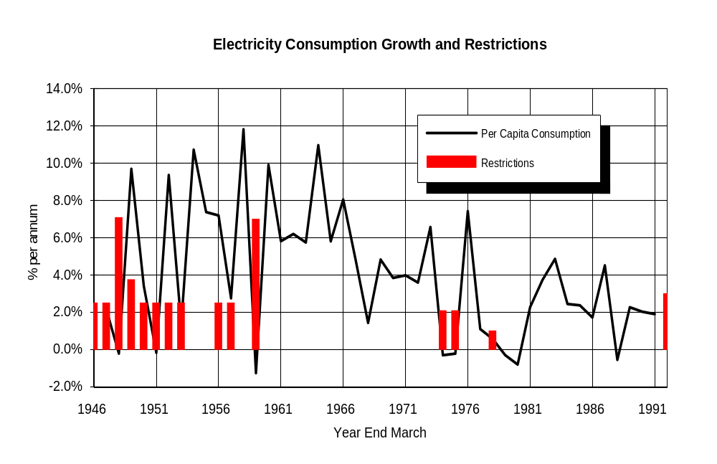
  - In the figure above, the height of the column represents the relative extent of the restrictions in terms of depth and duration. The impact of the restrictions on consumption is approximately indicated by the dips in the annual growth in per capita consumption of electricity.
  - The nature of each shortage event is described below:
Period | Issue
1942 | Use of space heaters and radiators prohibited during peak hours between May and August in the North Island
1943 | Space heating was controlled further, and so too were indoor and outdoor lighting
1946 | 20% power cuts imposed in the North Island
1947 | 30% power cuts imposed in the South Island
1958 | A 15% cut was imposed in the North Island
1973 | Supply authorities were requested to save up to 6%. Broadcasting hours were reduced, ripple control was increased and in some areas there were daily blackouts.
1974, 1975, 1976, 1977 | Government requested "voluntary" savings  Source: Appendix 3, Report of the Electricity Shortage Review Committee 1992

1988 to 1996: ECNZ pre-market

Industry structure
  - In 1988, the Electricity Division of the Ministry of Energy was corporatised to form the Electricity Corporation of New Zealand (ECNZ). It was established with over 95% of the generation and full control of the bulk transmission network, but without a legal duty to supply electricity.
  - The power boards and municipal electricity departments of local councils were corporatised in 1992, with a legal duty to continue to provide line services, but not energy. All retail franchise areas were removed by 1994. By a shareholding Minister’s direction under the SOE Act 1986, ECNZ was prohibited from acquiring any significant share in any electricity supply authority (now energy company).

Real time security
  - In 1994, ECNZ’s transmission assets were transferred to Transpower, a new stand alone State-owned enterprise. Legislation did not require Transpower to ensure any level of security or quality of supply. These were matters for Transpower’s directors to determine in the course of meeting the statutory objective of operating as a successful business under section 4 of the SOE Act.
  - Under section 5 of the SOE, all decisions relating to the operation of a State enterprise are to be made by or pursuant to the authority of the board in accordance with its statement of corporate intent. It is likely that Transpower’s statements of corporate intent during this period included, in the description of Transpower’s principal activities, the role of matching supply and demand in the short term, and coordinating ancillary services (including voltage and frequency control).
  - Under the then Government’s policy statement on transmission, “technical and commercial risks inherent in operating the transmission system [were to be] allocated where they [were] most efficiently and effectively managed”. In practice, Transpower decided security and quality levels on the grid, consulting with its customers but often not reaching agreement. It acted as the system operator, dispatching generation and matching real time supply and demand. Transpower also coordinated the provision of ancillary services, including voltage and frequency control. Instantaneous reserves were provided primarily by ECNZ.

Seasonal security of supply
  - In relation to seasonal security of supply (dry year risk), hydro storage levels were centrally managed by ECNZ, which estimated the opportunity of using water in the current period relative to holding water for future use. The opportunity cost (the ‘water value’) was derived from the fuel cost of thermal stations.
  - Required hydro storage levels were set to ensure ‘normal’ demand could be met if inflows were at least equal to the lowest recorded inflows over a certain number of the previous years. Between 1998 and 1992, it was the previous 20 years. From 1992 to 1996, it was the previous 60 years. However, these parameters were operating policies set by ECNZ. Neither was a legal requirement.
  - ECNZ published ‘spot prices’ a week ahead. The spot price setting process was internal to ECNZ. In essence, ECNZ matched an internal forecast of demand against an internal forecast of available generation. Prices were set at the marginal cost of the highest cost station expected to run in each half hour.
  - However, prices were capped at 15c/kWh (the cost at the time of oil fired generation at the old Whirinaki plant). As a result, prices could not rise in a dry year to reflect the full risks of shortage and ensure that electricity supply and demand were in balance. Electricity prices continued to have a significant political profile as evidenced by the 1992 Select Committee Inquiry into Electricity Pricing.
  - ECNZ maintained medium term reserves in the form of hydro buffer stocks and ‘hydro firming’ back up thermal capacity. These reserves were supplied as a ‘public good’, the costs of which were recovered from all customers by a mandatory ‘pool price margin’. Different values of non-supply for different customers were not recognised. Alternative and less costly insurance options were effectively excluded.
  - As in the pre-corporatisation period, if reserves were insufficient to meet demand in a shortage, ECNZ relied on conservation campaigns and physical rationing on a nation-wide basis.

Longer term security of supply
  - On corporatising ECNZ, the requirement to obtain a licence from the Minister to build new generation, and the traditional legal obligation on the State to supply, were removed. A key objective was that new investment should take place on a competitive and commercial basis, with independent generation initiatives competing to meet demand growth. Greater dynamic efficiency was viewed as probably the most important aspect of overall economic performance in electricity generation.
  - However, ECNZ remained a near monopoly and, in reality, managed longer term security based on its forecasts of future supply and demand. No significant ECNZ or independent new generation was commissioned during this period. As Culy observed, “[t]he surplus of capacity and relatively low growth rates in demand meant that design and construction of new plant was not a major priority for [ECNZ]”.
  - Decisions relating to the longer term security of the transmission grid were for ECNZ until 1994, then Transpower, to determine in the course of meeting the statutory objective of operating as a successful business under section 4 of the SOE Act.

Summary
  - In summary, ECNZ set a uniform security standard that was delivered by a single (supply side) mechanism with a uniform charge. This relatively costly and inflexible approach was physically possible while ECNZ controlled over 90% of generation assets and nearly all hydro storage. In effect, ECNZ internalised the risk within its balance sheet.
  - Legislation imposed no obligations in relation to security of supply. However, there was an implicit political and industry expectation that ECNZ and Transpower (from 1994) would ensure it to a relatively high level of security.

1992 Shortage
  - There was one major shortage event between 1988 and 1996. In 1992, hydro inflows were very low. The dry sequence started in March. The storage lakes reached their lowest point in June when the consequences of running were greatest.
  - An industry committee was established to manage the industry’s response. It was overseen by a Ministerial committee chaired by the Prime Minister. A large publicity campaign was put in place to reduce demand. Water heating was generally cut for 18 hours a day, and Comalco closed one of its three potlines. Emergency legislation was passed provide access to additional hydro fuel in Lake Pukaki. No physical rationing was required.

Government’s response
  - The Government set up an independent committee to review the 1992 shortage. It recommended that:
    - ECNZ’s security standard should be reviewed. Until the review was completed, the standard should in 1 in 60;
  - Better early warning mechanisms for low storage levels should be put in place;
  - The 15c/kWh price cap should be removed;
  - Communications and information flows with customers and the public were required;
  - ECNZ’s modelling should be improved, with increased research into forecasting, better testing of assumptions and improved demand information from power boards;
  - ECNZ should provide longer term flexible contracts; and
  - Financial incentives for demand reductions should be offered, together with increased awareness of energy efficiency opportunities.
  - The inquiry also noted a trend (even then) for statutory resource consents to limit flexibility of operations.
  - Between 1993 and 1996, ECNZ adopted the recommended interim 1 in 60 security standard.

1996 to 2004: Initial wholesale market

Industry structure
  - In 1996, about 27% of ECNZ’s generation assets were transferred to Contact Energy. An independent wholesale market was established by multilateral agreement among industry participants. By an agreement with its shareholding Ministers, ECNZ was restrained in the amount of new capacity it could build. ECNZ was also required to offer a high level of its firm capacity to customers on long term contracts.

Short term security of supply
  - Legislation continued to impose no legal obligations on any party in relation to short term security of supply. However, Transpower’s statement of corporate intent was changed in 1998 to provide that Transpower’s responsibilities in relation to system coordination and real time electricity security were to be governed by contracts with customers. In the process of agreeing the contracts, it was intended that customers would made trade-off choices between alternative levels of service (including grid security) and Transpower’s prices for each service level.
  - In late 1999, the industry established the Grid Security Committee under MACQS, which established a process to agree rules to allow standards to be set for common quality, including security, a contractual structure for implementing agreed common quality standards, and robust monitoring, compliance and dispute resolution process. However, MACQS never became operational.
  - In 2000, the Government issued a new Government Policy Statement under section 26 of the Commerce Act, which (among other things) stated that transmission services “should be provided at the standards of quality and security required by [grid] users through a process of agreement with those users, of the Electricity Governance Board on behalf of users”. It was intended that choices between prices and standards would be made by customers. This policy was reflected in Transpower’s statements of corporate intent until 2003.
  - In reality, the management of real time security of supply was largely unchanged with the introduction of the market. Transpower still determined the amount of reserve that was required and entered into contracts with generators and consumers to provide reserve services. Prices for reserves were published every half hour and participation by interruptible demand increased significantly. Common quality standards (including security) on the grid were also determined by Transpower.

Seasonal security of supply
  - In 1995, the Government issued a policy statement on dry year risk. While it had no legal force, it advised the industry and public at large that with the formation of Contact Energy and an external wholesale market in 1996:
  - ECNZ would cease to manage on a central basis. ECNZ and Contact would meet dry year risks to a standard established in contracts with wholesale buyers. Neither company would have any implicit obligation to supply or protect wholesale buyers if they do not have appropriate contractual arrangements;
  - Spot prices for electricity would be uncapped, pointing out that in dry periods spot prices could be expected to rise to very high levels;
  - Wholesale buyers could manage this volatility by contracting with generators, developing demand-side management strategies or arranging back-up generation;
  - Wholesale buyers should take a prudent approach to managing their exposure to dry year risk;
  - The Government would not step in to protect wholesale buyers who chose not to take out adequate protection. Such action by the Government would in fact increase the likelihood of future supply shortages by undermining the incentives on buyers and sellers to put in place effective insurance mechanisms.
  - In 1998 and 2000, the Government issued further policy statements in relation to electricity supply risk. The 1998 version accompanied the further break up of ECNZ into three competing SOEs. The 2000 version accompanied the Government’s decisions on the recommendations of the 1999/2000 Ministerial Inquiry into Electricity. Both policy statements reiterated that:
  - Responsibility for managing dry year and other supply risks rested with market participants;
  - The Government would not step in to protect buyers and sellers who failed to provide adequate protection;
  - Spot prices were uncapped and could rise to very high levels in a shortage;
  - A range of mechanisms was available to market participants to provide protection.

Longer term security of supply
  - Legislation during this period did not impose any obligations on generators, Transpower or retailers in relation to longer term security of supply. Responsibility for security continued to rest with market participants. The policy objective was that each party would put in place protection mechanisms that reflected their respective risk profiles and the value of non-supply, with an overall outcome that would, over time, be lower cost than a centralised uniform approach.

2001 shortage
  - In hydroelectric terms, 2001 was the worst drought experienced in the previous 71 years for the first seven month period of each year. It was worse than the shortage in 1992. It was also very cold. In June-July, demand was 5.8% higher than the same period in the previous year. The dry sequence started in March. Spot prices increased dramatically. However, most of the load was on variable quantity tariffs and hence there were no direct financial incentives for many customers to respond. A 10% nation-wide conservation campaign ran from late July until mid September. Some demand exchange arrangements were put in place. The industry also agreed a protocol for common quality standards to be reduced to enhance energy transfers. No compulsory physical rationing was required.

Government’s response
  - The main conclusions of an officials’ review of the 2001 shortage were that:
  - The electricity price spot market worked much as expected during winter 2001, with very high prices signalling an increasingly tight supply situation and record demand;
  - The market would have worked better if the reforms specified in the Government Policy Statement of the day had been fully implemented (such as improved information disclosure, demand-side participation in the market, and mechanisms to invest in the grid to relieve transmission constraints);
  - Some major retailers and large users were seriously under-hedged against dry-year spot prices. Although hedges were available, several years of surplus generating capacity and record low spot prices affected buyers' assessments about investing in hedges;
  - As a consequence of experience in 2001, increased awareness of dry-year risk is likely to result in better risk management. More sophisticated (and liquid) hedge and contracting arrangements are likely to emerge. An insurance mechanism to cover transmission losses and constraints would be desirable; and
  - New Zealand is facing the need to build new generation capacity in the next few years to meet rising demand. This means that wholesale market prices on average are likely to trend towards long run marginal cost (LRMC) which is set by the cost of new generating capacity. This will also lead to upwards pressure on retail prices, as retail margins adjust back to long-term averages.
  - A range of options and mechanisms were considered, including earlier disclosure of spot offers, separation of retail and generation and compulsory hedge offers. The Government accepted officials’ advice that the market would self-correct, with an appropriate warning from the Government.

2003 shortage
  - The dry year sequence in 2003 started in January. The first five months were similar to 2001, building an accumulated deficit of 2,000-2,500 GHw. Average monthly spot prices reached $200 MWh. The 2003 low inflows were compounded by a significant reduction in the available natural gas from the Maui field.
  - A shortage taskforce was established by the industry’s Grid Security Committee, which developed a nation-wide conservation plan, a fuel disclosure programme, protocols to reduce local transmission quality to increase energy transfers, and arrangements to coordinate generation outages.

Government’s response
  - Back in October 2002, Ministers had started to consider options for addressing security of supply issues relating to the provision of new generation to meet demand growth, and the transition to new fuel sources with the depletion of the Maui gas field. In February 2003, Cabinet established a group of Ministers to consider and develop the Government’s policy and response on infrastructure issues.
  - The extreme dry period starting in January 2003, following so closely after the 2001 event, significantly heightened the Government’s sense of unease. As the Minister of Energy emphasises in a paper to Cabinet, “[s]ecurity of electricity supply has become a serious concern to the Government and the wider community, and the lack of secure supply poses a significant risk to New Zealand’s sustainable economic growth”.
  - With the failure in May 2003 of the industry’s self-governance proposal to achieve the required levels support, the Government appointed the Electricity Governance Board (EGB) under the Electricity Act, and announced its intention to introduce legislation transforming the EGB into an Electricity Commission. The Commission, would, among other things, would be responsible for managing “the sector such that electricity demand can be met in a 1 in 60 dry year without the need for national conservation campaigns. This standard would have avoided conservation campaigns in 1992 and 2001 – and, so far, this year”.
  - The Government considered that, since it was formed, “the market – the industry – has been deemed responsible for managing dry year risk. It has not done that to our satisfaction”. “Infrastructure Ministers have concluded that the current policy settings for electricity are unlikely to ensure an acceptable level of supply security”.

Appendix 4: Bibliography
- Borenstein, Bushnell and Knittel (1999): Severin Borenstein, James Bushnell and Christopher Knittel, “Market Power in Electricity Markets: Beyond Concentration Measures”, February 1999, University of California Energy Institute
- Bower (2004): John Bower, “Blackouts: Invest, Intervene or Inveigh?”, Research Seminar, Oxford Institute of Energy Studies, UK, 2004
- Cabinet Paper (2001): “Power Winter Electricity Review”, from the Office of the Minister of Energy to the Chair, Cabinet Finance, Infrastructure and Environment Committee, 2001
- Cabinet Paper (2003): “Electricity Security of Supply: Policy Settings”, from the Offices of the Minister of finance and Energy to the Chair of the Cabinet, 2003
- COAG (2002: The Council of Australian Governments, Energy Markets Review, 2002
- Commerce Commission (1996): Decision 280 relating to an application by the Electricity Market Place Company for an authorisation of proposed electricity wholesale market rules, ISSN No 0114-2720
- Commerce Commission (2002): Decision 473 relating to an application by the Electricity Governance Board Limited for an authorisation of rules relating to the trading and delivery of electricity, ISSN No 0114-2720 J5010
- Concept Consulting (2004a): Concept Consulting Group Limited, “Draft Discussion Paper on Developing Emergency Security of Supply Provisions”, prepared for the Electricity Commission, September 2004
- Concept Consulting (2004b): Concept Consulting Group Limited, “Draft Discussion Paper on Tendering and Contracting for Reserve Energy”, prepared for the Electricity Commission, July 2004
- Concept Consulting (2004c): Concept Consulting Group Limited, “Draft Discussion Paper on Developing a Security of Supply Policy”, prepared for the Electricity Commission, July 2004
- Culy (1992): John Culy, “Electricity Restructuring: Towards a Competitive Wholesale Market”, Address to the Annual General Meeting of the New Zealand Institute of Economic Research, October 1992
- Culy (1995a): John Culy, “The Value Implications of Dry Year Risk Management Regimes”, Final Report to the Officials Committee on Energy Policy, May 1995
- Culy (1995b): John Culy, “Mandatory Security Hedges: Implementation Issues”, Report to the Officials Committee on Energy Policy, May 1995
- Culy (1995c): John Culy, “Managing Dry year Risk in a Fully Competitive Market: Issues and Options”, Report to the Officials Committee on Energy Policy, May 1995
- Evans and Quigley (2003): Lewis Evans and Derek Quigley, “Competitive and Centrally Planned Decision Making in the Electricity Industry”, May 2003 Supplement, New Zealand Institute for the Study of Competition and Regulation
- EEA (2000): Electricity Engineers’ Association of New Zealand, “Guidelines for Security of Supply in New Zealand Electricity Networks”, June 2000
- Farrier Swier (2002): Farrier Swier Consulting, “Analysis of Electricity Capacity Market: A Report prepared for the Australian Competition and Consumer Commission, April 2002
- Guthrie + Videbeck (2003): Graeme Guthrie and Steen Videbeck, “Approaches to Assessing Market Power in Electricity Market”, a presentation for the New Zealand Institute for the Study of Competition and Regulation, September 2003
- Hogan (2001a): William W Hogan, “Electricity Market Restructuring: Reforms of Reforms”, a paper to the 20th Annual Conference of the Centre for Research in Regulatory Industries, Rutgers University, 2001
- Hogan (2001b): William W Hogan, “Designing Market Institutions for Electricity Network Systems: Reforming the Reforms in New Zealand and the US”, a paper for the Utility Convention, 2001
- Hogan (2002): William W Hogan, “Market Power and Electricity Competition”, a paper to the American Bar Association, April 2002
- IEA (1996): International Energy Agency, Electricity Reform: Power Generation Costs and Investment, IEA/OECD, 1996
- IEA (2002): International Energy Agency, Security of Supply in Electricity Markets: Evidence and Policy Issues, IEA/OECD, 2002
- Infratil (2001): Infratil NZ Limited, “New Zealand Electricity: Lessons from the Winter of 2001”, Infratil Update, September 2001
- Joskow (2002a): Paul L Joskow, “Electricity Sector Restructuring and Competition: A Transactions-Cost Perspective”, The Economics of Contracts: Theories and Applications, Bronseeau and Glachant (ed), Cambridge University Press, 2002
- Joskow (2002b): Paul L Joskow, “Resource Adequacy Obligations”, December 2002
- Joskow (2002c): Paul L Joskow, “Electricity Sector Liberalisation: Lessons Learned”, a presentation to a conference in Oviedo, Spain, July 2002
- Joskow + Tirole (2004): Paul L Joskow and Jean Tirole, “Reliability and Competitive Electricity Markets”, Centre for the Study of Energy Markets, University of California Energy Institute, April 2004
- LECG (2003): Teece, Wilk and others, “California’s Electricity Markets: Structure, Crisis, and Needed Reforms”, January 2003
- Lieb-Doczy, Borner + MacKerron (2003): Enese Lieb-Doczy, Achim-Rudiger Borner and Gordon MacKerron, “Who Secures the Security of Supply? European Perspectives on Security, Competition and Liability”, The Electricity Joural, December 2003
- Littlechild (2001): Stephen Littlechild, “Electricity: Regulatory Developments Around the World”, The Beesley Lectures on Regulation Series XI, IEA/LBS, 2001
- MacKerron + Lieb-Doczy (2003) [of NERA]: “Balancing Security and Liberalisation”, Power In Europe, September 2003
- Morrison & Co (2003a): “Submission on the Proposed Reserve Generation Scheme”, June 2003
- Morrison & Co (2003b): “Issue Concerning the Reserve Generation Proposal”, August 2003
- Priddle (2002): Robert Priddle, Executive Director of the IEA, “Security of Supply in Liberalised Electricity Markets”, a paper to the Eurolectric Annual Convention, June 2002
- NERA (2002): National Economic Research Associates, “Security in Gas and Electricity Markets: Final Report for the Department of Trade and Industry”, October 2002
- Ofgem (2004): The Office for Gas and Electricity Markets [The British gas and electricity regulatory authority], “All About Ofgem”, available at www.ofgem.gov.uk
- PA Consulting (2004): PA Consulting Group Limited, “Preliminary Report on Options for Security of Supply Interventions in the Electricity Market”, prepared for the Electricity Commission, 2004
- Scott (2003): John Scott, Technical Director, The Office of Gas and Electricity Markets (Great Britian’s gas and electricity industries regulator), “Security of Supply: A View from the UK”, CAE/IEE Conference, November 2003, NZ
- Smith (2004): Steve Smith, Managing Director (Markets), Ofgem, “Can the Current Market Deliver Security of Supply? The Regulator’s View”, paper for the UK Institute of Electricity Engineers, July 2004
- Turner + Murray (1997a): Dr Keith Turner and Kieran Murray, “Security of Supply in a Competitive Market”, prepared for the Officials Committee on Energy Policy, December 1997
- Turner + Murray (1997b): Dr Keith Turner and Kieran Murray, “Competition in Electricity Generation – Options for a Further Split of ECNZ”, prepared for the Officials Committee on Energy Policy, August 1997
- UK Energy Review (2002): “The Energy Review”, A Performance and Innovation Unit Report, UK Energy Review, February 2002
- Wolak (undated): Frank Wolak, “Measurements and Mitigation of Market Power in Wholesale Electricity Markets” [a power point presentation], Stanford University

R v Barnet London Borough Council, ex parte Shah [1983] 2 AC 309 at 341
Excluding emergency conservation campaigns, as discussed later in this report
Paragraph 38 of the GPS
Paragraph 41 of the GPS
Priddle (2002). The prominence of security as a key issue reflected in the range of policy reviews carried out in many countries over recent years, some of which are mentioned in the bibliography in Appendix [ ] of this report
NERA (2002) at p4
A ‘public good’ is a product or service with two characteristics: (i) consumption of the good by one party does not reduce the amount available for other consumers and (ii) once it is provided to one consumer, there is no way that other consumers can be prevented from accessing it. This is discussed further in Appendix [ ] at paragraph [ ]
Joskow (2002a) at p523. See also Appendix [ ], which summarises NZ’s history of physical rationing
A brief overview of international trends is set out in section [ ] below and Appendix [ ]
IEA (2002) at p12
Evans and Quigley (2003)
R v Barnet London Borough Council, ex parte Shah [1983] 2 AC 309 at 341 per Lord Scarman
Most of the cases and authorities referred to in this section of the report are drawn from Statute Law in New Zealand, Prof J F Burrows, 2003, 3rd edition
Kingston v Keprose Pty Limited (1987) 11 NSWLR 404 at 423
Statute Law in New Zealand, Prof J F Burrows, 2003, 3rd edition, at p154
For example, Haira v Burbeery Mortgage Finance & Savings Limited [1995] 3 NZLR 396 at 404 per Richardson J
Note the Interpretation Act 1999 – Section 5(2) - The matters that may be considered in ascertaining the meaning of an enactment include the indications provided in the enactment Section 5(3) - Examples of those indications are preambles, the analysis, a table of contents, headings to Parts and sections, marginal notes, diagrams, graphics, examples and explanatory material, and the organisation and format of the enactment
Hanlon v Law Society [1981] AC 124 per Lord Lowry. The Electricity Governance Rules may provide some assistance in this regard
Marac Life Assurance Ltd v Commissioner of Inland Revenue [1986] 1 NZLR 694 at 699 and 713
Telecom Corporation of NZ Limited v Commerce Commission [1992] 3 NZLR 429 at 449 per McKay J
Since 1984 our Courts, most notably the Court of Appeal, have made express their abandonment of the old strict exclusionary rule – it is now clear that the Courts accept they have a discretion to admit and use parliamentary history, even parliamentary debates. They do so frequently: Marac Life Assurance Limited v Commissioner of Inland Revenue [1986] 1 NNZLR 694 and NZ Maori Council v Attorney-General [1987] 1 NZLR 641. However, as Prof Burrows notes, nearly all the NZ cases where statements discovered in parliamentary history have been used in the interpretative process they have been used to confirm an interpretation suggested by other factors in the wording and context of the statute.
Statute Law in New Zealand, Prof J F Burrows, 2003, 3rd edition at [ ]
Prebble & Others v Huata, with judgement delivered on 18 November 2004; and Zaoui v The Attorney-General, with judgement delivered on 9 December 2004
Prior to 1996, ECNZ operated a highly administered week-ahead pricing system
Commerce Commission Decision No.280, 13 September 1986.
Including the laws relating to competition, contract, tort, fair trading and so on
June 1995, April 1998, December 2000 and May 2003
Metering and Reconciliation Information Agreement
MARIA also allows consumer and retail prices to be linked by a system called ‘profiling’. It matches quantities under contracts between retailers and consumer (on the one hand) and retailers and generators (on the other)
The NZEM (New Zealand Electricity Market)
In 1999, this became the Grid Security Committee
The Multilateral Agreement on Common Quality Standards. Authorised by Commerce Commission Decision No.369
This description of MACQS is taken from Commerce Commission Decision No.473 at para 39. Note that MACQS never become operational as it was overtaken by the 2000 process described above
The provisions relating to a statutory EGB and market rules could by activated by Order in Council (see s4 of the Electricity Amendment Act 2001)
Government Policy Statement, “Further Development of New Zealand’s Electricity Industry”, June 2000
Subject to certain conditions – see Commerce Commission Decision No.473
http://www.egb.co.nz/#results
Before 1994, it is not clear that legislation imposed any obligations in relation to security of supply. There were statutory requirements in relation to access to supply (referred to as a duty to supply) on equivalent contractual terms. There was also the doctrine of essential services. However, the law did not seem to impose any standards in relation to the risk of non-supply.
Conclusion reached in Model Retail Contract Project process in 2004, which reviewed residential consumer electricity supply contracts. This project was a working group of the MARIA Governance Board
Other than an unclear reference to ‘good industry practice’
Except in relation to a limited number of larger customers
UK Energy Review (2002) at para 4.11. NERA (2002) notes at p4 that “adequate levels of security of electricity and gas supply are thus a significant preoccupation of OECD Governments; indeed most espouse adequate energy security as a major policy objective”
Cabinet Paper (2003)
Taken over the first seven month period of each year - Infratil (2001). 22% lower than mean - Cabinet Paper (2001) at para 12
Only one other year, 1971, had similar total inflows – Infratil (2001)
Cabinet Paper (2001) at para 12
Morrison & Co (2003a), p21, section 2.1.3
A 10-fold increase compared to previous years (from 4c to 40c/kWh). On Energy exited the market: Cabinet Paper (2001) at para 13
Morrison & Co (2003a), p25, section 2.1.5
Concept Consulting (2004) [Emergency Provisions], Appendix 2
Morrison & Co (2003a), section 2.1.1
Cabinet reference, EDC (02) 11
Cabinet reference CAB Min (03) 5/14
Morrison & Co (2003a) at p24, section 2.1.5
Morrison & Co (2003b) at p4
Alongside these legal-related objectives sits a mix of ‘real world’ political and public expectations
s172M provides that the Commission is the same body as the EGB
Under the Crown Entities Act 2004
In addition, the Commission (i) may become responsible for the Commerce Commission’s jurisdiction in relation to Transpower within the next year or so. Jurisdiction over other electricity lines businesses may follow from 1 April 2009; (ii) has a statutory power to direct Transpower and industry participants to enter into contracts relating to grid connection, use or investment; and (iii) has a statutory power to authorise any person to exercise certain powers relating to compliance investigations
s172N
s172N(2)(b): “…the Commission must seek to achieve…”
s172N(2)
ss172E, F, H and Z
s172E(1)
s172Z(3). The reasons for this decision must be made public [s172Z(4)]. For some reason (an oversight I would surmise), the Minister is not required to consider whether the proposed regulations would better give effect to the GPS objectives and outcomes, which are part of the Commission’s brief in s172X
ss49 and 50 of the Crown Entities Act 2004
s172N(2). It is not clear whether a court would treat them as coming within the meaning of ‘objectives’ in s49 of the Crown Entities Act 2004
s172ZC
No Ministerial directions have been issued at the date of this report
Of course, there were several major differences between the Crown and industry EGB models: in particular, the Government could control and direct the Crown EGB; and rules were made by the Minister under the Crown EGB model, not an industry voting process
It can require parties to enter into transmission contracts, and it can authorise a person to exercise certain powers relating to compliance investigations.
Examples under the current rules include the Commission’s decision-making powers in relation to transmission (investment planning, contracts and pricing). The potential breadth of coercive controls under s172D is very wide
Cabinet Paper (2003)
Speech notes from the Minister of Energy, May 2003
Cabinet Paper (2003), para 2
Cabinet Paper (2003) at para 20
Cabinet Paper (2003) at para 18
See also Appendix C of the May 2003 Cabinet Paper at paras 4 and 24
s3, 2004 Amendment
Report of the Commerce Select Committee on the EGIB to the House of Parliament (Report 86-2), at p2. As discussed in the next section of this report, it is incorrect from a legal perspective to describe the function of recommending regulations and rules as a ‘tool’ of the Commission’s function of ‘ensuring security of supply’
GPS on Management of ‘Dry Year’ Risk, June 1995, GPS on Management of Electricity Supply Risk, April 1998, GPS on Further Development of NZ’s Electricity Industry, December 2000 – Attachment 2: Management of Electricity Supply Risk
A GPS had legislative status under the 2001 Amendment, however I am not aware of a GPS issued under those provisions
As defined in s172ZJ and s172ZK
172ZK(4)
s172ZM(1 and s172ZP(1)
s172ZL(2)(c)
s172ZP
s172X
s172O(1)(j)
s49 of the Crown Entities Act 2004 does not refer to GPS objectives and outcomes. A court is likely to view ‘objectives’ in s49 as referring to the objectives in the relevant statute or at equivalent level
Paragraphs 35 to 73 of the GPS
Paragraph 38 of the GPS
Paragraph 41 of the GPS
This is the second sentence of paragraph 37 of the GPS, which is described in the GPS as the ‘security of supply objective’
Some of it could become binding if it was set out in a valid Ministerial direction under the CEA, or in regulations or rules made under the Act
I have searched several databases, including those used by Energy Library and Information Service Limited, now known as EnergyInfo
EEA Guidelines 2000
EEA Guidelines 2000. See also the discussion on ‘reliability’ in paragraph [ ] below
At section 4 of the Commission’s consultation paper on Grid Reliability Standards
The IEA notes that economic variables such as price levels and price volatility are excluded from this definition. However, economic variables generally reflect the state of energy security. Low reliability usually contributes to high and volatile prices” [Foot noted 1, page 9]
NERA (2002) at p2
UK Energy Review (2002), para 4.4
NERA (2002) at p17
Culy (1995c) at section 6, Morrison & Co (2003b) at section 4.2, Evans and Quigley (2003), NERA (2002) at section 4 and UK Energy Review (2002) at section 4
In particular, (i) the difficulty of smaller consumers signalling the price they put on security, (ii) the limited signalling of scarcity in prices to ordinary consumers; (iii) consumers’ incentives to under-report their true willingness to pay (expecting to be able to ‘free ride’ on any security enhancements), (iv) the problem of discerning different levels of willingness to pay for security, particularly where security is provided on a collective (network) basis, (v) concerns in relation to access to efficient hedges and (vi) lack of certainty in relation to forced rationing and spot prices if the Government steps in before the market ‘clears’ – see NERA (2002) at p11, Culy (2003c) at 6.1, Morrison & Co at 4.2, and UK Energy Review (2002) at 4.9 + 4.10
This is particularly so if electricity prices were held at a maximum level well below marginal cost of supply during an interruption or shortage
Office of Gas and Electricity Markets, UK. This is the UK electricity regulator
Smith (2004) at page 3
Farrier Swier (2002) at para 3.2.2
MacKerron and Lieb-Doczy (2003) at p9
NERA (2002) at para 3
This may include a process by which the probability or security standard is to be determined
This is relevant as an indicator of the level of security to be delivered
Whether security is to be delivered by a market, central planning or some hybrid combination of the two makes is a relevant factor in interpreting the Commission’s security of supply obligations
Note that the Foreword does not form part of the GPS
NERA (202) at p7, para 1
NERA (2002) at p66, para 11.1
UK Energy Review, p57 at para 4.13
NERA (2002) at p66, para 11.1
UK Energy Review, p57 at para 4.13
NERA (2002) at p7, para 3
NERA (2002) at p7, para 5
NERA (2002) at p7, para 6
UK Energy Review (2002), p57 at para 4.13
UK Energy Review (2002), p57 at para 4.13
NERA (2002) at p8, which refers to peak shaving LNG in the UK context
NERA, para 2.1, page 6
This may include a failure in a gas pipeline or platform
Turner + Murray (1997b) at p9, section 3.2
Due to political, market power or overseas infrastructure issues. This is a less significant security issue in New Zealand electricity, compared to oil in the transport and industrial sectors. However, it could become a consideration if future generation were to rely more heavily on imported coal or LNG. The 2002 UK Energy Review points out at para 4.13 that “the equation ‘domestic’ and ‘secure’ does not always apply. Imports of energy are not necessarily less secure than domestic sources. Where trade involves substantial market power on the part of producers, or there are good grounds for worrying about political reliability of suppliers, then there may be a case for government intervention”
This may be a physical constraint, but it is far more likely to be an economic (contract and pricing) or regulatory (RMA consents) limitation –
Unless the customer had not paid invoices in a manner that provided grounds under the Electricity Complaints Commission’s Code to disconnect. In very extreme scenarios, it is remotely possible that the creditors could ‘turn off’ a piece of plant owned by a collapsed market participant, which could adversely impact on the flow of power to customers, but in the NZ context this is highly unlikely
Depending on the state of competition, this could impact on overall electricity prices over time
NERA (2002) at pp31-32. NERA notes that when Enron failed in 2001, physical assets were involved, not just financial assets, and there was no interruption to supply. “In general, it would be expected that a company facing bankruptcy would be able to sell some or all of its assets to other parties…In practice, bankruptcy has not been a security issue and there is no sign that it will be in the future” – NERA (2002) at top of p32
This description of NZ’s hydro exposure is taken extensively from Morrison & Co (2003a). Other information comes from Morrison & Co (2003b), the Cabinet paper (2001) and Turner + Murray (1997a)
61% of hydro storage is in Tekapo/Pukaki, 14% in Taupo, 10% in Manapouri, 7% in Hawea, 4% in Waikaremoana and 4% in remaining South Island hydro lakes – Morrison & Co (2003b) at p29
Recognising that a range of additional factors need to be considered, including balancing individual reservoirs when transmission is constrained, and covering peak demands against the risk of thermal plant outages
The 1992, 2001 and 2003 experiences show that a relatively high level of demand savings (10-15% in a month) can be achieved through voluntary savings and response to spot prices. In each case, savings occurred well in advance of hydro storages actually running out, with the result that hydro storage remained above 500GWh throughout each winter
New high efficiency combined cycle gas turbine and cogeneration plant, and the geothermal plant, have lower variable operating costs so tend to be operated more continuously
As is the case in continental networks
Unlike some other markets, there is no payment for installed capacity
UK Cabinet (2002) at para 4.1
NERA (2002) at p4. “Because of the severe economic and social consequences of energy supply interruption, it is generally believed that governments will ‘step in’ if things go wrong” – UK Cabinet (2002) at para 4.11
IEA (2002) at p2
IEA (2002) at p17
Farrier Swier (2002) at para 3.2.2
A ‘public good’ is a product or service with two characteristics: (i) consumption of the good by one party does not reduce the amount available for other consumers and (ii) once it is provided to one consumer, there is no way that other consumers can be prevented from accessing it. This is discussed further in Appendix [ ] at paragraph [ ]
Joskow (2002a) at p523. See also Appendix [ ], which summarises NZ’s history of physical rationing
Including to varying degrees England and Wales, Australia, Norway, Sweden, NZ, several US States, Argentina, with EU countries to implement the 1996 EU Directive on electricity market liberalization. According to the IEA, in 1999 three quarters of OECD countries now have national or state-level competitive generation markets covering at least a portion of total demand. In the remaining OECD countries, non-utility generators are allowed to sell electricity to the monopoly utility or directly to large consumers – IEA (1999)
“The physical and economic attributes of electricity supply and demand make the creation of well-functioning competitive markets a significant technical challenge” – Joskow (2002a) at p526. “Electricity is an industry characterized by high levels of technical complexity, the need for coordination of continuous delivery of electricity to meet demand, and the need for coordination of transmission security and investment. These needs are met using sophisticated electronic communications and analytical tools to coordinate decentralized decision making by competing market participants” – Evans and Quigley (2003)
The IEA refers to ‘liberalisation’ in electricity as including corporatisation, privatisation, deregulation and/or introducing competition – IEA (1999) at p2
IEA (2002) at p12: “A key task for governments is to ensure that policies and regulations provide an adequate framework for investment. This task includes minimizing distortions to price signals, providing a predictable and stable investment framework, minimising regulatory risk and ensuring consistency among the growing number of policies and regulations that affect electricity system investments”
Joskow (2002c): “Wholesale electricity market design appears to be never-ending work in progress” - Joskow (2002a) at p525
Littlechild (2001). Under s3 of the UK Electricity Act 1989, the Secretary of State and the director of Ofgem have a duty to exercise their functions in a manner best calculated to (among other things) “promote competition in the generation and supply of electricity”
NERA (2002) at p22, para 1
Joskow (2002a) at pp517-525. See also UK Energy Review (2002) at para 4.9, Farrier Swier (2002) at 3.2.1, and NERA (2002) at p45, Evans and Quigley (2003)
For more on barriers to an efficient market, see Joskow + Tirole (2004) at pp2-3, Hogan (2002), Joskow (2002a) at pp506-510 and Joskow (2002b) at ‘market imperfections’
This uncertainty arises for several reasons mentioned in the previous section. Perhaps the root cause is an underlying ambiguity in political expectations as to whether electricity is a ‘public good’ that the Government is responsible for ensuring, or a private service the security of which is governed by interactions between buyers and sellers
Joskow (2002a) + (2002c), Hogan (2002) and Joskow + Tirole (2004)
It is not within the brief of this report to analyse the costs and benefits of these options
This is law made by judges, not Parliament
s172O(1)(d)
s172O(1)(g)
s172O(1)(j)
s172O(1)(a) and s172X
s172N(2)(b)
Except in recommending regulations and rules to give effect to GPS objectives and outcomes [s172X]
s172ZK(4)
s172N(1)
Each component represents a ‘wide canvass’ with considerable scope for divergent interpretations
s172N(2)(b)
s172N(2)(b)
While minimising distortions to the normal operation of the market and without assuming any reductions in demand from emergency conservation campaigns. These parameters are examined in detail in section [ ] below
Contracting for reserve energy is referred to in s172O(1)(d) as a measure that would come within “reasonable endeavours”
s172N(2)(b)
s172X requires the Commission, in formulating recommendations for electricity governance regulations and rules, to give effect to its principal objectives, specific outcomes and its GPS objectives and outcomes. This function under s172O(1)(a) is also governed by the scope of the purposes for which regulations can be made under s172D
This is discussed further in section [10] below
This reference, and others that follow, have been abbreviated. The prefix words ‘section 172’ have been omitted.
Although, as noted earlier, s172O(1)(a) is governed by the regulation-making purposes set out in 172D
Consistent with s172O(1)(d)
‘Ensure’ means “to make certain; guarantee” – Concise Oxford Dictionary (10th Edition) and Collins English Dictionary (1993)
Section 3 of the 2004 Amendment. See also the earlier section of this report on the Act’s legislative history and Appendix [ ] on the history of security of supply in New Zealand
Cabinet Paper (2003), Appendix C at para 10
Para 38 of the GPS
Unless it is set out in a regulation or binding Ministerial direction
Morrison & Co (2003b) and Concept Consulting (2004c).
As reflected in a working definition of 1 in 60: “At any time there is sufficient hydro storage and dry year generation capability to meet demand without forced rationing under a 1 in 60 dry sequence from that date until the minimum lead time of new capacity” – where ‘1 in 60 dry sequence’ is a New Zealand aggregate low hydro inflow sequence with a statistical return period of 60 years” [Morrison & Co (2003b)]
Morrison & Co (2003b) at section 4.1
Morrison & Co (2003b) suggest at section 4.1 that this increase was proposed because the cost of achieving it was lower than normal given the inherited surplus of generation at the time, and that it was intended it be reassessed once the surplus of capacity was used up
Morrison & Co (2003b) at 4.1 and Appendix D of that report
NERA (2002) at section 3 and MacKerron + Lieb-Doczy (2003) at p12
The Gas and Electricity Markets Authority
Their principal objective is “to protect the interests of consumers in relation to electricity conveyed by distribution systems, wherever appropriate by promoting effective competition between persons engaged in, or in commercial activities connected with, the generation, transmission, distribution or supply of electricity” [italics added]
s3A, Electricity Act 1989 (UK), as amended by s13, Utilities Act 2000 (UK)
See the discussion in section [6] above on the basic theory of prices and demand in a competitive electricity market
GPS at para 35
GPS at para 41
Although under the GPS, reserve energy can be used to help with other unexpected contingencies (para 47 of the GPS)
Although the Cabinet paper also mentions [at paras 18 and 49(5)] that “[i]n addition, the [security] standard should be set so as to help manage some other fuel shortage issues such as Maui platform outages”. The Cabinet paper also mentions [at para 12] “doubts about whether new generation generally will be built in good time to meet rising demand”
This assumes that prices will not be allowed to keep rising until consumers sufficiently reduce demand on a voluntarily basis
The question of how these sections 172N(2)(b) and O(1)(d) should be read together is discussed further below
Under section 172O(1)(a). Directing parties to enter into transmission contracts under section 172KA is another (more direct) coercive measure
The Commission carrying out its functions by contracting is expressly mentioned in section 172O(2). Its legal powers are set out in section 172P
Excluding emergency conservation campaigns, as discussed later in this report
There is clearly some overlap between ‘contractual’ and ‘exhortatory’ options
Section 172X requires the Commission, in formulating governance regulations and rules, to give effect to its principal objective and specific outcomes and its GPS objectives and outcomes
See the Select Committee’s commentary on the EGIB and the Cabinet Paper (2003) at Appendix C, paras 4, 24 and 25. The Cabinet Paper (2003) at para 49 (12.2) also called for the “Commission to ensure increased security of supply through a balanced programme which encourages or ensures investment in baseload generation, dry year reserves, transmission lines and demand-side management”
Which cross-refer to the purposes in s172D
Guthrie + Videbeck (2003). Problems in measuring market power also arise in overseas electricity markets – see Borenstein, Bushnell and Knittel (1999). Also see Wolak, who notes that concentration indices miss key aspects of electricity supply which enhance the ability of firms to exercise market power, including inelasticity of short term demand, transmission congestion and the non-storability of electricity
Barriers to competition in electricity are further discussed in Hogan (2001a), (221b), (2002), Joskow (2002a) and Joskow + Tirole (2004)
Morrison & Co (2003b)
Whether the ‘spot’ market, the market for electricity contracts and hedges, the market for transporting electricity, the market for new generation capacity, the electricity fuels market, the market for demand-side savings, the market for industrial and commercial customers, the market for retail customers, or all of these markets
These considerations come within the criterion under section 172O(1)(d) of minimising distortions to the normal operation of the market, as discussed in section [11] below.
This assumes that prices will not be allowed to keep rising until consumers sufficiently reduce demand on a voluntarily basis
On ‘best endeavours’, Hospital Products Ltd v United States Surgical Corp Ltd (1984) 156 CLR 41, Artifacts Design Group v NP Rigg Ltd [1993] 1 NZLR 196, IBM UK Ltd v Rockware Glass Ltd [1980] FSR 335, Midland Land Reclamation Ltd v Warren Energy Ltd (20 January 1997 QB), SVI Systems Pty Ltd v Best and Less Pty Ltd [2001] FCA 279, Rackham v Peek Foods Ltd [1990] BCLC 895. On ‘reasonable endeavours’, see Anchor Butter Co Ltd v Tui Foods Ltd [1993] 3 NZLR 124, UBH (Mechanical Services) Ltd v Standard Life Assurance Co (The Times, 13 November 1986, CA), Phillips Petroleum Co UK Ltd v Enron Europe Ltd [1997] CLC 329, Australian Securities Commission v Gallagher (1994) 11 WAR 105, Silhouette International Gesellschaft mbH v OHL Corp Ltd (HC Auckland CP 1090/90, June 1991). On ‘all reasonable endeavours’, see Lambert v HTV Cymu (Wales) Ltd (The Times, 17 March 1998, CA), Fletcher Challenge Energy Ltd v Electricity Corporation of NZ [2001] 2 NZLR 219
This summary is distilled from “’Best endeavours’ and ‘reasonable endeavours’”, Q Lowcay, NZLJ, June 1999, at p211 and “What do ‘best endeavours, ‘reasonable endeavours’ and ‘all reasonable endeavours’ mean?”, Doyle and Mulgrew, The Australian Corporate Lawyer, 2002 at p11
Sheffield District Railway Co v Great Central Railway Co (1911) 27 TLR 451
See the Phillips case referred to in the earlier footnote
See sections [4 + 10] above
“Reasonable endeavours’ has also been held to be unenforceable is some contexts – see the Phillips decision referred to above
See Australian Securities Commission decision referred to above
(1911) 27 TLR 451
The Gas and Electricity Markets Authority
Their principal objective is “to protect the interests of consumers in relation to electricity conveyed by distribution systems, wherever appropriate by promoting effective competition between persons engaged in, or in commercial activities connected with, the generation, transmission, distribution or supply of electricity” [italics added]
s3A, Electricity Act 1989 (UK), as amended by s13, Utilities Act 2000 (UK)
Cabinet Paper (2003) at p12, para 5
Section 2 of the Act
Para 47 of the GPS
s172CA. Regulations in relation to ‘securing and use of reserve energy’ includes types of reserve energy, procedures to be followed in securing it, conditions of securing and use, and circumstances in which, and terms on which, reserve energy must or may be offered into the wholesale market
See paragraph 64 of the GPS
Including a cap of 1200GWh over any given four month period; a preference for plant with low fixed costs and high operating costs, rather than baseload plant; criteria for evaluating alternative reserve energy proposals, including demand-side savings; and conditions of using reserve energy, including a minimum offer price – as described in paragraphs 47 to 61 of the GPS
Para 67 of the GPS
Appendix 1 identifies the GPS provisions that are binding
This risk also applies to the Commission’s statutory obligations more generally relative to the GPS
Concise Oxford Dictionary (10th Editions) and Collins English Dictionary (1993)
There is relatively scant reported judicial consideration of the expression ‘market distortion’. It is mentioned in Ithaca (Custodians) Ltd & Anor v Perry Corporation & Rubicon Ltd [2003] 2 NZLR 216
s172O(1)d) does not require the Commission to ameliorate existing distortions, or to make the market work better
s172O(1)(c)
The UK obligation is outlined in section [ ] above
Commissions over time may conclude that the specific outcomes would be better achieved by various interventions. Indeed, a principal purpose of the 2004 Amendment is “to otherwise facilitate a regulated electricity industry”?. (Note it does not say “electricity market”)
As discussed in section [4] above
Cabinet Papers (2003) at paras 12 and 21, the Regulatory Impact Statement at para 13, and the GPS at para 35
Concise Oxford Dictionary (10th Edition) and Collins English Dictionary (1993)
So long as the Commission’s intervention does not make the distortion worse
Under the Commerce Act, “market'' refers to “a market in New Zealand for goods or services [including electricity] as well as other goods or services that, as a matter of fact and commercial common sense, are substitutable for them”. If a court were to apply this sort of approach, the electricity market would be determined “as a matter of fact and commercial common sense”. To help define a market under the Commerce Act, the Commerce Commission uses the ‘ssnip test’ (this is where a party could impose a small yet significant and non-transitory increase in price). Note, however, that the expression ‘market’ in section 172O(1)(d) may be viewed as having a different purpose and role under the scheme of the Commerce Act
Concise Oxford Dictionary (10th Editions) and Collins English Dictionary (1993)
Concise Oxford Dictionary (10th Editions)
Clearly, the plain and ordinary meaning of ‘demand’ does not fit the statutory context
Concept Consulting (2004a), Appendix [ ]
Searching electronic databases LINX and Briefcase
Concept Consulting (2004a)
A narrower view of ‘emergency conservation campaign’ would allow the Commission to credit more potential demand reductions in its assessment of security, which would mean a lower need for back-up generation
Any security of supply measures under section 172O(1)(a) to deal with an emergency security situation would be regulations or rules (not contractual or exhortatory arrangements) made under section 172D, such as establishing markets for exchange of demand-side savings, ripple control of hot water heating, and the management of outages [s172D(1)(12)-(14)]
Para 45 of the GPS. Note the slight difference of emphasis in para 72 of the GPS: “Where there is a material risk of shortages (for example, in a worse than 1 in 60 dry year)…the Government expects the Commission to activate a conservation campaign in a timely manner…” [italics added]
Cabinet Paper (2003), Appendix C at para 3. These advertising campaigns are described in summary in Concept Consulting (2003a)
Cabinet Paper (2003) at paras 3 and 18
Paras 72 to 74 of the GPS, which correlate with the regulation-making powers provided under s172D(1)(12)-(14)
As discussed in Appendix 2
Under section 172N(2)(b)
Unless set out in regulations or (if possible) a binding Ministerial direction
It would include demand-side buy-back schemes, cuts for targeted uses (like street lighting), rolling cuts and stronger price signals to consumers, where these measures are applied in an emergency
As discussed in section 4 of this report and Appendix [ ], only two GPS security provisions not also in the Act are binding on the Commission: the objective of providing well-researched information on short and long term security of supply, including likely availabilities of fuels, new generation options, and likely price trends under various scenarios (para 38 of the GPS); and the ‘overriding’ objective of giving as much certainty as possible to the market in relation to the Commission’s security of supply policy (para 41 of the GPS)
Any security of supply measures under section 172O(1)(a) to deal with an emergency security situation would necessarily be limited to regulations or rules made under section 172D, such as establishing markets for exchange of demand-side savings, ripple control of hot water heating, and the management of outages [s172D(1)(12)-(14)]. (1)(a) would not authorise the Commission to put in place similar arrangements on a contractual or exhortatory basis
As noted in section 11, Concept Consulting (2004a) outlines a broad range of possible measures, which it describes as pre-emergency and emergency. Many measures from both categories could fit within the legal definition of ‘emergency conservation campaigns’
Cabinet Papers (2003) at paras 12 and 21, the Regulatory Impact Statement at para 13, and the GPS at para 35
Concise Oxford Dictionary (10th Edition) and the Gresham Comprehensive Dictionary
This is discussed in more detail in sections 5 and 12 of this report
At section 12 of this report, discussing section 172O(1)(d)
Para 45 of the GPS. Note the slight difference of emphasis in para 72 of the GPS: “Where there is a material risk of shortages (for example, in a worse than 1 in 60 dry year)…the Government expects the Commission to activate a conservation campaign in a timely manner…” [italics added]
Paras 72 to 74 of the GPS
Cabinet Paper (2003) at paras 3 and 18, and Appendix C at para 3. These advertising campaigns are described in summary in Concept Consulting (2003a)
Section 172D(1)(2)
As noted at the end of section 12 of this report
As established under a series of Commerce Act cases
Adapted from the definition of ‘give effect to’ in the s2 of the Commerce Act 1986
As defined in s172ZJ and s172ZK
Paragraphs 35 to 73 of the GPS
Paragraph 38 of the GPS
Paragraph 41 of the GPS
Under sub-sections 172ZK(4) and (5), GPS objectives and outcomes (i) must be consistent with the purpose of Part 15 of the Act and the functions, principal objectives, and specific outcomes of the Commission; and (ii) must not require the Commission, in respect of a particular person, to make a particular decision, or to do or refrain from doing a particular act, or to bring about a particular result (other than in relation to Transpower)
http://www.electricitycommission.govt.nz/opdev/secsupply/Consultation
For example, the Statement of Intent 2004-07, Annual Report 2003/04 and the Commission’s web site at ‘About the Commission’
As defined in s172ZJ + ZK
Other than s172O(1)(j)
This column describes the legal nature of the GPS provision in terms of the hierarchy described in section 5 of this report
As defined in s172ZJ + ZK
Other than s172O(1)(j)
This column describes the legal nature of the GPS provision in terms of the hierarchy in section 5 of this report
As defined in s172ZJ + ZK
Other than s172O(1)(j)
This column describes the legal nature of the GPS provision in terms of the hierarchy section 5 of this report
As defined in s172ZJ + ZK
Other than s172O(1)(j)
This column describes the legal nature of the GPS provision in terms of the hierarchy section 5 of this report
As defined in s172ZJ + ZK
Other than s172O(1)(j)
This column describes the legal nature of the GPS provision in terms of the hierarchy described
Cabinet Paper (2003) at p12, para 5. Emphasis added with italics
Concise Oxford Dictionary (10th Editions) and Collins English Dictionary (1993)
Morrison & Co (2003) – 12 AUGUST
At para 4.3.5
Morrison & Co (2003) at 4.3.5
‘Reduced’ became ‘minimised’ in the Act – see s172N(2)(c)
None of the draft September 2003 draft GPS specific outcomes were included in the EGIB as it was introduced into Parliament. The specific outcomes were inserted in the EGIB following recommendations from a majority of the Select Committee
In s172N
See para 31 of the March 2004 draft GPS and para 38 of the April 2004 draft GPS. In particular, note how para 37 of the April 04 draft sets out three components of security of supply – new generation to meet demand growth; better fuel coordination to deal with dry periods; and sufficient reserve energy to cope with dry periods and other unexpected disruptions. Of these three elements, the Commission’s security of supply objective was defined in terms of hydrology risk – coping with a ‘1 in 60 dry year’. Various measures were set out in the draft GPSs – information disclosure, ‘minzones’, reserve energy, and supply coordination (fuels and hedge cover) – as mechanisms for achieving the Commission’s security of supply objective. The Commission’s other security of supply role – coordinating conservation campaigns and black-outs – would only come into play if the objective was not achieved or an another unexpected similarly extreme event occurred (see paras 66 + 68 of the March 04 draft and paras 73 + 75 of the April 04 draft)
See para 38 of the July 04 draft GPS
Para 37 of the August and September 04 drafts of the GPS
As set out in s172O(1)(d)
Together with strategies for dealing with them
The GPS would be binding if its specific provisions could be included in regulations, rules or a Ministerial direction under the Crown Entities Act 2004
Culy (1992) at section 4.1
And retail tariffs since these were under price control until the 1980s.
Culy (1992) at section 4.1
From Culy (1992)
s72 of the Electricity Act, which required licensed suppliers to supply electricity, was repealed in 1994. However, s62 of the Electricity Act still requires electricity distributors that held licences as at April 1993 to continue to supply lines function services to consumers. This obligation expires in 2013
Under s14 of the SOE Act
I have not reviewed a copy of Transpower’s statements of corporate intent (SCIs) during this period. Earlier SCIs are only published on Transpower’s web site back to 1998/99
Issued in December 1994 under s26 of the Commerce Act 1986
As a subsidiary of ECNZ until 1994, then as a stand alone SOE
Pricing methodology has been a recurring problem. However, as reflected in successive policy documents and various court cases, agreeing contracts with customers for transmission services in general has been a problematic since Transpower was separated in 1994
Turner + Murray (1997b) p10, section 3.2. If too much water was released in the current period, more costly thermal stations would be required to run in later a period to meet demand
Following a recommendation of the 1992 Electricity Shortage Review Committee
Turner + Murray (1997b) p10, section 3.2
See the discussion at paragraph [ ] above
It was a fixed levy of 1.2 cents per kWh. This is a form of capacity payment, to cover the fixed of capacity and fuel which is rarely used. See paragraph [ ] above for how this mechanism fits in the wider spectrum of options
See paragraph [ ] above for how this mechanism fits in the wider spectrum of options
Culy (1992) at p12, section 3.3. In the same section, Culy notes that with the benefit of hindsight, capital investment of around a billion dollars might have been saved if forecasts of demand growth made in the early 1970s had not been so astray, and if the cheapest projects had been commissioned first. Another half billion might have been saved if the cheapest equivalent scheme had been chosen in place of the expensive Clyde power scheme
Culy (1992) at section 4.2
For example, in a dry year, ECNZ was exposed to lower sales from its hydro generation in the South Island. These losses would be off-set to some degree from higher profits earned by its North Island thermal and hydro stations…The diverse nature of ECNZ’s portfolio of assets [as at 1995] had not emerged as the most efficient means of managing risk in a market environment. Rather, it was the outcome investment decisions made centrally in the absence of both spot and contracts markets – Turner + Murray (1997) at p43
In relation to energy, as opposed to lines services
In lower 25% of the historical range for a significant period – Morrison & Co (2003a) at p21, section 2.1.3
Morrison & Co (2003a), p25, section 2.1.5
This power was not exercised
Morrison & Co (2003a), section 2.1.1
1992 Electricity Shortage Review Committee Report
The Memorandum of Understanding between ECNZ and the Government dated 8 June 1995 explains that these restraints were imposed with a viewing to mitigating ECNZ’s market power and promoting competitive new entry into generation
See section A, para 1.2(c) and section B, para 1(b) and 1(c)of Transpower’s 1998/99 statement of corporate intent
Multilateral Agreement on Common Quality Standards, which was authorised by the Commerce Commission in August 1999
It was absorbed and overtaken by Part F of the rules developed under the industry’s self-governance proposal. This also did not become operation (see Commerce Commission (2002) at para 39). Parts C and F of the rules issued by the Minister of Energy under the Electricity Act have similarities to the self-governance proposed versions, but also many key differences
Para 4, second bullet, Attachment 1 to the GPS entitled “Further Development of New Zealand’s Electricity Industry”, August 2000
As noted earlier, the SCI governs the board’s decision-making under s5 of the SOE Act, so these SCI provisions have some legal force. Transpower’s 2003/04 SCI was significantly changed. In relation to grid security, it provided that “Transpower will work with regulatory agencies to ensure that risks to security of supply assessed by Transpower are highlighted; and provide transmission services at the standard of quality and security agreed with grid users or required by regulatory agencies”. The notion of customers making trade-off decisions was deleted
For example, spinning reserve and back-up generation to provide frequency and voltage control
This paragraph is taken from Turner + Murray (1997a) at p11, section 3.3
Infratil (2001). 22% lower than mean: Cabinet Paper (2001) at para 12
Only one other year, 1971, had similar total inflows – Infratil (2001)
Cabinet Paper (2001) at para 12
Morrison & Co (2003a), p21, section 2.1.3
A 10-fold increase compared to previous years (from 4c to 40c/kWh). On Energy exited the market: Cabinet Paper (2001) at para 13
Morrison & Co (2003a), p25, section 2.1.5
Concept Consulting (2004) [Emergency Provisions], Appendix 2
Morrison & Co (2003a), section 2.1.1
http://www.med.govt.nz/ers/electric/chronology/chronology-01.html#P237_31023 – summarising the 2001 Winter Review findings
Morrison & Co (2003a) at p21, section 2.1.3
Morrison & Co (2003a) at p24, section 2.1.5
Morrison & Co (2003b) at p4
Concept Consulting (2004a) at p49, Appendix 2
In Early October 2002: Cabinet reference, EDC (02) 11
Cabinet reference CAB Min (03) 5/14)
Cabinet Paper (2003)
Votes in favour of the proposed rules: 5% in the consumer class, 66.2% in the trader class, and 53.2% in the transporter class
Part 15, Electricity Act prior to the 2004 Amendment Act
Speech notes from the Minister of Energy, May 2003
Speech notes from the Minister of Energy, May 2003
Cabinet Paper (2003), para 2

